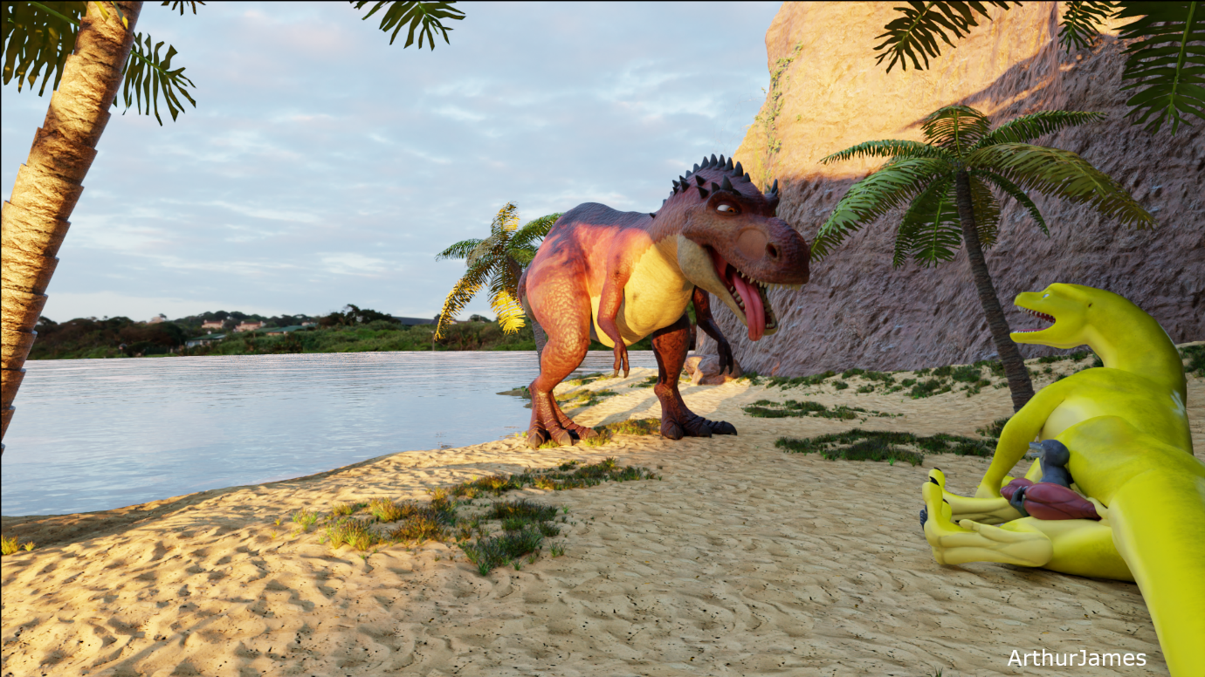It was a warm sunny morning and Noel was walking towards the beach with his big companion, a large male drake called Yaxley. Noel shared his adapted mansion with Yaxley as he had to make several adjustments to ensure he was happy inside. Noel had learnt over the first month that Yaxley had feelings for him. Noel was chuckling as he carried on walking towards the beach. Yaxley had heard him chuckle and turned his head around asking Noel what was on his mind. Noel patted him on the left side of his shoulder.

“It’s alright, I was just reminiscing when you first moved into my home. We’re nearly there at the beach, I remember you saying how much you love this beach. Although, I don’t know why. Can you tell me?”

They had stopped walking and Yaxley looked at Noel with his bedroom eyes.

“It’s a nudist beach, sex is allowed, hehe.”

Noel just rolled his eyes and playfully rubbed his nose.

“You’re such an exhibitionist. It’s lucky I was gifted with stretching to accommodate any size and take any weight, otherwise, you wouldn’t be able to mate me everyday or sit on me.”

Yaxley sniggers as he looks ahead and marches on. Noel is trying to keep up with him. Soon they finally reach the beach, it’s got many different creatures on the beach. All of them look taller than Noel, who was looking at them. Yaxley was chuckling as he gave Noel a push with his paw to go forwards. Noel cleared his throat and began to walk down the wooden walkway. Noel could see 2 large anthro male rhinos spitroasting a smaller male anthro lion, he was able to see many other creatures having sex or they were sunbathing. Yaxley ushered Noel to the left of the beach.

“Come this way. No one comes on this part of the beach.”

Noel looked up at him.

“Why is that?”

Yaxley stopped and turned his head to look at him.

“Because if you look at that sign, it reads ‘For the big ones.’ There’s even a height chart, it only shows from the minimal height, anything above is fine. You’re fine because you’re with me.”

Noel saw the sign he was on about and nodded. They continued to walk closer and around the corner was a deserted part of the beach. While they both walked to a specific spot, Noel was looking around for anyone else nearby. Yaxley noticed as he sat down.

“There’s no-one here, for now.”

Noel looked back to him and smiled. Yaxley used his tail to wrap around Noel’s waist to bring him closer. Once Noel was close enough, Yaxley lowered his head looking down at Noel who looked up at him.

“You are my love, my sweet, my mate, my toy, my everything.”

Noel went red as he blushed at Yaxley’s remarks. Noel placed his hands on both sides of Yaxley's muzzle and started to kiss him. Yaxley smiled as he gave Noel a little lick on his face. Yaxley was starting to kiss him passionately as well, the two of them were locked in a passionate kiss. Yaxley was starting to drool as he was kissing Noel on the lips for a bit until he used his paws to open Noel’s mouth. Yaxley giggled as Noel opened his eyes to see Yaxley’s tongue hanging out dripping with saliva.

Yaxley licked his lips with his slobbery tongue before tilting his head as he started bringing his face down and sticking his tongue down Noel’s throat. Yaxley moaned as his tongue went deep inside of Noel. Saliva was running down from his mouth and all over Noel’s face and body. Yaxley liked French kissing but, he would every now and then use his tongue like a cock and move Noel up and down while he was deepthroating him. Noel would be gurgling as he felt Yaxley’s drippy tongue as Yaxley was using his head to go up and down, he was enjoying this so much as drool was falling out more. Yaxley was bobbing his head up and down while his tongue was deep inside of Noel’s mouth, the saliva was dripping all of Noel’s body as he became covered in Yaxley’s slobber.

After several more minutes of Yaxley deepthroating Noel with his tongue, he removed his tongue and placed Noel back down on the ground. Turning onto his back, Yaxley spread his hind legs open, and he licked his lips looking at Noel.

“Climb up Noel. I’d love to feel your cock in my slit again, the feeling of our cocks rubbing against each other is wonderful.”

Noel smiled at him while he tried to wipe the saliva off his body. Noel walked around his back legs and started to climb on Yaxley’s tail, he was seeing his large twitching anus as he started to place his knees on the groin area of Yaxley. Noel placed his hands on both sides of Yaxley’s genital slit, rubbing them and opening them, he could see the huge cock was dripping as he moved up to get his cock ready to penetrate him.

Noel started to push his cock in Yaxley’s slit, the wetness wrapped around his cock as he went down past Yaxley’s. Noel moaned along with Yaxley as he laid down and began humping him at steady rhythmic speed.

“Oh yes, fuck my slit. I love the wet sound it makes to have our cocks grinding next to each other.”

Noel was humping Yaxley’s slit faster until he felt Yaxley’s cock starting to erect. Yaxley couldn’t contain himself and keep it together. Noel was having a hard time humping as he was slowly getting pushed up by the huge cock. Yaxley looked down his stomach to see Noel having a little harder time, with a chuckle he slowly turned onto his side. Noel slide off and landed on the ground with a puff of sand. Yaxley sniggered as Noel got up and brushed the sand off, Noel could see Yaxley’s huge cock fully hardened and dripping. He walked up and lifted the heavy cock so he could then turn around and sit down on Yaxley’s inner thigh, after that he let the huge cock flop watching it bounce a little.

Noel was rubbing along Yaxley’s cock which was making him moan and his cock was dripping more and more, until the ground started to shake. Yaxley looked around as well as Noel and they couldn’t see which location it was coming from. The ground shook a little frequently as a growl was heard, Yaxley looked to his right and his jaw dropped as well as Noel’s.

A huge t-rex came around the corner, the dinosaur saw them both and walked closer shaking the ground as it came. Noel was small enough to see the gender of the dinosaur.

“It’s female, Yaxley.”

Yaxley looked at him and then back at the dinosaur.

“I can tell. I’m able to smell that she’s in heat. I think she’s looking for a mate.”

The female dinosaur stuck her tongue out to the right side of her mouth as Noel looked up at her and Yaxley had his jaw wide open. Noel still had his hand on Yaxley’s cock, he looked at the dinosaur and then at Yaxley.

“Yeah, I think you’re right. She wants a mate and I think it’s you, she wants to mate with you. She’s huge and I don’t know if she can talk. Wait, why is she looking at me?”

The dinosaur was looking at Noel, or he thought she was looking at him with a lustful expression. The dinosaur walked closer until she was close enough to sniff Noel and Yaxley’s dripping cock. She made a little growl in her throat as her tongue came out and was licking Yaxley’s knot and a bit of his slit, while she was licking him, Noel was noticing she was smiling from the corners of her mouth and that Yaxley was moaning, and his cock was throbbing more than earlier when Noel was rubbing it. The dinosaur stopped licking him and with her right paw, she pushed him on his back with his cock flopping hardened with lust and anticipation. Noel looked at her as he was standing on the side of Yaxley, wondering what she was thinking of doing with him.

Yaxley turned his head around to see the dinosaur knock Noel over as she placed her right leg over Yaxley’s hips. She was above his throbbing cock; she wasn’t finished as she looked back to see Noel was standing between her toes. She lifted her left foot up and turned her foot to the side and bent her toes to curl around Noel’s body. Her great strength was demonstrated as she lifted Noel off the ground and turned him onto his back. She placed her left foot back down on Noel’s body as she grumbled with pleasure as she felt him huff at her weight on him. Yaxley looked around to see him under her foot partly in the sand as she grumbled at the feeling of Yaxley’s cock touching her underbelly.

“Are you alright under there, Noel?”

Noel had his arms and legs pinned, he just huffed while trying to keep his mouth closed as much as he could. He tried to say very little words.

“Yeah, I’m doing alright, I’m just not wanting sand in my mouth.”

The dinosaur moved her pelvis to feel Yaxley’s cock. She grumbled when she felt his cock touch her wet vagina. She began to move down to get his cock in her vagina, with a wet sound of the penetration. She went down until she felt his knot, with great ease due to the size of her vagina. She had a thick, plump labia and a very large opening which was always soaked inside. She began to bounce on Yaxley’s cock to his knot, she was huffing and puffing at the feeling of finally being able to ride on someone’s cock that would satisfy her needs. She wasn’t paying any attention to Noel underneath her foot as she was squashing him harder as she continued to ride Yaxley’s cock with an intense feeling of lust.

She was riding Yaxley’s cock faster as she stuck her tongue out with lust and pleasure of his big cock hitting all the right spots in her vagina. Yaxley was moaning as he knew that his climax wasn’t far away, and she knew this as she felt him shoot a bit of pre-cum in her. Noel was having to keep his mouth and eyes closed as the sand was building up from her pressing down more and more. He couldn’t do very much as he was under her foot while she was enjoying riding Yaxley’s cock.

Yaxley began to moan, and the dinosaur sat down engulfing his whole cock and knot. Yaxley was cumming so much into her vagina that it was leaking out and over his cock and hips just as her cum was leaking out too. The dinosaur was panting as she orgasmed over Yaxley the same time he cummed in her. The sheer volume of fluids falling out were soaking up the sand around them, Noel felt the fluids touch his face as he tried not to say anything. The dinosaur grinded her hips a little on Yaxley as she was slowly getting up from him. The cum was starting to burst out as Yaxley’s knot popped out that blocked the rest of the cum to pour out. She stood back up and lifted her foot off Noel and moved forwards until she was above Yaxley’s face. He stared at her dripping wet vagina with cum hanging off, he was wondering what she was going to do until it was answered. She squatted down and was squirting her juices all over his face, Yaxley kept his eyes closed as she continued. Noel was wriggling out from his hole that was made due to her squashing him, Noel sniggered at the sight of the dinosaur constantly pouring out her juices over his face.

After a while, she rose and began to walk away leaving Yaxley coated in her juices and Noel who was giggling at what he saw. Yaxley turned his head to look at him, while dripping in her juices. Yaxley opened his mouth to speak until the liquid went into his mouth, he licked his lips.

“Mmmm, that was tasty. If I had known that I would’ve kept my mouth open for her. Also, what are you giggling about?”

Noel walked around to meet him at his face.

“You. It was funny to watch after I managed to get myself out from my hole, she had kept me under her foot while she mated you. Did she feel good? It’s a shame I couldn’t see it at least.”

Yaxley licked his lips as he huffed at the feeling of the session, his cock had slipped back into his slit.

“Oh dear, that means you wouldn’t have been able to see her mate me. Her vagina felt amazing, it’s so big and wet. I think she was in heat though, as she came for me and me only. So, I think she just wanted a big cock to fill her up. I’m not sure what the squirting over my face was for though.”

Noel stroked Yaxley’s face and he then had the fluids go onto his hand. He gave his hand a lick and then he looked at Yaxley.

“Hmm, I prefer your cum and saliva than females. You’re right though, she was in heat. I think the squirting of her vaginal fluids was just to mark you. Don’t worry though, I’m sure it’ll wash off.”

Yaxley nodded as he turned on his stomach and got up. Looking around and down at Noel he ushered him to go in the sea with him to wash off the juices and for Noel to wash off the sand from his body. They both went in the water smiling at each other, Noel swam closer to Yaxley until he reached his face. Giving a kiss on the lips, he then asked if being bisexual is complicated. Yaxley broke off from the kiss to tell him how it feels amazing to be with anyone, he then brought his mouth to Noel’s ear to whisper.

“But I love you more than anyone I’ve been with. I’ve always felt more alive with you, sharing your mansion has been the best thing that’s happened to me in a while.”

Noel moaned as he held onto Yaxley’s neck like he was trying to give him a big hug.

“I love you so much. I was very happy the day we met and the loads of meet ups we had. Sharing my mansion with you and having altered it for your fittings, was a forward step for me and you. I will always be at your side for support and love.”

Yaxley and Noel kissed and hugged each other in the sea for a while before looking at themselves seeing the sand and the fluids had come off. They both swam to shore and began walking back around the corner to see some people cheering as they walked past. Noel went red in the face as he was wondering why they were cheering.

“Why is everyone cheering for us?”

Yaxley continued walking and he looked around at some of them cheering before looking back at Noel.

“I think they knew about the huge dinosaur that came over to the beach. They must’ve heard what happened. It’s fine though, I don’t mind people hearing anything. Next time, we’ll stay on this side of the beach, and we’ll fuck each other.”

Noel and Yaxley looked at each other and laughed as they left the beach. On the left of the wooden path was a tap for cleaning feet from the sand. Yaxley and Noel took turns washing their feet before they set off down the walkway. They continued walking into the mid-day sunshine as Noel and Yaxley continued talking about lunch and where to go. They couldn’t look any happier walking together. It was a companionship that was admired by many of their friends and family as they normally did plenty of things together. They walked off into the distance to get lunch and for a big future that would lie before them.