Story © 2023 Ziel

Art © @cbl_art on twitter

The Shocking Adventures of Lumen

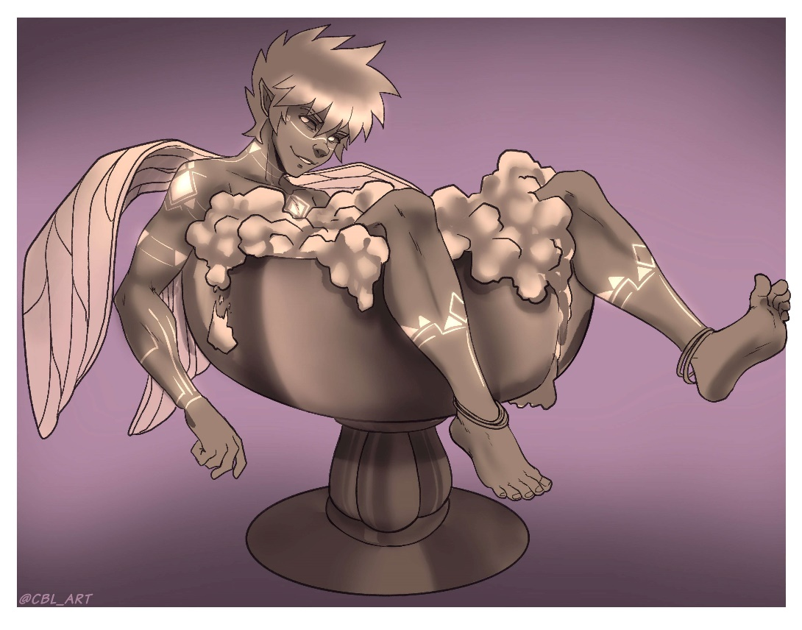

**Part 5**

Lumen still wasn’t sure how he felt about being so huge. He loved the feeling of having such an immense package. Every morning, he woke up to a semi the size of a city block. His pleasantly plumped member was several orders of magnitude larger than his body so that even just the sensation of a nice semi was intoxicating. He also liked the feeling of the more adventurous sorts exploring the mountainous expanse of his cock and balls. Some even chose to go spelunking in his Cave of Wonders. The people scurrying up and down his shaft and stones tickled. They felt like gnats against his enormous meat. Every time he thought about how tiny these people were compared to his colossal cock and balls, he couldn’t help but chuckle. Did these people know that they were so thoroughly outclassed by a *faerie*!? One of the smallest creatures in the land, and yet his cock could cow a dragon.

Yet… as much as he loved how massive his cock was, he hated being immobilized by it. He could do nothing but recline against his mountain sized stones and stare up as the clouds floated overhead. He wished he could be like the clouds. He wished he could lazily drift from continent to continent. Clouds could still float despite being the size of a city so why couldn’t he!?

Lumen knew the answer to that. Clouds were light as a feather, but he was heavy as a mountain. It was possible to make such an incredible mass levitate, but it required far more power than Lumen had access to in his tiny body. And so, despite how much he loved the feeling of having such a huge cock and dwarfing all the “big” races, Lumen grew antsier and antsier with each passing day.

Had Lumen stuck around at that size, he may have become a draw for the community. Now that the dao’s palace had vanished, the oasis was sorely lacking in tourist spots, but eventually, the magic of the dao’s potions had run its course and Lumen’s cock steadily shrunk down to a more manageable size. By the time that his cock size had finally stabilized, Lumen found that he had significantly more mass below the belt than he had had before ingesting all of his potions at once!

At first, Lumen thought that his cock was going to slowly shed the last bits of his additional size, but it steadily dawned on him that this was his new normal size! Lumen’s mind raced as he tried to figure out what had happened. He figured that this must be a side effect of overdosing, but had the dao known this would happen? Lumen figured that the dao must have known, but this knowledge was not included in the compendium that Lumen had absorbed! Was this information intentionally kept from him?

The dao didn’t seem like the type to deceive Lumen, but he did seem like the type to enjoy imparting a nice life lesson or three – kind of like a wise and kind uncle. Lumen had no doubt that this side effect would have become apparent sooner or later. After all, the dao had said there were ways for Lumen to increase his size once he had grown stronger in his control of magic. After all, more mass meant he needed more power to lift it all. If he had gotten much larger, it would have been impossible for him to even move at his current strength.

That was probably why the dao had given Lumen the number of potions that he had. Sure, Lumen now knew how to craft more, but the process was slow and the ingredients rare. It would be a while before he would be able to craft a fresh batch, and by then, he’d probably be strong enough to handle a little extra weight.

Lumen had to be careful as he flew, if he took a turn too quickly, the sheer momentum of his enormous package would pull him wildly off course! If he wasn’t careful, his meat and two vegs could go swinging like a wrecking ball. The sheer force of his battering ram of a cock and his massive boulders could easily body check an orc! In fact, he had nearly done just that as he struggled to gain altitude and escape the city!

As things currently stood, Lumen’s cock and balls were so heavy that Lumen had had to practice for hours before he could even lift the damn thing! He had had to resort to the trick he had learned when he was running on fumes a few days earlier. It was clear that Lumen could no longer levitate the entire leviathan even when using his full power. Instead, he had to focus his energy on key points which left his bait and tackle to swing like a pendulum beneath him as he flew.

Lumen had barely made it a few blocks before he had to land and catch his breath. Stopping and swerving were far too taxing. If he could get up and over the rooftops, he could cover some decent ground, but his junk was just too. Damn. HEAVY!

As Lumen lay gasping for breath atop his own enormous, invisible cock and balls, a thought crept into the back of his mind. If only it was a little smaller…

Lumen recoiled at the mere thought of it. He wanted to be *bigger*! How could he even entertain the thought of going back! And yet… that would solve so many problems. He didn’t need it to be much smaller. If his junk was even the size it had been before his potion mishap, he would have a much easier time escaping the city. He didn’t even need to remain small for long! Just long enough to get up and over the walls so he could zoom over the rooftops and out past the outer gates.

As Lumen lay back atop his own ale-keg sized cojones, the answer became apparent so suddenly that Lumen actually had to stop panting long enough to gasp in shock. Lumen slapped his forehead. It was so *simple*! He was so obsessed with getting bigger that he forgot how easy it would be to get smaller. He’s a *faerie!* A being known far and wide for being tricksters and masters of size manipulation. He had used his innate fae magic just the other day to make Llorian taller than the garden walls! He could just as easily turn his magic on himself! A quick reduction spell would only last a few minutes, but that was all he needed! He just needed to stay small long enough to hop the fence and zoom out into the desert proper!

Lumen placed a palm against his chest, took a deep breath, and let his innate fae energy course through him. His whole body glowed with a blue light. Lumen had no idea if anyone had seen him casting. If they did, they would have seen a spectral outline of his immense cock and balls for a brief second before Lumen rapidly dwindled to half his original size.

It the span of a second Lumen went from being as tall as an apple to being as short as a plum! The sheer speed at which everything around him seemed to surge and stretch outwards left him dizzy for a second, but the momentary sense of vertigo quickly faded and was replaced by a bevy of conflicting emotions and sensations.

Lumen had never felt so small before. He was used to being able to fit in the palm of the larger races, but now he was barely as big as a person’s thumb! He felt weak and vulnerable. Everything seemed so loud and so large. Heavy footsteps reverberated from the nearby thoroughfare. The walls loomed over him so high that for a moment he began to panic that he’d never be able to fly high enough to escape, but before the panic could fully set in, another sensation took hold.

Lumen felt… *light*! It wasn’t just a physical weight that had been lifted but a mental one as well. He was lighter than he had been all week, and with his newfound control of the wind, he could effortlessly send himself – body, cock, balls and all – soaring into the sky!

Lumen summoned a quick gust of wind to send him spiraling upward. As he spun and swirled through the air, the constant weight of his impressive package reminded him that even though he was small, he was still *huge!* His heavy schlong was still well over a foot long. Even at his reduced height, he could still outclass an ogre below the belt.

Lumen stopped spinning and stunting long enough to stare down at the desert city that sprawled out beneath him. From up here, *they* were the ones that looked like ants!

A devious smirk spread across Lumen’s face. At his current size, he could effortlessly fly up and over the city, but he could also easily fly *through* it! He was small! He was agile! He was swift as a sparrow! He could stop on a dime!

Lumen’s fingers reached down and tapped the trinket that hung from his hip. It was a small, ornate fox mask. It was the perfect size for a faerie and was imbued with the power of a trickster spirit. The mask was a going away present from Llorian. The dao’s glamour had long-since faded, which left Lumen’s immense junk exposed to any onlookers. Part of Lumen wanted to leave his cock flying free, but he understood that sometimes discretion was key.

This was not one of those times.

With a quick flick of the wrist, Lumen dropped the glamour that hid his endowments, spread his arms wide, and fell backwards into the city below. Lumen closed his eyes and chuckled as the air rushed past him, and as he careened towards the streets below, he could hear the surprised gasps from the onlookers that had caught sight of the sizeable schlong which was falling from the heavens. Even at his reduced size, Lumen’s cock would put even the most blessed courtesan to shame. His schlong was every bit as long as a full-grown orc’s forearm and every bit as thick as a goliath’s bicep! His nuts were as large as watermelons, and all that mass was hurtling towards the streets below like an owlbear meteor.

Lumen fell and fell. The feeling of the winds rushing by made his heart soar. It was as if the winds themselves had hurried to his side to carry him home. He had never felt so in control before. Controlling the wind and thereby controlling his own flight was as easy as breathing. It was nearly instinctual when he flipped backwards and righted himself. He quickly came to a stop and hovered a few feet above the ground. His huge dick and massive nuts hung heavily beneath him. Lumen found himself floating nearly eye level with a dwarven merchant. The man’s jaw hung slack as he stared at the cock which was as long as his torso and almost as thick. Lumen may only be as big a few inches tall, but the thumb-sized sprite’s schlong left the man feeling incredibly tiny.

Lumen had no idea if the dwarf even saw him. As far as Lumen knew, the guy assumed the giant cock hovering before him was bereft of a body. Lumen chuckled softly to himself. It took every ounce of self-control he could muster to maintain his reduction magic. Some dark part in the back of his mind was goading him to drop the spell and let the dwarf see a cock that rivaled the merchant’s whole body for sheer mass, and an even darker part of his mind was egging him on to turn his size magic in the opposite direction! If the dwarf was feeling small now, just wait until he was staring down a schlong that was more than *double* the dwarf’s current size!

As much fun as that would be, Lumen was itching to get onto the open road. He had enjoyed his time in the desert, but there were new frontiers to explore and new extremes to push his magic! The skies were calling!

Lumen summoned up another gust of wind and rocketed down the street. He zipped between market stalls and under carriages. His fat cock and heavy balls effortlessly bobbed from side to side like a dragonfly. In a matter of moments, Lumen had made his way across town and towards the city gates. He summoned one last massive surge of wind and launched himself up and over the walls. As he crested over the gate, the last traces of his size magic faded. His body doubled in size. He surged outwards in all directions. Lumen suddenly felt incredibly heavy. The sheer weight of his massive cock and colossal balls weighed him down and pulled him towards the earth below, but Lumen had accomplished what he had set out to do. He had cleared the walls, and as gravity took hold and slowly pulled him downward, he spun around and gave the city one last clear look at his impressive girth.