NOW YOU SEA
COMMISSION STORY
BY CHALDEACHANGE
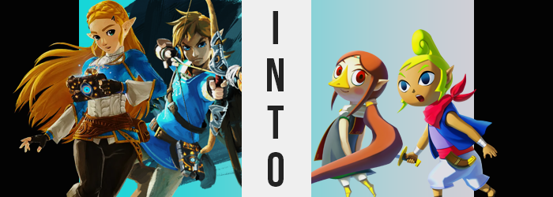

It wasn’t long after the defeat of Calamity Ganon that they appeared. Ruins never before seen by anyone who lived in Hyrule, their entrances opened by what could best be described as a mysterious force. Five in all, it almost seemed like they had been crafted beneath what most of the regions of Hyrule considered to be their capitals. Princess Zelda had caught wind of their appearances, but having been close to Rito Village with Link at the time, it was the ruins there that the two ultimately had opted to check out.

Torches lit, the two had entered the entrance cavern without an escort. Rito Village was dealing with food shortages at the time and were short on extra hands, but since it had been deemed that the ruins contained minimal threats, that escort wasn’t really necessary anyways. After all, the hero that had saved Hyrule was with the princess. No assurances other than that were truly needed, really.

“Link! Look at this! Have you ever seen a blade quite like this? It reminds me of the scimitars that the Gerudo use, but much smaller. Why would this be found beneath Rito Village of all places, though?” Upon entering a chamber teeming with unusual treasures, the princess was quick to clamor about and touch every little thing that struck her eye. The first was a tiny, rusted blade that she handed off to Link – before pulling the second, a golden hairband, up the length of her locks to tie it up into a ponytail.

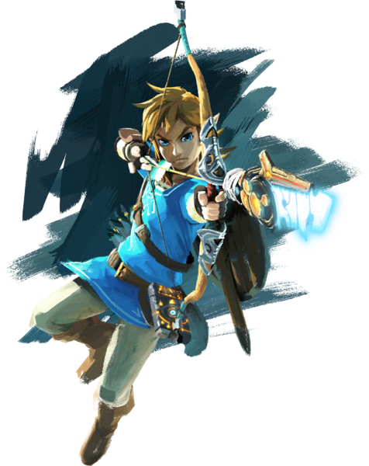
Link, being Link, said little about it as he weighed the tiny blade in his hand. Was it a sword meant for a child? It was rusty, but he was experienced enough to recognize that the blade had once been sharp, and it was certainly crafted with authentic steel. He’d sought to examine it more, but a cool and salty breeze suddenly prompted him to look up…

To find himself standing on a big, wooden ship.

“…?” The heat of the sun above was as blinding as it was hot, eyes forced to adjust to a sudden change in environment. Docked at what looked like a tall island of some sort, it was clear to the knight that something awry had just taken place. The princess was no longer at his side, either! A brief glance down at the rusted blade in his hand revealed something else, too. Something strange.

All of the rust and wear that had plagued it had been entirely removed. Instead, the blade practically looked brand new. But how? Was it related to the sudden change in scenery? Was it the cause of it? He tapped a foot on the wooden ship and looked behind him, surprised by just how huge the ship was. It didn’t look like a conventional civilian ship, either. Almost like it belonged to a group a little more menacing in reputation.

With his attention removed from the ship again, his gaze ended up pointed right back down at the blade again. And much to his surprise… “Bigger?” It definitely appeared to seem bigger within the grasp of his hand, but the fact that he’d commented on it aloud was something worth noting simultaneously. Link wasn’t the type of person that expressed anything aloud.

Had the blade actually grown bigger though? While it might have appeared that way from his perspective, in truth while something had changed in size, it wasn’t the sword. It was Link himself. His mass had diminished and was continuing to diminish, body collapsing in on itself in a way that looked rather uncanny but still carried a strange consistency.

Because for every inch his torso lost, just a little more than that was shaved off of both sets of his limbs. It was a phenomenon that was much more clearly dramatic in his legs, which became shorter and stubbier than ever – and toes became little more than nubs on their little tips – but there was still something to be said about the shortness of the arms themselves. Even his fingers and hands had suffered the same loss, digits struggling to fully grasp the hilt in the end.

“Huh? Wait, am I tiny now?” Still using his words in a very out of character fashion, it struck Link very quickly that he’d shrunk. The pitch of his voice was dramatically higher, and while you’d think that his clothes would be falling off him at this juncture they had actually shrunk along with him. Retaining their design, they merely shrunk to fit him as if they’d sat in cold water for a long time.

Despite the loss of overall sizing, there was a part of him that had actually grown, although it was a strange part of the body to have done do. Nonetheless, his head had grown both wider and rounder in every sense of the word. Be it the overall shape of his skull or the fact that his cheeks had inadvertently puffed outwards, in way it almost looked inflated. Yet, at the same time there was a childlike whimsy to it.

Perhaps that wasn’t all that surprising, all things considered. He’d shrunk so much that he could only be a child – right? Or, at the very least, someone who had just emerged from childhood. A fair youthfulness was something that had seized his facial features in the same way that the roundness had, and Link’s eyes were growing wide not because he was shocked but because they were literally doing so.

Whether it was eyelids, irises, or pupils; his baby blues expanded into horizontal almond shapes that weren’t exactly typical of Hylians… at least not from the era he hailed from. Their bright blues also appeared to darken, ultimately fusing with his pupils in terms of darkness that almost appeared as if they didn’t exist in the first place.
“But why did I shrink? Actually, I’m younger, right?” Leaning into his new keenness to speak, Link began to rationalize his situation aloud – ignorant to the fact that the color of his hair was brightening to a highly contrasted yellow while its overall style shifts. Bangs withdrew to reveal the very same color in thinned brows, and at the sides it lengthened into what resembled lightning bolts in shape. More miraculously, however, was what happened to the styling in the back. It lifted high and curled, becoming a wound-up ponytail upon her— his head.

The confusion wasn’t exactly unwarranted in this case, for with Link’s softened facial features came an unassuming androgyny. In many ways, his facial structure had come to resemble that of his princess. It was just overall much rounder. And the freckles certainly didn’t do the look any favors.

Wait, freckles?

The brown spots that had appeared across the boy’s face certainly could be misinterpreted as such, all things considered. They stood out considerably against his porcelain complexion, and yet before long that porcelain color would find itself in the minority. Tanned spots from the light of the sun erupted all over his skin, and it certainly didn’t take very long for this color to be the norm. Even everything beneath his clothes, as if he went out of his way to sunbathe.

Strangely enough, what had once been seen as bizarre was soon becoming the norm from Link’s perspective. Hadn’t he always been this height? And even upon seeing his hand, he hadn’t at all considered anything to be awry with his tanned flesh. “YIP!?” Not even after she rightfully let out a squeak in direct response to her junk being tugged inside of her did she actually stop to wonder if her sex had just changed.

Of course now that she possessed a girl’s equivalent, it was only natural that other features would change similarly. Her chest was one of those areas, growing puffier with plumper nipples but hardly amounting to anything sizable, all while her butt cheeks showed signs of budding all their own. Rather than fixate on any of this though, she pouted thanks to a sudden agitation. Something about her surroundings was bothering her.

While trying to figure out just what that was, she sheathed her tiny scimitar in a sheath that actually hadn’t been on her hip just moments ago. In fact, from white pants to a purple shirt to a blue jacket and a red scarf, her entire outfit was different now. Far more befitting of a girl that called herself a pirate.

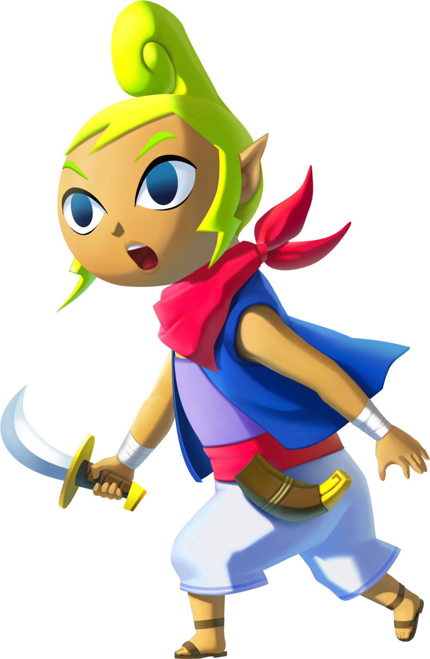
“Where is everyone!? We’re supposed to be setting sail at dusk!” Stomping tiny tootsies against the floorboards of her pirate ship’s upper deck it was evident that Tetra was short on patience. Not that this was unusual for her, but from the girl’s perspective things still seemed a little off. Even though she could recall having woken up early in the morning after they had docked at Dragon Roost Island late the night before, she felt as if she’d just literally awoken from a strange dream.

A dream that had left her with the thought of ‘Aren’t I supposed to be looking for someone?’ even though she couldn’t plausibly remember what that someone was. The pirate girl shook her head from side to side, trying to clear the grogginess that had accommodated it, before turning her attention back to the state of her ship. Or, at least, the very absence of her crew. “I bet they’re out helping Link with this and that again, even though I told them to leave him alone! I wonder how many of them I can put on cleaning duty as punishment when we set sail, then?”

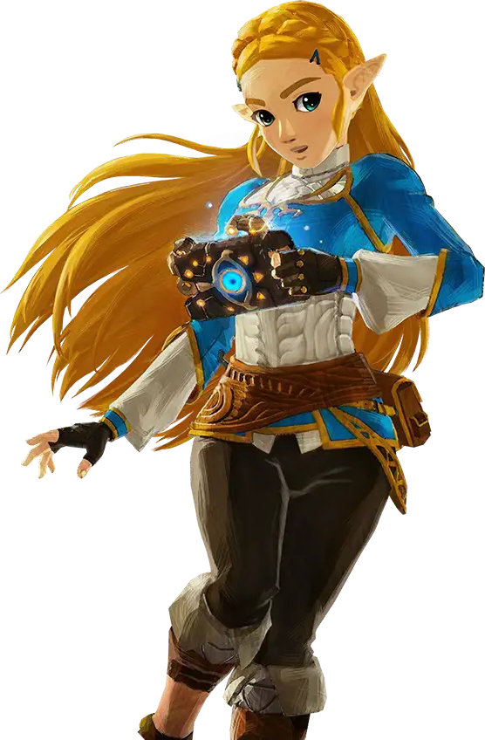
“Link? Link!? Oh, where in Hyrule am I?” Was she even in Hyrule any longer? After putting the gold piece in her hair, she had turned to examine a gemstone nearby that had shown visions of what looked like an island. The next she realized? She had found herself in a cave that had been filled out with wooden furniture, sporting a glassless window. Through it she could see the sea nearby, as well as a harbor with what could best be described as a pirate ship down below. “This doesn’t look like Hyrule at all, actually.”

She was so high up as well! She couldn’t fathom all of the stairs necessary to reach such a height just for the sake of accessing a bedroom. Her bedroom. “Ah? No, this isn’t my room. I’ve never before seen it in my life…” But was that really the case? Something deep down was telling her the opposite. That she had woken up in the wooden bed lined with straw earlier that morning.

Could that possibly be true? No, she’d been exploring the ruins beneath the Rito’s island— Erm, no! Rito Village! A whole island? Perhaps with the chasm around it, it could be seen that way by some?

Had she been transported to the island that gemstone had reflected?

Whether that was the case of not, she was already falling victim to the gemstone’s more pressing effects. One need not look any farther than the princess’ beautiful, golden hair to see that. Mostly because that beautiful gold color was dwindling, beginning at the tips. These tips took on a rich albeit rather plain looking brown, and the color slowly worked its way up the ponytail held by the holden clasp.

As the color drained though, it was clear that more was transpiring at the very same time. The ponytail tightened until it all looked like it was practically a single piece, and the braid atop her head unwound so that it was all completely flat – composed of many little hairs, but almost resembling a single piece to the naked eye. It all grew as well, mostly in the back but the lengths that framed her face fell several inches past her shoulders.

The color of her eyes succumbed not long after, too. Brilliant emeralds lost their luster before igniting once more, this time in a fiery red that seemed to be more sinister in color than her personality suggested – and would continue to suggest regardless of how far Zelda strayed from her true self.

“A-ACHOO!? Huh? Why is breathing through my nose so awkward?” A sudden sneeze had forced the princess away from investigating her the room more thoroughly, and after wriggling it a moment she found it became more difficult to be able to continue doing so. Furthermore, the pigmentation of the skin there appearedto yellow and harden. More and more and more.

But it was also growing. More and more and more. “E-Eh!? EHHH!?” Hands immediately flew up to grasp the swelling growth, which quickly took up so much of her face that she thought her eyes were going to pop out of her head. Fortunately they didn’t, but only because she shape of her head was swelling and rounding out – providing much needed room for this nose to flourish. While growing in size, the tip sharpened and her nostrils both rose and thinned until they were only tiny holes within what could best be described as…

A beak.

Big and hard, it certainly resembled one more than a nose even if her mouth was still a separate piece of her below. “I have… Don’t birds usually have these!?” And members of the Rito tribe, in fact. Zelda’s eyes had gone terribly wide, but it was both from shock and actual growth. With more head to take up, her crimson eyes had grown much larger and rounder. “No… am I supposed to have a beak? I’m not, right?”

Why was she doubting this? Of course I’m supposed to have a beak! She reaffirmed this to herself, but it still didn’t sound quite right somehow. Going back to her earlier assertion, she wasn’t a bird so she couldn’t have a beak, correct? But tufts of white and downy feathers had begun to poke out from Zelda’s pale skin in great numbers. Whether it was her face, her torso, her arms, or her hands – this plumage covered them all, so light that from a distance it didn’t look like she had any feathers at all. When it came to areas like her nipples and bellybutton, they were all completely concealed in the end.

On the other hand, there were much bigger ones that had sprouted somewhere where they could remain properly concealed. Tucked under her arms and folded up against them discreetly, if the princess were to swing her arms out in a certain way these feathers would unfold to turn her arms, which now sported nail-less fingers, into wings capable of flight. Well… Sort of.

While the plumage had decorated even Zelda’s ears, there was two portions of her body they had left untouched. The first was her beak of course, but the second? The area below her knees had dried and hardened while the feathers farther up had been in the process of sprouting. A familiar, yellowish tinge had struck them, and layers cemented themselves all of the way down to feet that found their toes shrinking and gaining tiny talons while the heels of each foot naturally rose so that it appeared like she was standing on her tiptoes even in her boots.

“No, I’m… I’m a Rito, aren’t I? That’s the only thing that makes sense!” Her desire to use logic for all things more or less bit her in the ass here, because it became the means through which she found herself accepting this bizarre reality where she was a Rito that didn’t at all resemble the Rito she knew. In the end, her body’s proportions also found themselves imperiled thanks to her height dropping just as dramatically as Link’s had down on the ship below.

But Zelda didn’t cry out in surprise or anything of the sort as her age dipped back down into the twelve or thirteen age range, along with her height bottoming out at a point where she appeared even younger than that. Instead, she seemed to be temporarily in awe of how big the room suddenly seemed. “Maybe it was just my imagination, but weren’t things a little cramped in here before?” Short as could be now, her ponytail now had to curl to the side to stop itself from dragging on the floor.

What’s more, her clothing felt like it was more comfortable? It had all felt so tight in the beginning, but now she was in a simple, green tunic with white shorts and a matching scarf. It was all loose and airy, perfect for if she had any reason to spread her winds! The thought of flying made her a little anxious though, but not as anxious as another realization made her feel. He was late! It certainly wasn’t like him to be later, even if he could be something of a scoundrel at times!

If there was one thing that hadn’t changed, it was that there was a Link in her life.

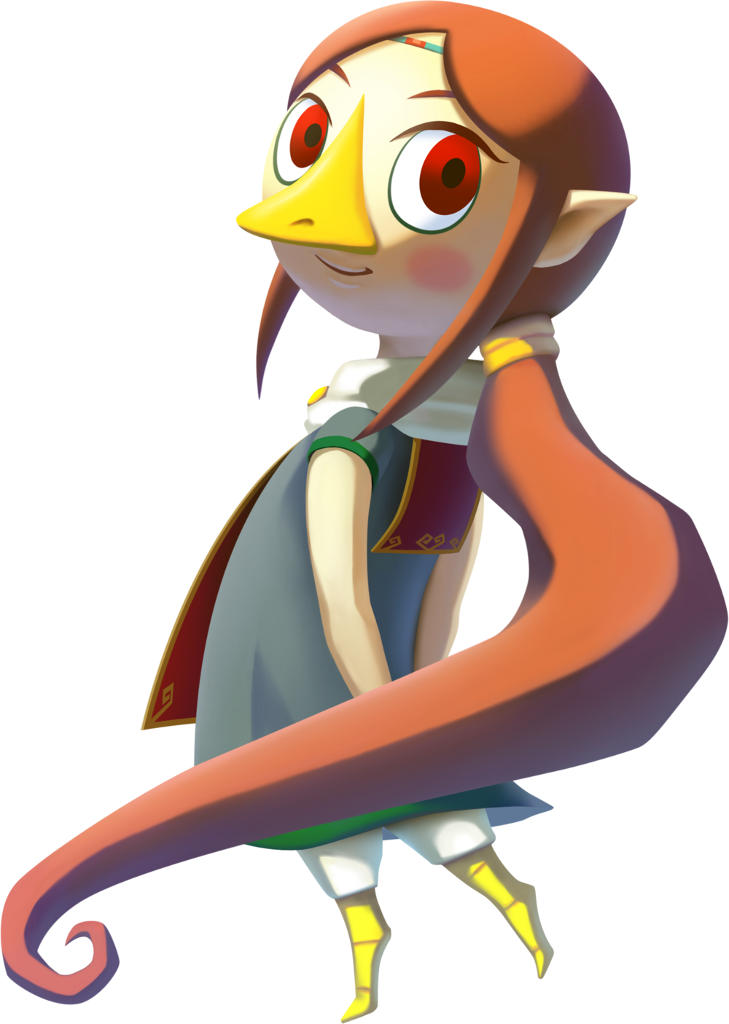
“Hum… I’m getting a little worried. Link told me he’d visit, but it’s well into the afternoon and nothing.” The young Rito girl, Medli, looked wistfully out of her window at the ocean outside. The pirate ship that typically carried the boy had been docked in Dragon Roost Island’s harbor since the night before. He promised that the next he came to the island he’d seek her out, and so the Rito had put aside her responsibilities as Valoo’s attendant aside for the day in hopes he’d drop by. But even so, it was strange for him to be so late!

Young and softspoken as she was, it was inevitable that her impatience would lead way to anxiety, something she always treated the same way. And so her tiny, bird feet carried her over to her bed, from behind which she pulled her harp to practice strumming. “I’m sure he’ll arrive with time. I just need to be patient!”

But Link would never arrive, because like the Link and Zelda from the future, figures from all over Hyrule’s time and history had been shuffled all at once – each being dealt a new life to lead. The Link of this era was only one of many, many victims.

Zelda never should have tampered with that gemstone.

