ROCK AND ROLLING V
COMMISSION STORY
BY CHALDEACHANGE
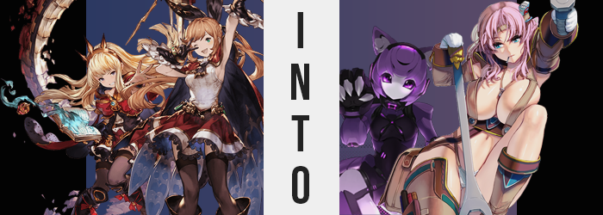

Some weeks prior to Lecia and Monika’s raid on the Grandcypher Recording Company…

“So it started with Lyria, then spread to other members of the crew from there, is that it?” The infamous alchemist, Cagliostro, was within her laboratory aboard the Grandcypher, taking down notes while her fellow alchemist Clarisse was making preparations in the outer halls in an attempt to fortify their space. It had become noticeably clear over the course of the past few days that avoiding any contact with any of the transformed crewmates was mandatory, for interacting with them would inevitably lead to an assimilation of their own.

Assimilation into what, exactly? Well, it wasn’t difficult to see, though understanding the reason was an entirely different dilemma. One only needed to look around the understand that while the Grandcypher hosted its fair share of beautiful women already, the number of them had increased, as well as their quality.

Each and every woman that the alchemists did not recognize were admittedly excessively beautiful, sporting curves that should have been far less common unless they were upon the frame of a Draph. What’s more, each of these women bore some sort of relationship to something that was being called ‘The Grandcypher Recording Company’, be they sultry musicians or attractive crew members.

Careful observation confirmed their worst suspicions. Existing crew members were being transformed both in body and mind to become a part of this project. It was done through interaction with musical equipment of some sort typically, and those that were transformed seemed to know as much. Whenever they could, they coaxed unchanged crewmates into interacting with these devices so that they became one with the project, and the moment they had realized that? Cagliostro and Clarisse had warned as many as they could to get away, all while holing themselves in the ship.

They couldn’t leave themselves, not in good conscience. Not when there was a chance they could help with the reversal. Cagliostro had already identified Lyria or Laura Lars as the Singularity Point that had started it all, so if they could manufacture a reversal for her and go from there…
Yet, the alchemists weren’t the only ones looking at developing something that might alter the flow of this Sexy Musician Pandemic. The true culprit behind it all had been working just as tirelessly, and she had figured out a way to spread the effects without having the targets make physical contact with any devices nor instruments at all.

And so, a techno tune began to blare over the speakers that were built into Cagliostro’s lab.

“Huh!? The hell is this crap!?” There was no cutesy act to be found in Cagliostro at that moment, for she was thoroughly peeved by the tune thumping through her quarters. Every room had speakers installed in case the captain needed to make an announcement, but this was the first she’d heard music blasted over it. Was it the work of the invading faction? “What? They going to annoy me into giving up? Unlikely.”

Even so, she knew she had a pair of earplugs in her conjoined bedroom, so she swiveled off her desk chair and began to head towards said room. But something gave her pause. “Why… am I so cold?” How long would it take her to realize?

That the effects of the curse could now be spread through special music tracks?

“Wait, is the music doing something, nya!?” Evidently it hadn’t taken the alchemist long to notice, but what was that noise she had made just now? “Did I just nya like a cat, nya?” Shit, again!? Cagliostro wasn’t engaging in its usage intentionally, it was just blurting out naturally! “Ugh. So it’s already too late, nya?” This was in line with what she had observed in others. Initially, something bizarre happened to throw the target off-kilter before-

RIIIIIIIIIP!

Before some unusual physical amendments were made to their bodies.

However, as she peered over her shoulder at the source of it? Cagliostro was certain she hadn’t seen an effect like this in any of the transformees thus far. Because what it was that had pierced a sizable hole in the back of her top was a long appendage forged with purple steel, a black, square accessory with a glowing purple stripe wedged upon it halfway down its length.

“A cat’s tail, nya!? Am I turning into a cat, nya!?” It all made sense, really. She was making cat noises, so why not ear cat-like features? Even now, her ears were sliding up the sides of her head, stretching into triangular shapes with purple, steel exteriors. But if she was becoming a cat, then what was the deal with the metallic look and feel to it all? Even though she found she could control the tail, she couldn’t really feel it short of the weight at the base of her spine.

But if she were becoming a cat of any sort, would she not shrink? Rather, her chilled body was now overcome with the opposite sensation, for her point of view had suddenly begun to spring upwards. “Nya!?” The alchemist’s childlike body stretched in every way imaginable, arms and legs becoming lankier while her torso pulled wider, and hands and feet found new length as well.

The extra height wasn’t excessive, but she did grow three or four inches before the phenomenon came to a halt. This left her tummy exposed since her top had been yanked away from her skirt, though on the whole? There was an additional abundance to her figure’s design, suggesting it was more than just a simple vertical growth spurt. Her shoulders and hips had also widened, the latter significantly so to that point that her skirt was entirely flipped upwards to reveal her panties. This meant that the back of her top now had a big tear in it though, from where her tail had erupted and eventually escaped as the top was raised higher.

“Wait, am I older- WHERE ARE MY CLOTHES, NYA!?” Her clothing malfunction was only a short-lived situation though, because without her realizing a burst of extraordinary heat fired off from her body’s core, completely eviscerating any cloth scraps that had dangled from her body.

Looking down at herself, had her figure been engorged as well? “My chest, nya!?” Gone were her childlike proportions, and instead she possessed a B-cup bosom that, suspiciously, was without nipples. “Er…?” Wait, that wasn’t normal. Where had her nipples gone?

Even while she contemplated concern over this, similar events were transpiring all across her body. While her panties had disappeared, for example? Her crotch was completely smooth. Completely. No hair, no genitals, nothing. And her ass fared similarly, for the crack filled in even though the rump retained its shape and size. Cagliostro was just feeling colder and colder, and the rate of her heart was… “This is getting—MMF!? MMF!?”

The girl – woman? cat? – couldn’t even finish that thought, for her lips were sealed shut all of a sudden, in tandem with the color of her skin distorting from pink to silver. Her nostrils flattened, her cheeks narrowed, and the weight of her face? It was significantly heavier. She couldn’t really feel it like she once had. Only cold. Until finally, her vision flickered off.

Cagliostro was left fumbling around without vision or a means of communicating, unaware of the cause of the weight that was now plaguing her mass. From head to toe her skin lost its fleshy color, but depending on where it was on her body, that color differed. Her legs, for example? They became silver. Her arms? Dark purple. Her torso? Black. But rather than just taking on new colors, the material of her body itself was changed.

No longer was the woman’s body composed of flesh and blood, but was instead forged of steel with coolant running through what counted as veins. Her heart did not beat for it was a generator, and even the depths of her joints were left fully exposed, giving her a doll-like look.

But while her hands and feet were steeled like everything else? Their shapes grew engorged and distorted. Fingers and toes shifted into silver claws, while hands and feet that were dyed black thicken and earned guards so that the resembled the paws of a monstrous cat-like creature.

The machine woman bumped into a table and fell forward, ultimately catching herself on all fours. Blonde hairs that swished from side to side were shrinking, ultimately forming a bob cut that solidified into additional purple steel. It was like a dome that guarded her brain. One that only resembled hair at the end of the day.

Who am…? What am…? Nya…

Before Cagliostro could mentally process much else, her thoughts stopped entirely. The human brain that resided within her skull had been in the process of digitizing, her consciousness transferred to a small computer that acted as her brain, with programming that would force her to act a certain way. And by the time she could see again? It was through big, glassy purple eyes.

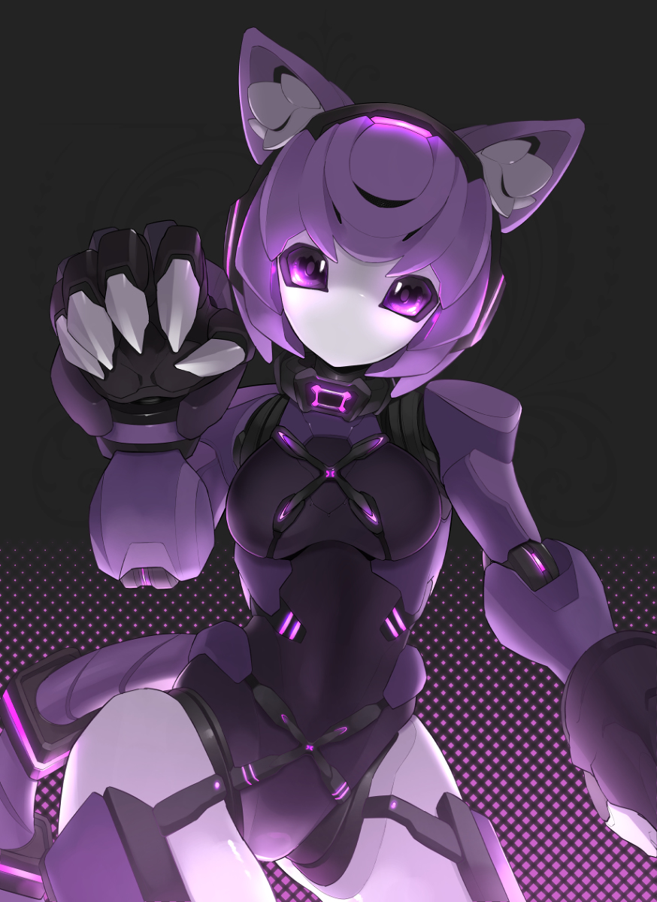
“Systems online. Playback requires additional adjustments, nya.” The metallic paws of the world’s first robotic idol, N3K0, spun around as her mind rebooted, now as digital as her flesh was steel. She perceived the world through camera lenses, heard it through censors, and communicated with others using a speech program that called out from a series of tiny holes where a mouth had once been. She was an impressive piece of hardware that could think and feel like a human. But what she wasn’t? Was an alchemist.

It was ironic in a way, for Cagliostro had always been seeking a way to remain cute for eternity. As a cat-girl machine, whose mind could just be backed up and placed into a new body if the need ever arose, she had more or less found that. But that desire was no longer recorded in her memory – in fact, she hardly had any memories to speak of.

N3K0 was a new model that knew only her purpose and the face of her creator. A creator that, for some reason, was not present despite typically needing her to active. “Was there a glitch in the hardware, nya? I should find her, nya.” Her purpose was to sing, and to those ends she had been programmed with a number of songs. But each song? It would transform any that listened to it so that they became a member of the GRC.

Cagliostro had been transformed into what was essentially a weaponized version of what she was trying to stop.

Yet, she was also a sexbot, if you enabled a certain function.

Not far from the lab, but far enough that she remained ignorant to the music that was playing in the lab, the young alchemist Clarisse had been setting up a number of traps and censors born from alchemy around the two entrances to the lab. “And that should do it! They won’t hurt anyone, but they’ll definitely catch anyone who tries to come in uninvited!”

She wiped the sweat from her brow after etching the last marking necessary on the floor before it disappeared into nothingness. Special alchemic sigils that, if stepped on, would teleport the one that walked onto them into a small holding cell they had set up in the lab’s back corner without any clothes or devices that they had been carrying. This would make it easy for them to reverse the changes in anyone they caught once they figured out the means of doing so. It also meant no one could sneak up on them and use a weird doohickey that might transform them without their realizing.

…Even though Cagliostro was presently being turned into a robot cat girl inside the room she had been working so hard to protect.

“All that’s left is to— OW!?” A blow to the head knocked the girl to the ground without warning, and when she finally managed to pick herself up again? Her head aching and vision blurry, she could see a huge wrench laying on the ground beside her. “Huh…? Did someone throw that at me?” Who? How? Was this a problem? None of the objects that had spurred transformations so far had been as mundane as a wrench, so it was probably fine? It wasn’t, though.

By the time she had pushed herself up and onto her feet once more, she was disoriented still but of sound mind enough to keep her balance. But the ill-effects of being thwacked in the head by an enchanted item had already begun – focused on the head she had been struck in. The bump on her head had already healed which was odd enough, but it was the hair around it that was more aesthetically different.

Pink. A bubblegum pink had rooted itself midst her brunette locks, each hair tainted with this color turning a little thinner and scragglier, at least compared to how the girl typically kept said hair. The long ponytail behind Clarisse rescinded itself, unwinding to the point that her hair only dangled just past her shoulders and the ribbon that tied it came undone before fluttering to the ground.

“The pain already went away? That’s strange.” Considering the apparent size of the wrench on the ground, it did strike her as a little strange that she already didn’t feel any aftereffects from being struck. Although even though her bangs had lengthened a little to dangle before her eyes, she remained surprisingly ignorant to the fact that they were pink.

That said, it wasn’t the only thing she was ignorant about. Because Clarisse was being changed via contact with an object, she didn’t have as much awareness as Cagliostro had that things were changing in the first place. So, even as her body began to swell with a firm muscle that altered the landscape of her body so that it was much more chiseled and brought a tightness to her dress, she was more or less oblivious to it. With a strength like that, she’d have had no problem picking up a wrench of the size of the one that had hit her, though it was still rather long compared to her body’s height.

…At least briefly. The young alchemist soon sprung up like a weed, her height peaking at a massive 5’10” (or, well, massive compared to her prior height). For the sake of consistency, her elbows broadened, and her hips swung wider as well, but without any notable curvature to speak of her figure just looked a little strange as is. Of course, the face that her tummy was fully exposed, her blouse was torn at the shoulders, and the waistband of her skirt had been stretched to its limits certainly didn’t help things.

“My clothes always been this uncomfortable, or am I goin’ crazy?” Clarisse finally acknowledged her growth in a sense, albeit in a huskier pitch that carried an accent that wasn’t previously present in her manner of speech. Between the blouse, skirt, and her thigh highs now resting at her knees, it sure as hell felt all wrong. “Mmn!” A feminine moan announced the arrival of further cause for clothing malfunction, though.

Her thighs had begun to rub together – which, with her wider hips, absolutely hadn’t been possible just moments ago. But a tender, meaty tissue had found its way into her lower body, seeing thighs swell like sponges so that the gap between her legs gradually closed. There was so much fat that her swollen muscles were smothered, and it didn’t take long for the insides of her thighs to gingerly brush up against one another.

Her panties, already tested by widened hips, had one hell of a time avoiding snapping as her ass soon swelled. Fortune shone upon her, and the elastic waistband was just stretchy enough to accommodate. But on the other hand, the cloth itself was rightfully wedged in both her crotch and ass, cameltoeing the hell out the front as an impressively bushy plume of pubs erupted from a space that was once trimmed. Now her skirt hardly fit atop her lower half like a drink umbrella, too small compared to the gratuitous flesh to hide little, if anything.

Her blouse, on the other hand? It did not fare as well, for it was torn to shreds just as quickly as her bosom engorged. Tiny tits swelled until they were massive constructs that eclipsed even the woman’s head in size. Each one bouncing free as the front of the cloth top exploded into tattered, dark, and erect nipples highlighting their girth like cherries on a sundae. “Mm…” Even though she was standing in the middle of the hallway though, she couldn’t help but fondle them. Her skin just felt so sensitive, and Clarisse hardly understood why. But then again?

Clarisse couldn’t even recall what her body had once looked like.

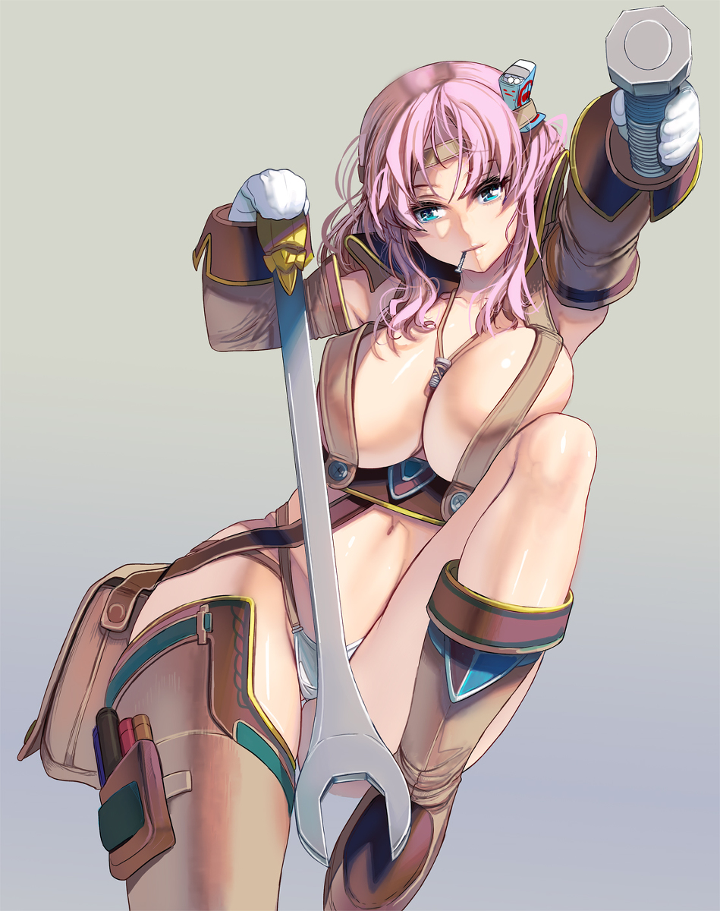
Cheeks burned crimson and her lips pouted, not intentionally because her lips had engorged themselves to ridiculously sensual proportions. On the whole, her face now better resembled one of a woman pushing thirty, though evidently nothing about her curves had begun to sag or the like. Her outfit was a mess, but she didn’t feel enough shame to care. If someone saw her hot ass this exposed, then what did she care?

After a few more squeezes of her bosom, the woman sobered. Horny as she was, the middle of the hall wasn’t where she should be masturbating, and so…

The mechanic, Jessie Jane, finally leaned forward to pick up the giant wrench on the floor, her huge breasts swinging like a pendulum at first, before smacking the peak of her belly as she brought herself upright once more. “How’d my wrench get all the way out here?” Her voice, gruff and carrying something of a country accent, expressed her confusion. Didn’t make much sense to her, but maybe she had just dropped it?

Truth be told, she was working on a pretty big project for the GRC, and she’d finally finished. The world’s first singing robot girl; pretty impressive, right? Not the kind of thing you’d expect a country bumpkin mechanic like her to whip up, but using the tools she’d given her, it had been pretty easy. Speaking of… “MASTER-NYAAAA!?”

Distracted by her wrench, she hadn’t noticed her creation, N3K0, sneaking up on her. The machine glomped her, paws wrapped around her breasts, and the two of them shared a tumble… right into one of the teleportation traps Clarisse had set up. Before either of them realized what was happening, they were alone in the holding cell of the lab – with N3K0 still groping Jessie’s naked breasts since even the scraps of her old outfit she’d been wearing had been obliterated by the alchemic reaction. “How… did you activate?” Was all the mechanic really had to say on the matter, with a sigh.

At least N3K0 was strong enough to pry the bars open.

