KITSUNE SEASON
COMMISSION STORY
BY CHALDEACHANGE
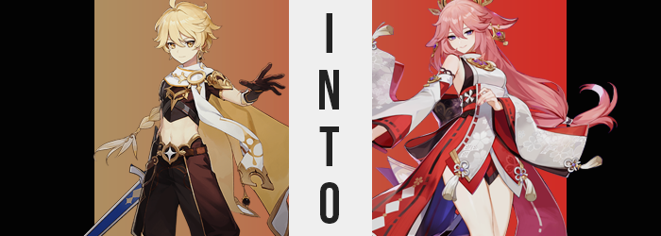

“Hmm. Do we really not have enough hands to deal with the workload? That certainly won’t do.” Yae Miko, or the Guuji Yae as she was known by many, was a very busy woman. Not only was she the overseer of Inazuma’s Grand Narukami Shrine, but she also ran her own publishing company in the Yae Publishing House. It was a busy life, but nonetheless one she still enjoyed despite its hiccups. If she ever got stressed or upset, it hardly ever showed on her features. Rather, challenges were meant to be overcome, were they not?

And she had gotten very creative when it came to overcoming them.

In fact, this was one of those moments where she would have to put her quick thinking skills to work. Things at the shrine were going well enough. When she went away? Simply leaving one of the senior shrine maidens in charge was enough. It wasn’t like there would be any emergencies to speak of unless Ei sent someone knocking with an issue. Which wasn’t all that likely these days, since Inazuma was finally finding some semblance of peace after its more tumultuous era.

Her issues were instead with the publishing house. A number of clients had commissioned pieces outside of their regular releases, and a new intern had foolishly accepted all the work not realizing there were no writers to take the tasks up. Even if Miko took on some of the burden herself, and she was known to, there wouldn’t be enough hands to get the work done by the deadlines.

“If only there were two of me. I could certainly get the job done then.” The fox-eared shrine maiden paused no sooner than she had said this. “Hm…” Her expression revealed all. A thought had clearly crossed her mind. “Actually, the isn’t all that terrible of an idea…” And come to think of it, the perfect circumstances would align tomorrow, would they not?

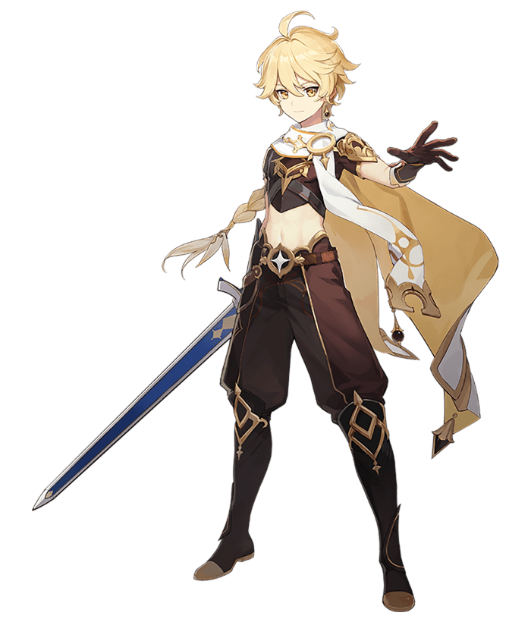
“Miko? What did you want to talk to me about privately? Did something happen with Ei again?” The Traveler, Aether, was a little concerned. He had already made plans to visit Yae Miko at the Grand Narukami Shrine some days in advance since he was back in Inazuma with Paimon for a week or two, but he had expected their meeting to be quick and without incident. That didn’t appear to be the way things were going in the end, though.

No sooner than he had arrived, the shrine maiden had ushered him into the private quarters of the inner shrine after asking Paimon to wait outside. Typically if there was something Aether had to hear, his fairy-like companion should have been there to hear it as well. But Miko had been very insistent to the contrary, which was why he had assumed something was wrong.

Yet pouring herbal tea for the two on the table between them, Yae Miko still acted with an overwhelming calm. “No. Everything has been fine with Ei as of late, and I have you to thank for that.” Aether immediately shook his head. He couldn’t really accept credit for that. Inazuma’s Archon overcame her demons all by herself, he had simply been there to observe these events. “Ah, I see you’re as humble as ever!”

Wait, something wasn’t right here. She was buttering him up for something. Suspicious, he took a sip from his tea. “Although now that you mention it…” There it was. So she did have a favor to ask. “Work at the Yae Publishing House has been a little overwhelming, and we’re in need of a little extra help. Would you mind?” So it was related to work.

“I… Don’t really know anything about writing, I’m not sure how much help I could be.” Aether took another sip from his tea. It was better just to let her down gently. After all, who knew what sort of shenanigans he would get tossed into if he went along with Miko’s machinations?

Miko’s ears twitched as she observed the boy take another sip from the tea she had put out for him. She had yet to touch her own. “A shame, but… Give me a moment, I have something that I believe will help change your mind.” Without warning she disappeared into a door in the back of the room, leaving him to his lonesome. Was there some sort of special reward if he helped? That was the only thing that he could think of. Maybe it was some sort of treasure? If so that would certainly explain why Paimon of all people had been forbidden from seeing it.

Seconds passed though, and so too did minutes without Miko returning. “Huh, I wonder where she went?” All the while he had completely finished up the cup of tea that had been poured for him. It was a shame since his host hadn’t even touched hers. Yet by the end of the cup? His body did feel strangely warm. “Is it getting hot in here? I guess not, we are on top of a mountain after all.” He had been wrong of course, the room wasn’t getting warmer. But that didn’t mean that warmth didn’t have a source.

Realistically though, the source of the feeling should have been the least of the Traveler’s concerns. Because for better or for worse (definitely for worse) the feeling had begun to manifest in the form of some rather perplexing changes to his body. Unless his blonde hair was supposed to have streaks of a cotton candy pink running through it? Which it definitely wasn’t.

Yet Aether continued to sit there, anxiously awaiting Miko’s return so that he could finish their business and reunite with Paimon at the end. His fingers were simply fiddling together on his lap beneath the table, though he raised a brow or but a brief moment. It almost had felt like his fingers were mingling incorrectly for but a moment. But that had to have been impossible, so he dismissed it in the end.

…Even though he had legitimate grounds to investigate. In truth his fingers had mingled with each other oddly. Because those fingers were not as they should have been. Rather? Not only had the bones in his fingers lengthened so that these fingers themselves had a slightly longer reach, but the nails on their tips now extended several inches past his fingertips and had been painted with a pink not unlike the streaks in the boy’s hair.

“She’s taking a really long time, but that is oh so typical of her…” Aether eventually sighed, speaking with a familiarity towards the kitsune that he probably shouldn’t have possessed. Actually, what was with how he was talking at the end there? It sounded far more playful than the usual, casual tone he wielded. But it came when the full breadth of his hair had finally been dyed in that familiar pink. His brows and pubes included.

Still sitting on his knees beneath the table, the boy found himself shuffling awkwardly for a moment. It wasn’t really a matter of being unable to sit still, but instead it had just felt a little awkward? Like he was having difficulties getting comfortable in a position he’d been sitting in fine for some ten minutes now. It wasn’t even like his legs had been falling asleep or anything like that.

The issue that brought about this discomfort however was something a little more unimaginable. That is to say that it was something just as bizarre as his hair color suddenly changing. Nonetheless it was happening. The lengths of not only his legs, but the length of his body as a whole was extending. He was getting taller. It wasn’t substantially so, only adding four or so inches to his overall stature, but it was certainly enough to lift his crop top so more of his belly was exposed while simultaneously pulling his pants up so that his ankles were left bare.

Aether blinked, and unbeknownst to him in doing so his eyes changed in color from gold to a striking purple. As he blinked his lashes appeared much more luscious as well, as did his pink brows seem much thinner. “How strange… Something is wrong with my outfit? No, not just that… My voice as well?” Even as he spoke with a higher pitched tone, the lips through which these words were communicated became fuller and rosier, resting in a slight smirk when not forcing a different expression otherwise.

His eyes narrowed to better resemble those of someone from Inazuma, and his nose shrunk between them to boot. Cheeks, a little rounder by nature, likewise arched more gently into a pointier chin. This was not the face of a teenaged boy, not any longer. But instead? The familiar face of a sly, Inazuman woman that Aether knew all too well. After all, he had just been face to face with her.

And now he had that face!

“I’m no fool. I can see what’s happening here…” The man rose, feeling the tightness of his outfit as he did so. He was certainly taller, around her height. The sound of his own voice made it obvious enough as is, but as strands of pink dangled between his eyes – a sign that his hair was growing fuller – it was oh so quickly becoming undeniable. After all, his hair quickly spilled out slightly to the same length and volume as hers, falling past his rear while bangs were swept out to the sides short of the tuft in the middle. It wasn’t a substantial growth ultimately, but it did force his braid to come undone so that they hair fanned out behind him.

But why wasn’t he fighting it? Why, despite recognizing the changes, did he not shun them or react negatively? It was simple. The nature of the one who was becoming had bled into his own, and they were not someone that would reject a change like this. Rather? They would embrace it. And so there was no resistance whatsoever as two nubs of fluffy pink appeared on the sides of his head, nor as they eventually grew out into a pair of flattened points that curled upwards. Until they were undeniably a pair of fluffy, pink fox ears.

Such was the change that triggered the endgame of the entire process. His waistline had pinched in previously, but now it was time for it all to culminate and make good on the intended form. This meant expanding his hips, and they did so until they stretched an extra four or so inches – which naturally meant that his pants were fitting much more snugly around them.

It certainly wasn’t a feeling that was difficult to miss, but the young man did not protest in even the slightest. “Oh! …Oooh. So the time has come, has it?” In fact he, no… She seemed to beckon the coming change, fingers now pressing against the bulge in her pants as the lump gradually dwindled away, until she could feel those fingertips dipping into a newly born pussy. This changed sex simply left the woman feeling complete and whole. Not to mention powerful.

And so she savored it as the remaining acclimations settled into place. She had a woman’s face and a woman’s genitals, but her figure by large was still more androgynous than anything. So a swell focused upon her thighs was a welcome one by Aether, though perhaps not her pants. The fabric gripped bulging flesh tightly, struggling to keep it in place as those thighs each peaked at the same thickness as her waistline.

Fortunately the pants survived without any noticeable tears, but that didn’t mean that she was exactly out of the woods. Her rear, after all, had a new role to fulfill as well – and it expanded with all of the gravitas that her thighs had. This rump wasted none of the weight that was applied to it as cheeks burgeoned, yanking down her waistline to reveal the peaks of her ass crack above. Before long she reached a hand back to give a cheek a cup and a squeeze, cooing to herself with curiosity while peering over her shoulder.

“Yes, excellent. And now there is only one thing not in order, correct? Or I suppose two things, technically.” The kitsune woman wasn’t wrong, and hands slowly drifted to her chest from both her ass and her crotch to take hold of what was needed. By the time they had reached her once vacant chest, the puffs of something growing could sensitively be felt through her crop top. But it didn’t take long for hard, erect, and substantially larger nipples to be felt poking up against the leather. Aether even gave them a playful, little twerk while the skin beneath stretched around fat deposits that otherwise gave her new D-cup tits their shape. In the end, their size was smothered by the tightness of the top.

A realization that led her to consider stripping, if not for the fact that she had been interrupted.


“Oh, I see you finished up nicely while I was out. So… Do you feel a little more cooperative now?” At the end of the other woman’s transformation, Yae Miko finally returned. However she returned to the sight of her own doppelganger wearing the Traveler’s clothing. This, of course, had been wholly intentional. The tea had been laced with an enchanted herb and a sprinkling of her essence. The goal? To create a copy of herself that could aid her with her workload. Because not only did she bestow Aether with her beautiful image, but her personality, memories, and talents as well.

Deep down she would still retain recollections of her past life, though.

The duplicate Yae Miko blinked a moment, tugging at the undersized clothing that adorned her before a mischievous smile played upon her features. “Oh you. What a mischievous plot, turning me into your copy!” And yet while it was certainly alarming, she certainly didn’t take any issue with it. This was intentional, of course. Miko’s will had become her own, there was no way she would attempt to resist the shackles of the new identity that had been bound to her. “And I see you brought exactly what I needed.”

Her eyes were fixated on the original Yae Miko’s arms, or what she had in them. An outfit that was identical to the one that she was wearing, because there was no way she could go out dressed the way she was. “And after I get changed, how about we pay Ei a visit, hm? I can already picture the look of confusion on her face. Oh, how we could tease her.” Aether had never felt particularly fond of the Raiden Shogun after all she had done, but now Miko’s affections for her burned brighter than anything. “Oh, but what of Paimon? Surely she’ll notice I’m missing, won’t she?”

The original giggled and gave a wave after handing the clothes over. “Oh, don’t you worry about that. We weren’t lacking in help at the shrine, but turning her into a generic shrine maiden certainly gave them some useful, extra hands.” Now she didn’t need to worry about overworking herself at either of her jobs!

