**Organic Chemistry Exam 1**

**Worksheet**

Organic Chemistry Tutor

1. Glutathione (GSH) is a tripeptide molecule composed of three amino acids – Glutamic Acid, Cysteine, and Glycine. It functions as an antioxidant capable of neutralizing free radicals and plays a role in detoxification. Which of the following functional groups is not found in Glutathione?

A. Carboxylic Acid

B. Ketone

C. Amine

D. Thiol

E. Amide

2. Identify the functional groups found in each molecule shown below:

3. Draw a Lewis structure for each molecule shown below:

I. CH3CN

II. C2H2

III. C6H5-CH2-N2+

IV. CH3COCH3

V. CH3CO3H

VI. CH3CO2CH3

VII. CH3(CH2)3CHO

VIII. (CH3)2CHCONH2

4. Which of the following Lewis structures contain a colored atom with a formal charge of 2+?

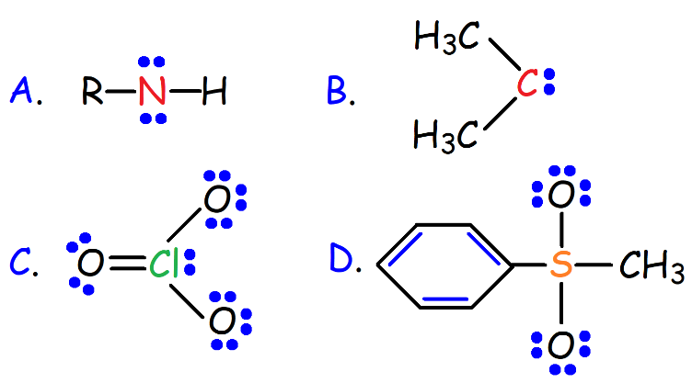

5. What is the condensed formula for the skeletal structure shown below?

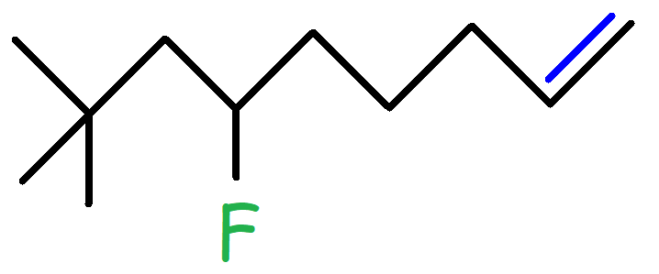

A. (CH3)3CCH2CHF(CH2)3CHCH2

B. (CH3)3CCH2CHF(CH2)3CH2CH3

C. (CH3)3CCHCHF(CH2)3CH2CH3

D. (CH3)2CHCH2CHF(CH2)3CHCH2

E. (CH3)2CHCH2CF(CH2)3CHCH3

6. Consider the chemical structure of Biotin – Vitamin B7. How many hydrogen atoms are in this molecule?

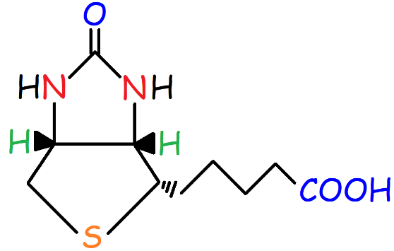

A. 14

B. 15

C. 16

D. 17

E. 18

7. Consider the structure of iso-octane, a compound found in gasoline. How many primary hydrogen atoms are found in this molecule?

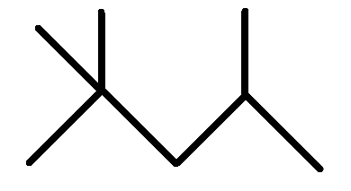

A. 0

B. 1

C. 2

D. 9

E. 15

8. Identify each functional group and determine if it’s primary, secondary, or tertiary.

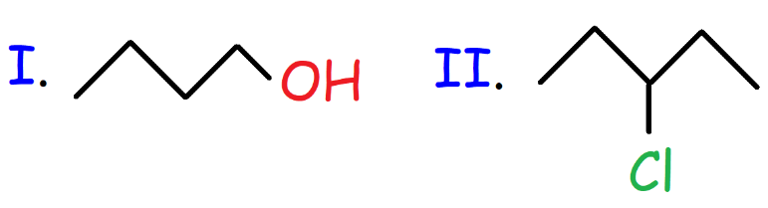

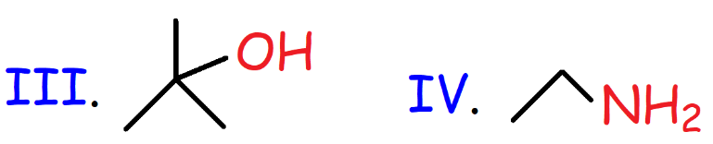

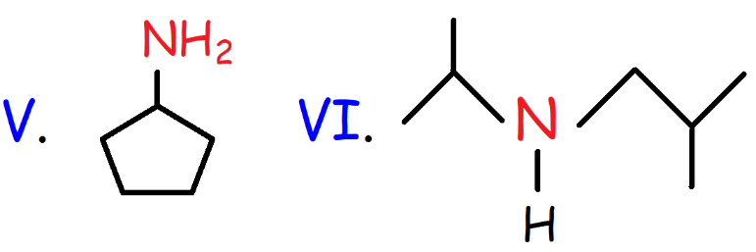

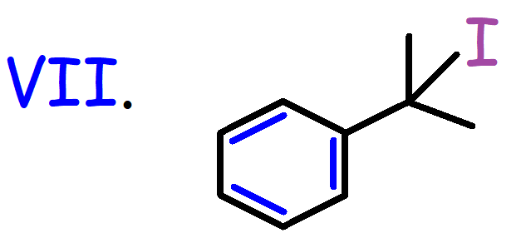

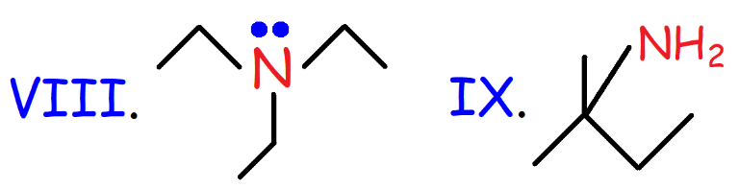

9. Which of the following bonds is most polar?

A. C-C

B. C-H

C. H-F

D. N-H

E. C-O

10. Which molecule has the largest dipole moment?

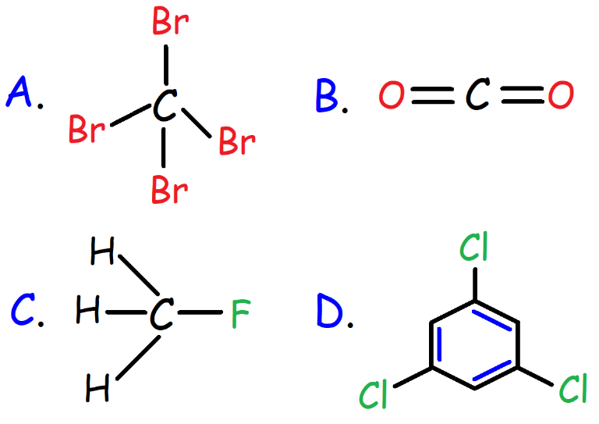

11. Falcarinol is a natural antifungal agent found in carrots that has been studied for its potential anticancer activity. How many sigma and pi bonds are present in falcarinol?

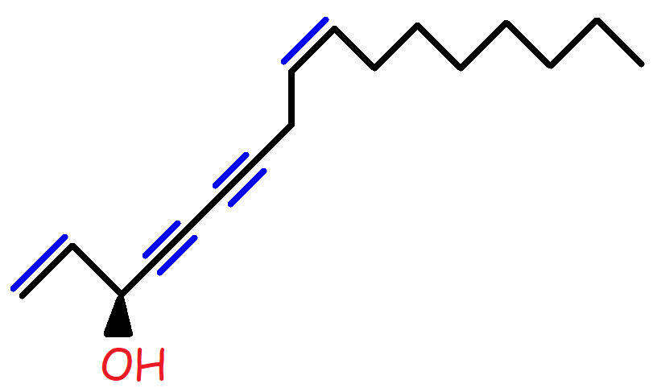

12. Melatonin is a hormone produced by the body from the amino acid Tryptophan. Melatonin is associated with the circadian rhythms regulating the sleep-wake cycle. The chemical structure of Melatonin is shown below. What is the molecular formula of Melatonin?

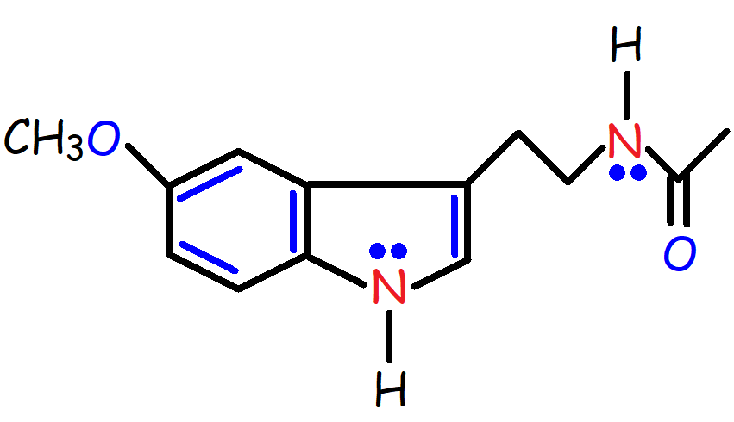

13. The chemical structure of Niacin, a form of Vitamin B3, is shown below. In what type of orbital does the Nitrogen lone pair reside?

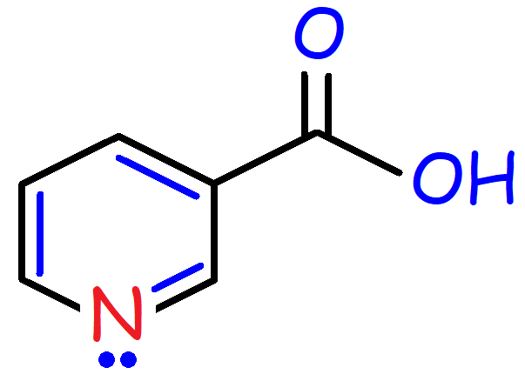

A. s

B. p

C. sp

D. sp2

E. sp3

14. Identify the hybridization of the indicated atoms shown below from left to right.

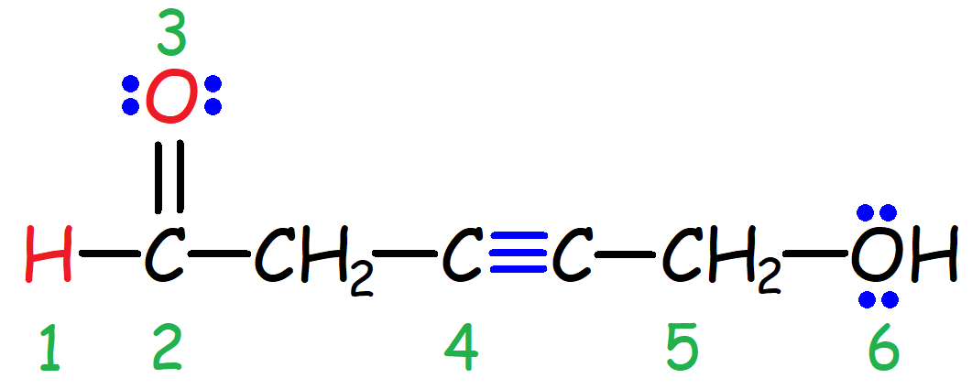

15. The core chemical structure of Penicillin, a natural B-lactam antibiotic, is shown below. What type of orbital overlap is present in the indicated bond?

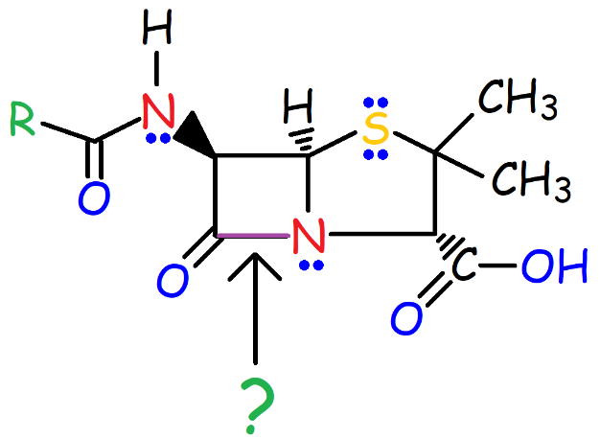

A. sp2 – sp2

B. sp3 – sp

C. sp2 – sp3

D. sp2 – sp

E. sp3 – sp3

16. Rank the following Carbon-Carbon bonds in order of increasing bond strength.

I. H3C-CH3 II. H2C=CH2 III. HCCH

17. Rank the following Carbon-Carbon bonds in order of increasing bond length.

I. H3C-CH3 II. H2C=CH2 III. HCCH

18. The C-C bond energy in Ethane is 377 kJ/mol and the C-C bond energy in Ethylene is 720 kJ/mol. Given this information, would you expect the π bond in Ethylene to be weaker or stronger than the σ bond in Ethane?

19. Rank the following Hydrogen Halides in order of increasing bond strength and in order of increasing bond length.

I. H-F II. H-Cl III. H-Br IV. H-I

20. Rank the indicated bonds in order of decreasing bond length.

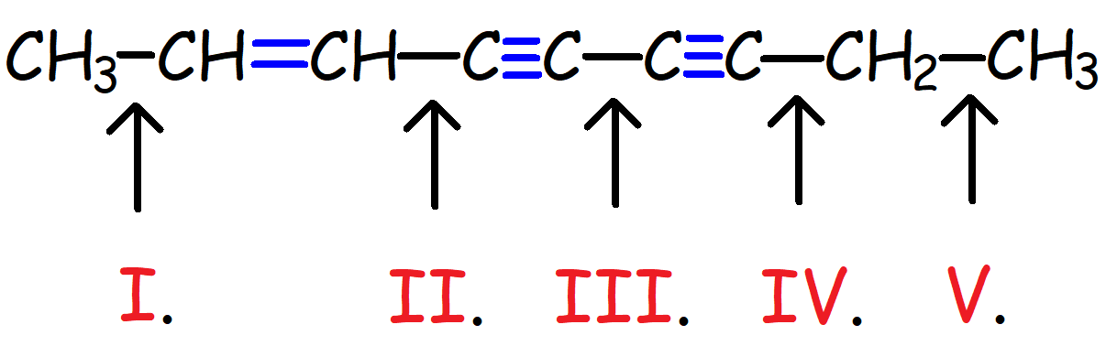

21. Rank the indicated bonds in order of increasing bond strength:

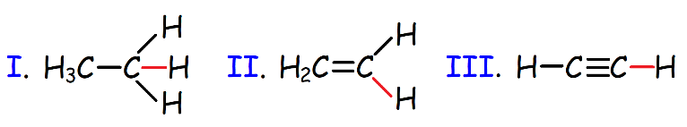

22. What is the molecular geometry and approximate bond angle for the indicated atoms shown below?

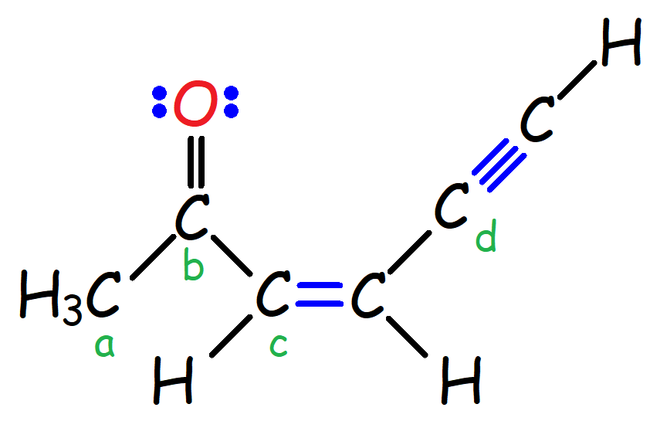

23. Consider the chemical structure of ethyl methyl ether. (a) What is the molecular geometry of the Oxygen atom? (b) What is the electron-pair geometry of the Oxygen atom?

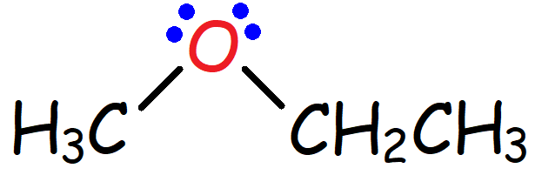

24. Which of the following pairs of structures represent resonance structures?

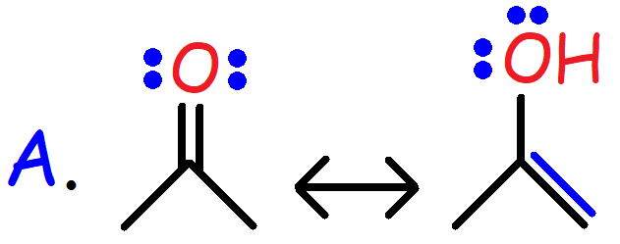

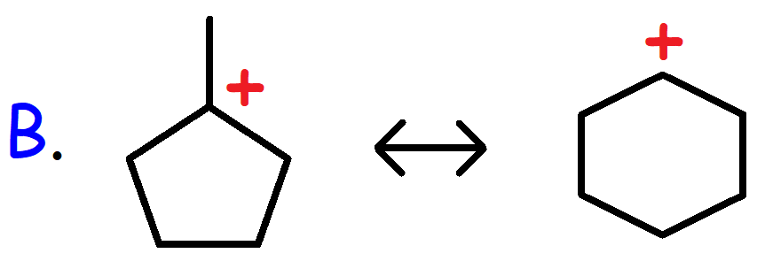

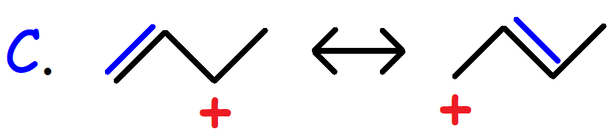

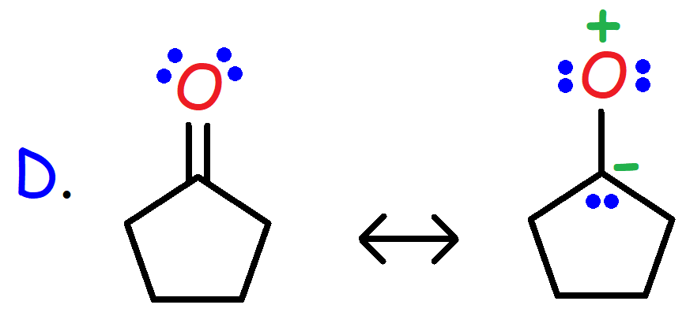

25. Consider the resonance structures shown below. Which structure is the major resonance contributor?

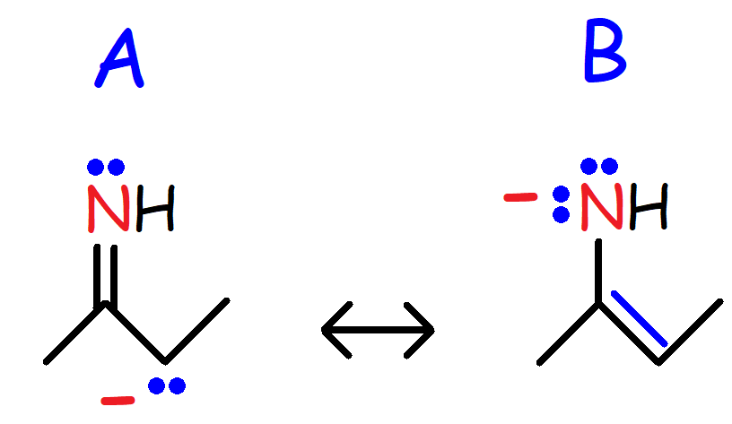

26. How many resonance structures can be drawn for the Cyanate ion (-OCN)?

27. Consider the structure shown below. (a) Draw all possible resonance structures. (b) Identify the major resonance contributor. (c) Draw the resonance hybrid.

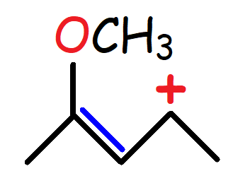

28. Consider the structure shown below. (a) Draw all possible resonance structures. (b) Identify the major resonance contributor. (c) Draw the resonance hybrid.

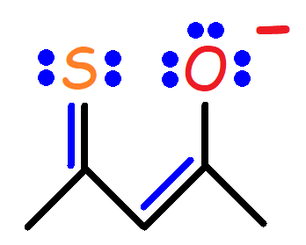

29. Which of the following statements is false?

A. Lewis acids are electron-pair acceptors.

B. A Bronsted-Lowry acid is a proton donor.

C. A strong acid will generate a very weak base in an acid-base reaction.

D. Strong acids have a large Ka value.

E. Strong acids have a high pKa value.

30. Which of the following is not an acid?

A. BH3

B. HF

C. AlCl3

D. CF3OCF3

E. (CH3)3C+

31. Which of the following is the strongest acid?

A. CH4

B. NH3

C. HBr

D. H2O

E. HI

32. Which proton will a non-bulky strong base abstract preferentially?

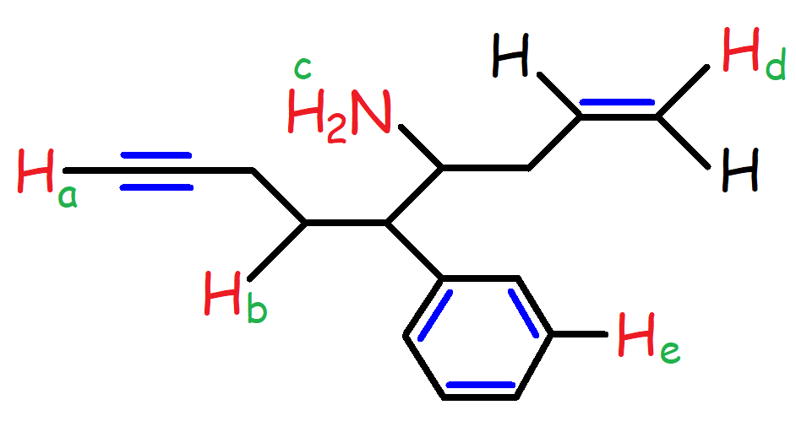

33. Rank the following acids in order of increasing acid strength:

I. CH2FCOOH

II. CH3COOH

III. CH2BrCOOH

IV. CH3CHBrCH2CH2COOH

V. CF3COOH

VI. CH3CH2CHBrCH2COOH

34. Which of the following acids have the lowest pKa value?

I. CH3CH2OH

II. CH3COOH

III. H2N-CH2-CH2-SO3H

35. Which of the following molecules have the highest pKa?

A. CH3OH

B. H2O

C. EtOH

D. Cyclohexanol

E. (CH3)3C-OH

36. Which proton is more acidic? The green or red proton?

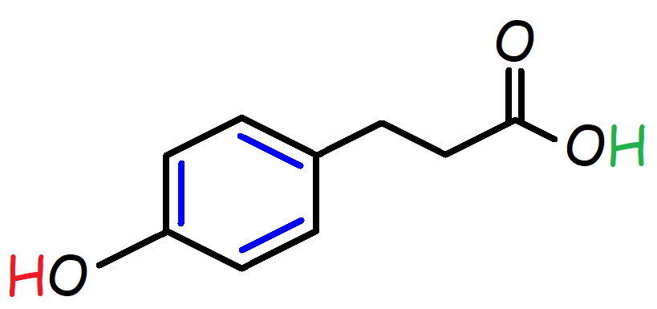

37. Rank the following acids in order of increasing acidity.

I. CH3OH II. CH3OH2+ III. CH3NH2 IV. CH3NH3+

38. Consider the chemical structure of N-acetyl Cysteine (NAC) shown below. Rank the following in order of decreasing pKa values.

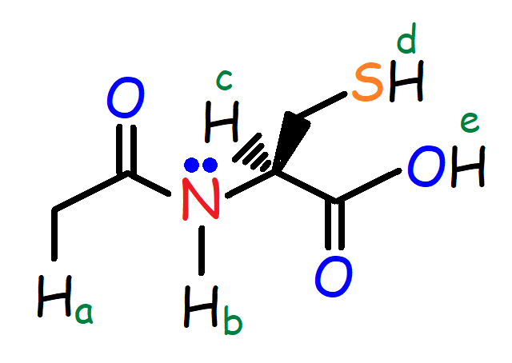

39. Which of the following represents the strongest base?

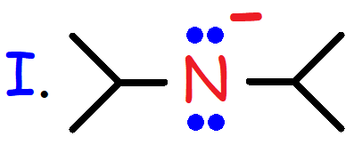

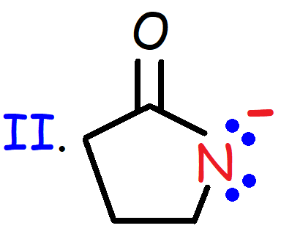

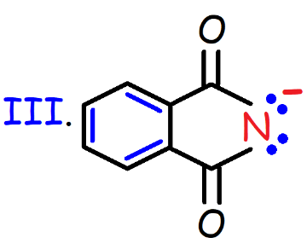

40. Which of the following effects explain why compound B is more acidic than compound A?

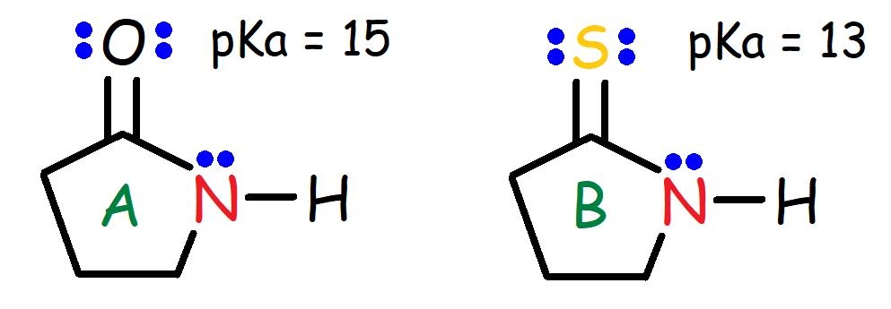

A. Inductive Effect

B. Hybridization

C. Electronegativity

D. Electron Delocalization

E. Atomic Size

41. Circle the strongest acid. Determine the effect associated with each example. (Inductive effect, Hybridization, Electronegativity, Electron Delocalization, or Atomic Size?)

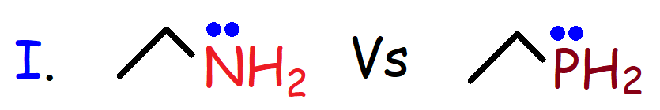

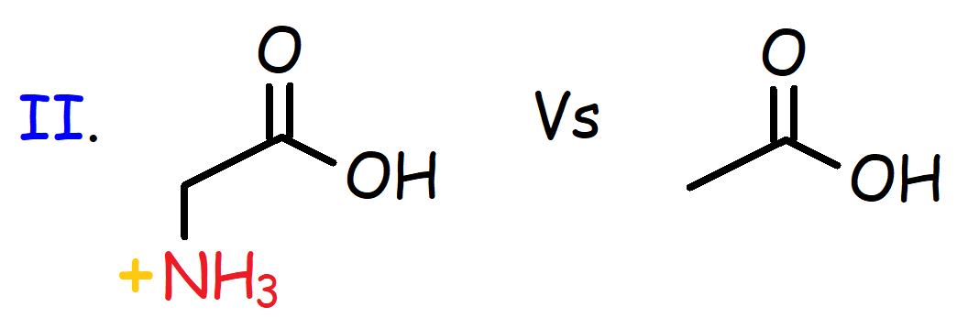

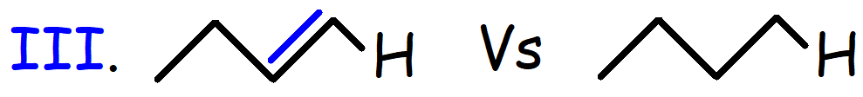

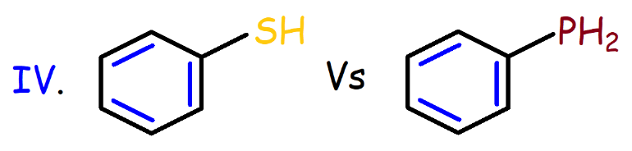

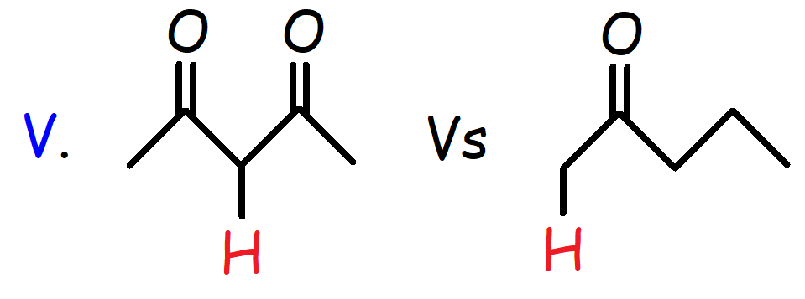

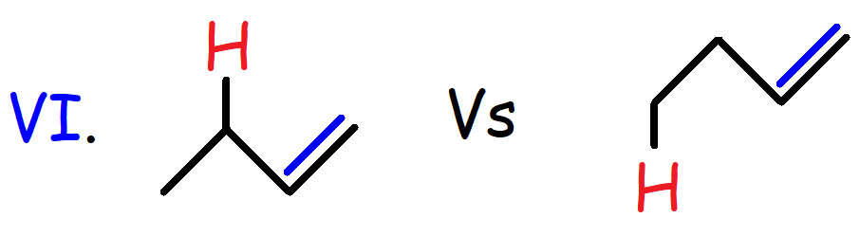

42. Consider the reaction shown below. (a) Predict the products of the reaction. (b) Draw the curved arrows to show the flow of electrons. (c) Identify the Bronsted-Lowry acid and base as well as the conjugate acid and base. (d) Predict the position of equilibrium – is the reaction reactant favored or product favored?

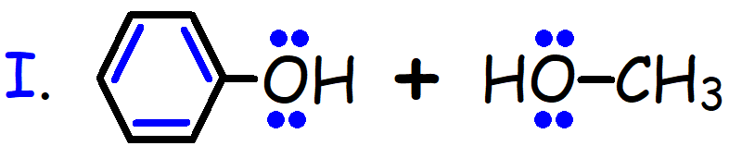

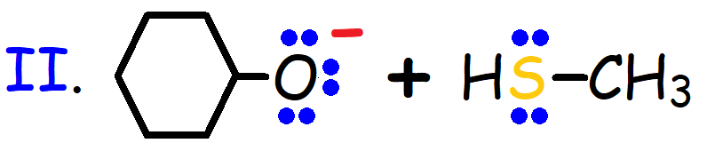

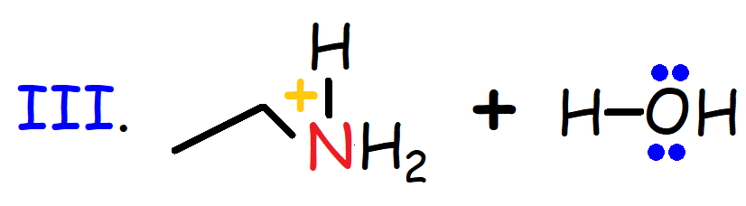

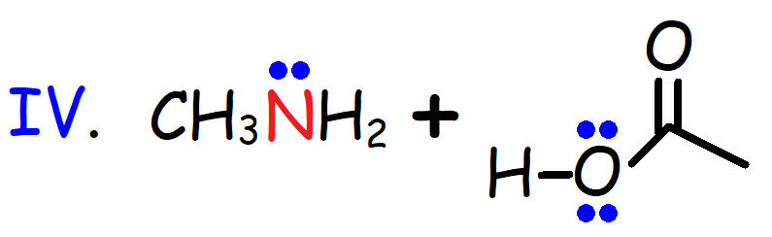

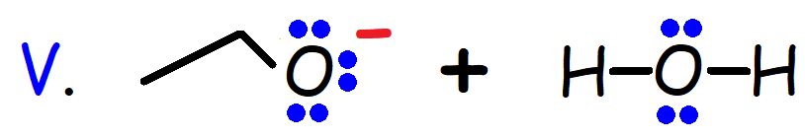

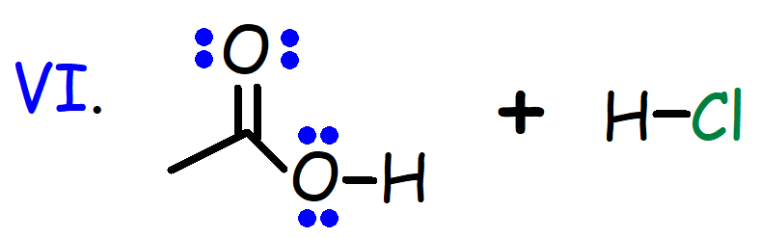

43. The chemical structure of the amino acid Glycine is shown below. The pKa values are 2.3 and 9.6. What is the predominant form of Glycine at a pH of 7?

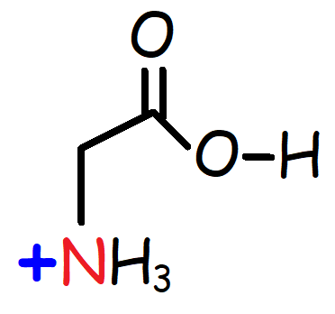

44. Which of the following carbocations is most stable?

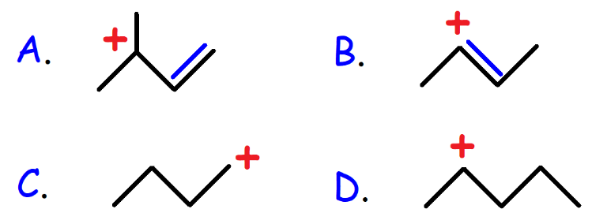

45. Which of the following structures represent a saturated compound?

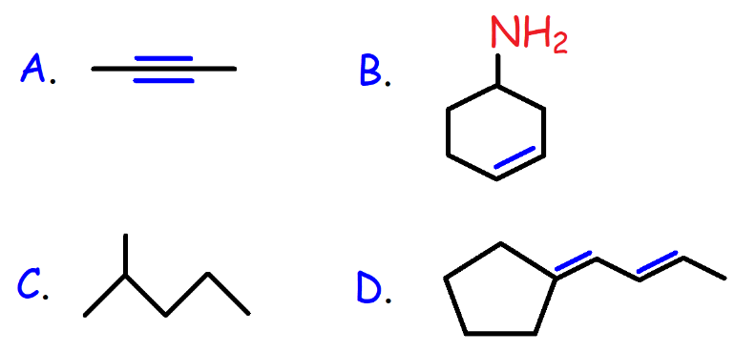

46. Which of the following protons is most acidic?

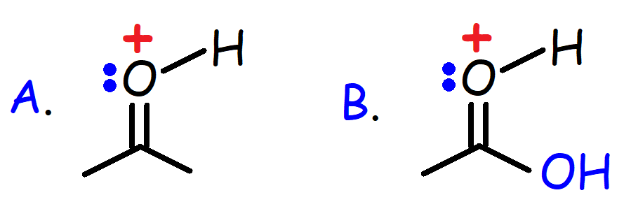

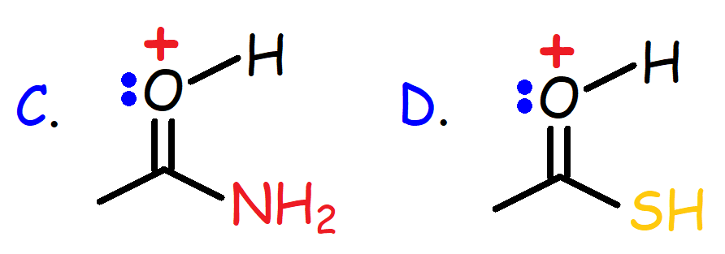

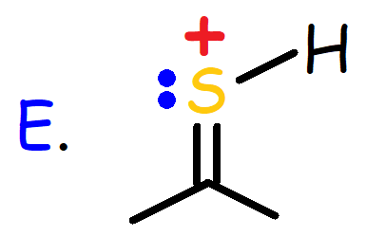

47. Menatetrenone (MK-4) is a form of vitamin K-2 usually found in fermented foods. What is the index of hydrogen deficiency (IHD) of Menatetrenone?

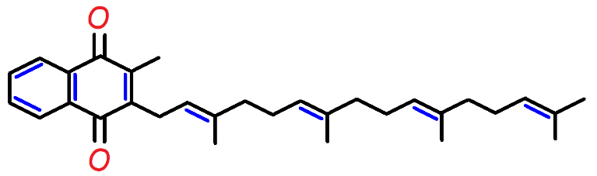

48. Calculate the Index of Hydrogen Deficiency (IHD) for each of the following molecular formulas: (a) C5H10 (b) C4H8O (c) C6H11Br (d) C7H9N

49. How many hydrogen atoms are present in (a) a saturated hydrocarbon with 15 Carbon atoms?

(b) an unsaturated 18-Carbon hydrocarbon with an IHD value of 4?

50. Draw an uncharged Lewis structure for each molecular formula: (a) C5H12 (b) C3H6O (c) C6H10N

(d) C4H7Br.

51. Which of the following molecules have the highest boiling point?

A. CH3CH2CH2CH2CH2CH3

B. CH3(CH2)6CH3

C. (CH3)4C

D. (CH3)2CHCH2CH3

E. CH3CH2CH2CH2CH3

52. Which of the following molecules will have the lowest boiling point?

A. CH3CH2CH2CH3

B. CH3CH2OCH2CH3

C. (CH3)2CHOCH3

D. CH3CH2CH2CH2OH

53. Rank the following compounds in order of increasing boiling point.

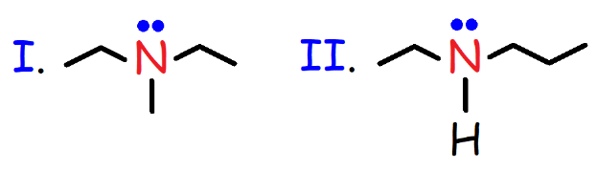

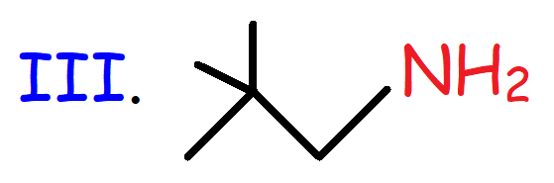

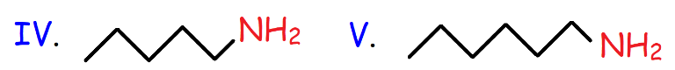

54. Which of the following compounds have the highest boiling point?

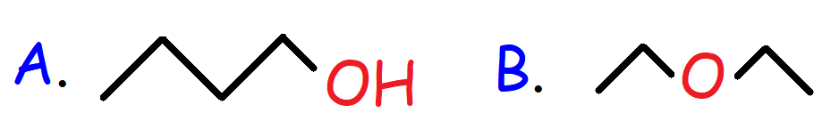

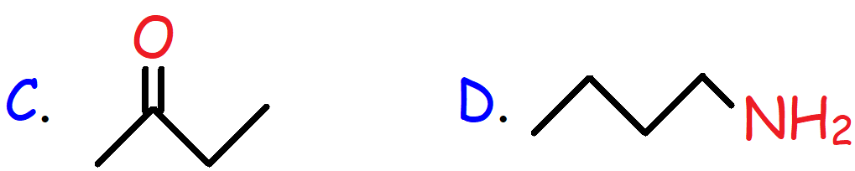

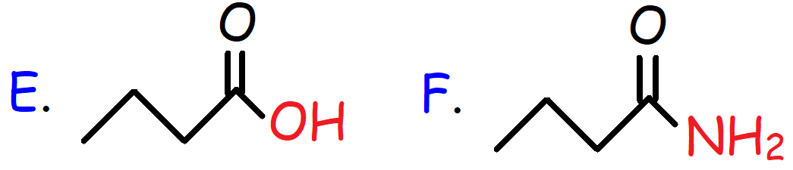

55. Which of the following compounds have the lowest boiling point?

A. CH3CH2CH2CH2-**OH**

B. CH3CH2CH2CH2-**I**

C. (CH3)3C-**Cl**

D. CH3CH2CH2CH2-**Cl**

E. CH3CH2CH2CH2-**SH**

56. Consider the melting points of various alkanes shown below. As the number of carbon atoms increase from an odd number to an even number, why is there such a large increase in the melting point values?

|  |  |
| --- | --- |
| **Alkanes:** | **Melting Point:** |
| Methane | -182o C |
| Ethane | -183o C |
| Propane | -188o C |
| Butane | -138o C |
| Pentane | -130o C |
| Hexane | -95o C |
| Heptane | -91o C |
| Octane | -57o C |
| Nonane | -51o C |
| Decane | -30o C |

57. Which of the following compounds have the highest solubility in water?

A. 1-Hexanol

B. 1-Butanol

C. Heptane

D. Di-isopropyl Ether

58. Consider the chemical structures shown below. Identify each vitamin as either water-soluble or fat-soluble.

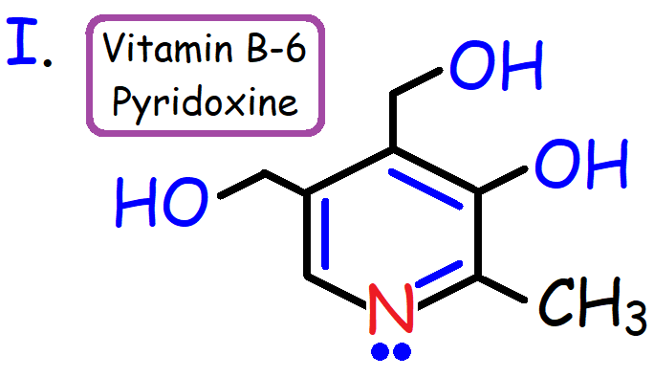

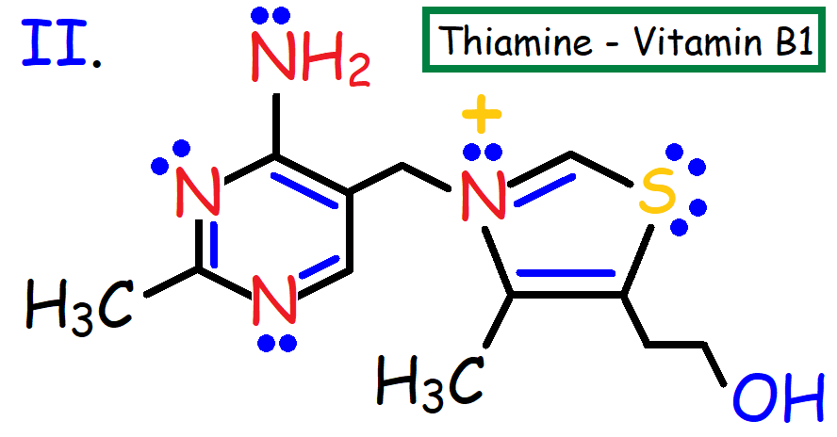

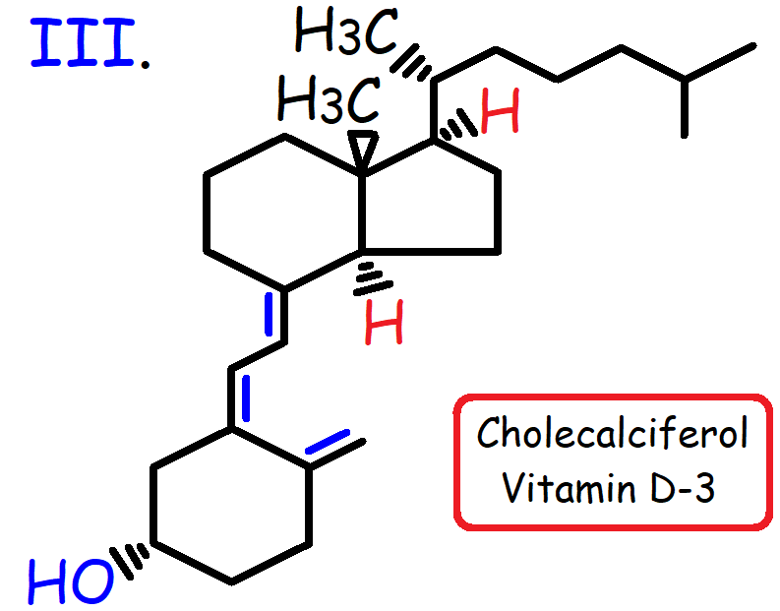

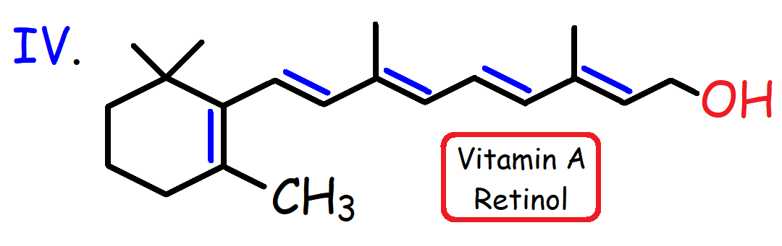

59. Draw a skeletal structure for each of the following molecules:

(a) 4-bromo-1-chlorohexane

(b) 3-ethyl-2,4-dimethyloctane

(c) 1-ethyl-3-methylcyclopentane

(d) 2,2,3-trimethyl-4-phenylheptane

60. Provide the IUPAC nomenclature for each compound shown below.

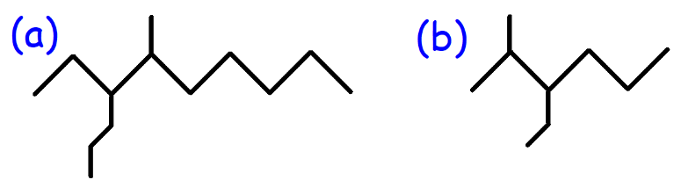

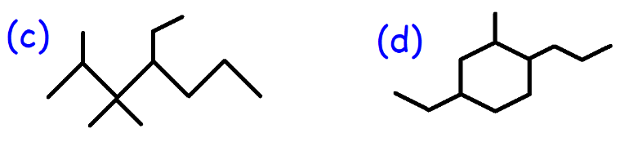

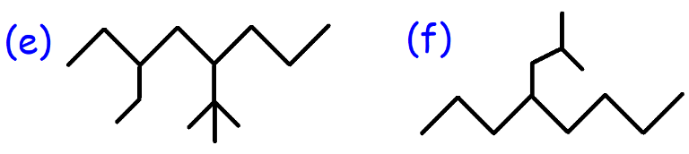

61. Give the IUPAC nomenclature for each molecule shown below.

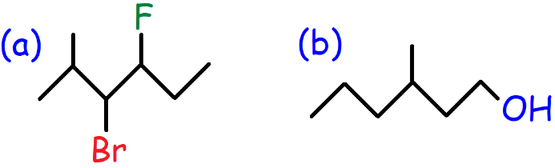

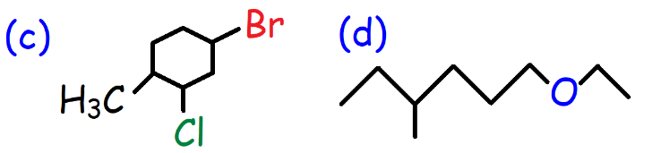

62. Provide the IUPAC nomenclature for each bicyclic compound shown below.

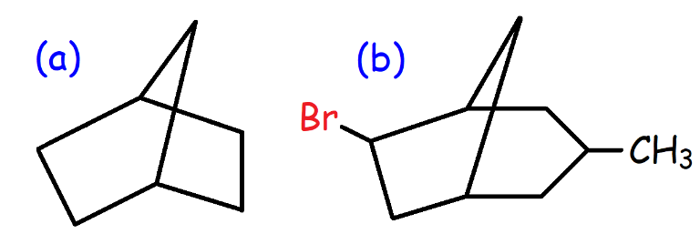

63. Which of the following alkyl halides have the greatest solubility in water?

A. CH3CH2-**Br**

B. CH3CH2-**Cl**

C. CH3CH2CH2CH2-**I**

D. CH3CH2-**F**

E. CH3CH2CH2CH2-**Br**

64. What type of orbital overlap is present in the C-H bond of the methyl cation (+CH3)? Draw the orbital picture of the methyl cation.

65. Draw the orbital picture of Acetylene (C2H2).

66. Which of the following alkanes have the highest density?

A. CH3CH2CH2CH2CH3 – Pentane

B. CH3CH2CH2CH2CH2CH3 – Hexane

C. CH3(CH2)6CH3 – Octane

D. CH3(CH2)8CH3 - Decane

67. The heat of combustion for Octane, 2,5-dimethylhexane, and 2,2,3,3,-tetramethylbutane are -5470 kJ/mol, -5460 kJ/mol, and -5452 kJ/mol respectively. Based on this data, which of the three alkanes listed above would you expect to be most stable?

68. Which of the following statements is false?

A. Longer straight-chained alkanes have a higher melting point than shorter straight-chained alkanes.

B. The density of an alkane increases with increasing molecular weight.

C. Branched alkanes are more stable than straight-chained alkanes.

D. Branched alkanes have a lower boiling point than straight-chained alkanes.

E. Alkanes are nonpolar molecules that have London dispersion forces which makes them water-soluble.

69. (a) Draw the Newman projections for butane along the C2-C3 bond. (b) Identify the most stable conformation. (c) Draw a potential energy diagram with respect to the degree of rotation about the C2-C3 bond.

70. Calculate the energy barrier to rotation for the process shown below:

|  |  |
| --- | --- |
| **Group Interaction** | **Potential Energy** |
| CH3–CH3 Gauche | 3.8 kJ/mol |
| H-H Eclipse | 4 kJ/mol |
| H-CH3 Eclipse | 6 kJ/mol |
| CH3-CH3 Eclipse | 11 kJ/mol |

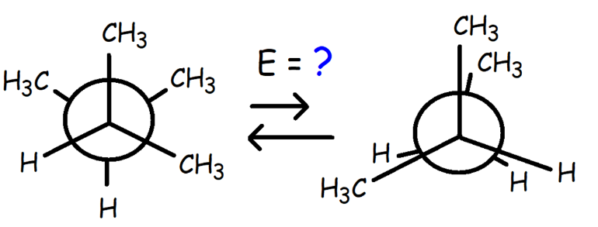

71. Draw the least stable conformation of

2-methylbutane along the C2-C3 bond. Determine the relative potential energy of this conformation.

|  |  |
| --- | --- |
| **Group Interaction** | **Potential Energy** |
| CH3–CH3 Gauche | 3.8 kJ/mol |
| H-H Eclipse | 4 kJ/mol |
| H-CH3 Eclipse | 6 kJ/mol |
| CH3-CH3 Eclipse | 11 kJ/mol |

72. Convert each perspective formula into a Newman projection.

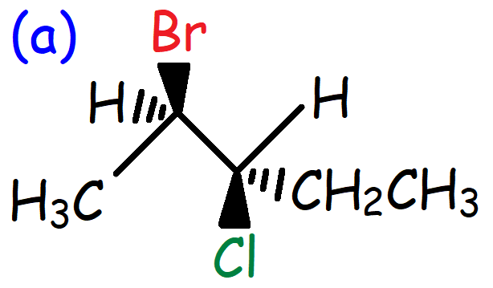

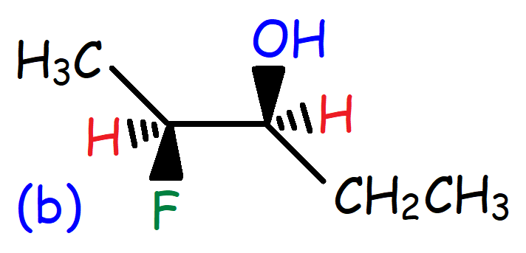

73. Which of the following highlighted bonds have the highest energy barrier to rotation?

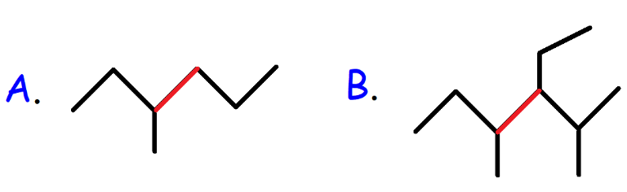

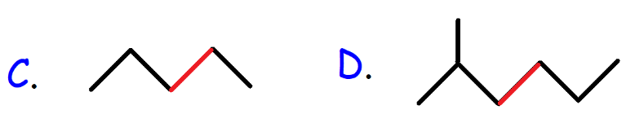

74. What is the IUPAC nomenclature of the Newman projection shown below?

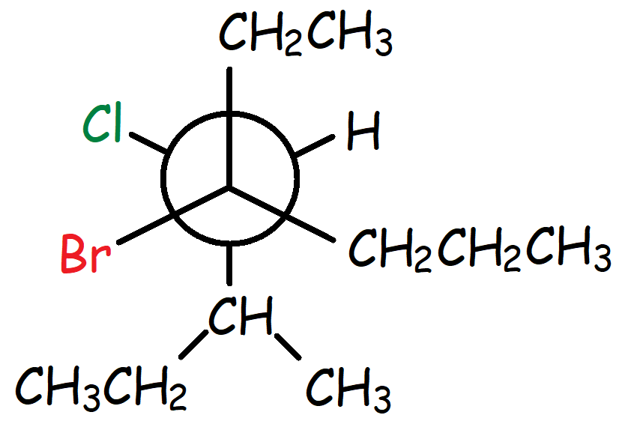

75. Which of the following conformations contain steric strain only?

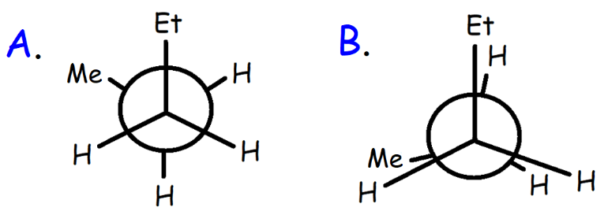

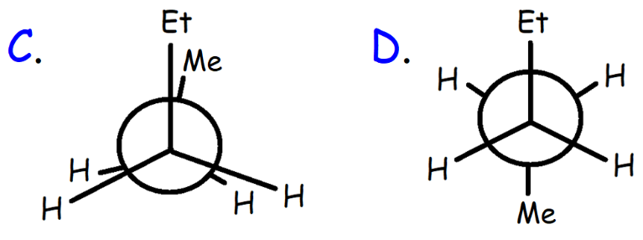

76. Which of the following cycloalkanes have the least amount of angle strain?

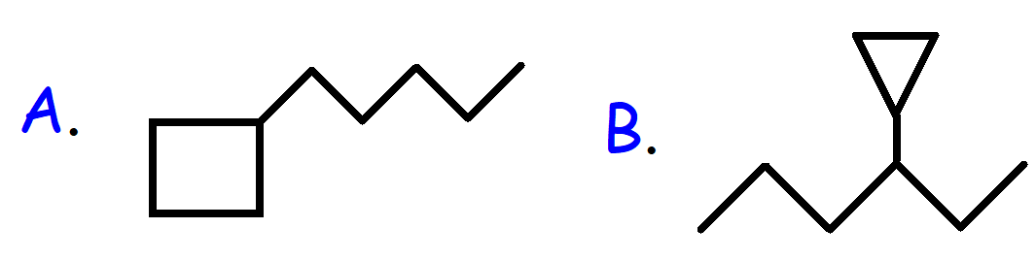

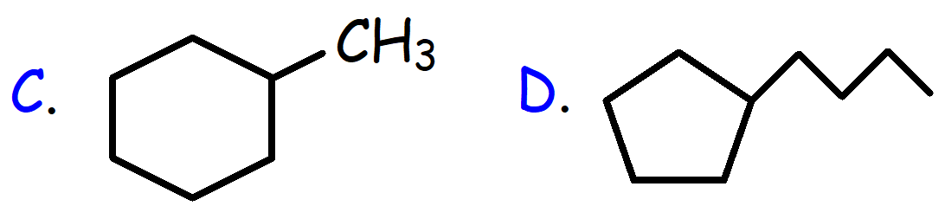

77. The heat of combustion per CH2 group for Cyclopentane and Cycloheptane are -658 kJ/mol and -657 kJ/mol respectively. Which cycloalkane has less angle strain? Cyclopentane or Cycloheptane?

78. Which of the following chair conformations of 1-ethyl-4-methylcyclohexane is most stable?

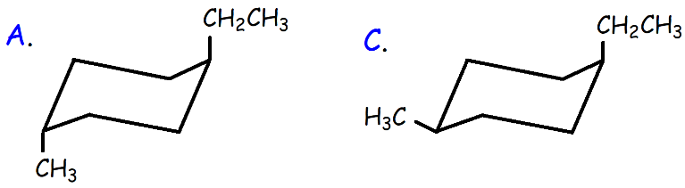

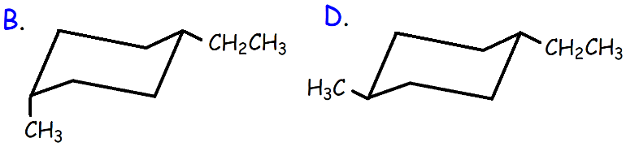

79. Draw the most stable chair conformation of trans-1-methyl-3-isopropylcyclohexane.

80. Describe the relationship of each pair of compounds as constitutional isomers, conformers, cis-trans isomers, identical compounds, or completely different compounds.

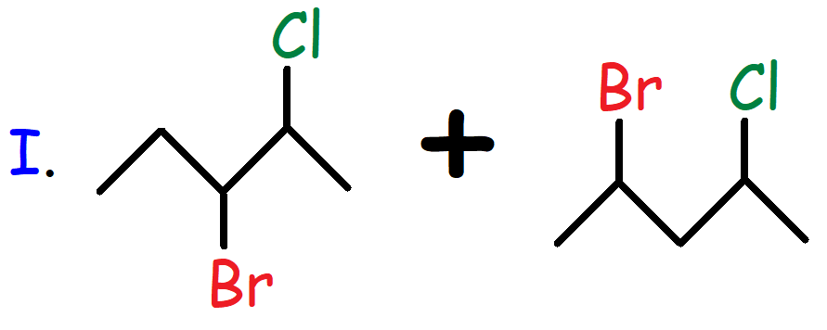

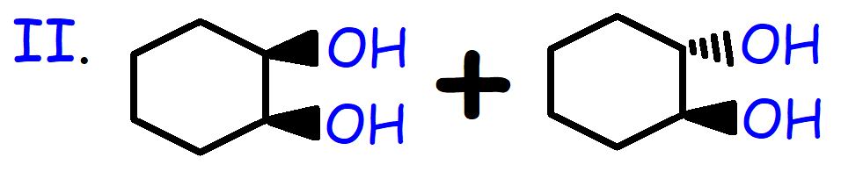

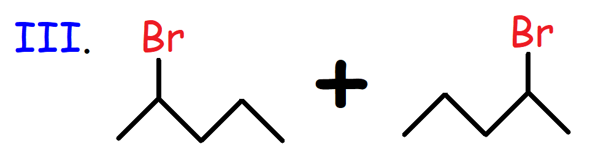

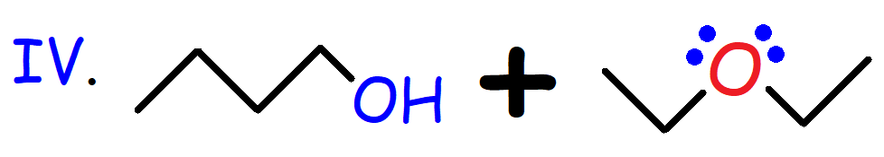

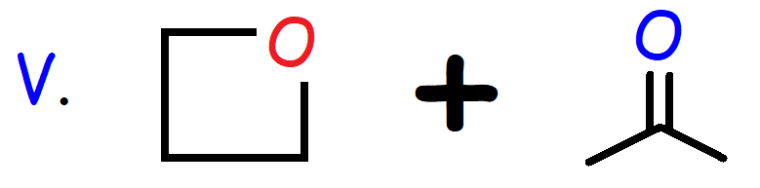

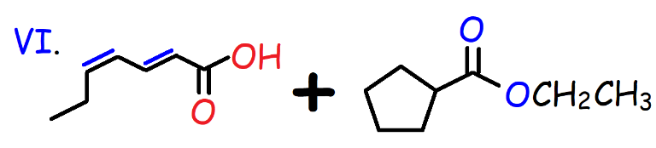

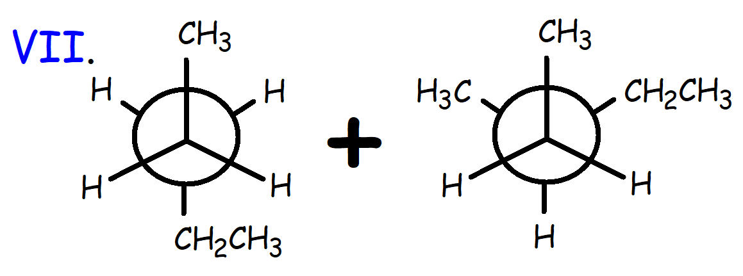

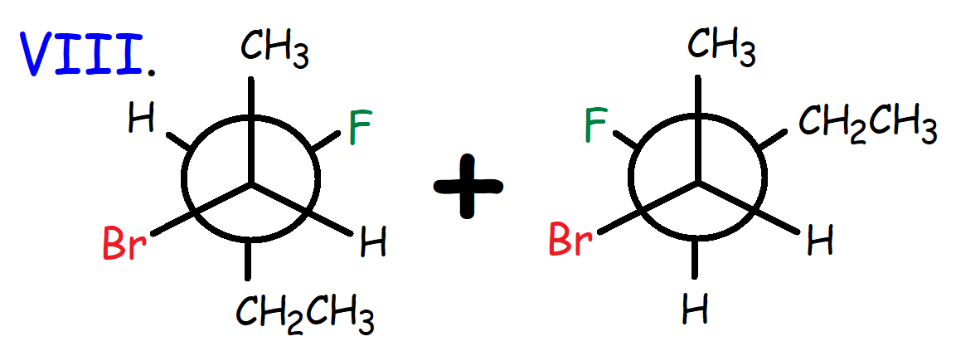

81. Which of the following statements is false?

A. Constitutional Isomers have the same chemical formula, but the atoms are connected differently.

B. Stereoisomers have the same chemical formula with the same connectivity, but the atoms are arranged in space differently.

C. Cis-Trans geometric isomers are diastereomers – a type of stereoisomer.

D. Constitutional isomers have the same physical properties but differ in chemical properties.

E. Conformational Isomers have the same chemical formula, same connectivity but differ in atomic spatial arrangement by rotation and have different chemical potential energies.

82. Which of the following conformations of Cyclohexane is the least stable?

A. Chair Conformation

B. Boat Conformation

C. Twist-Boat Conformation

D. Half-Chair Conformation

83. What is the IUPAC nomenclature for the compound shown below?

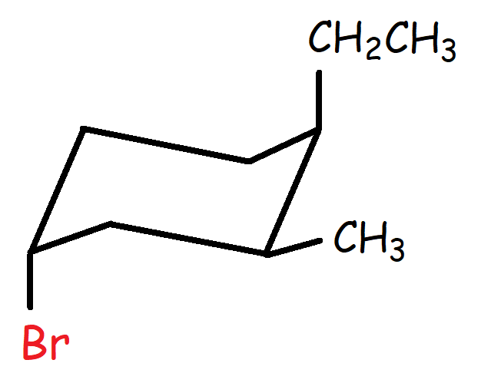

84. The chemical structure of Inositol, formerly known as Vitamin B8, is shown below. Draw a chair conformation of this molecule.

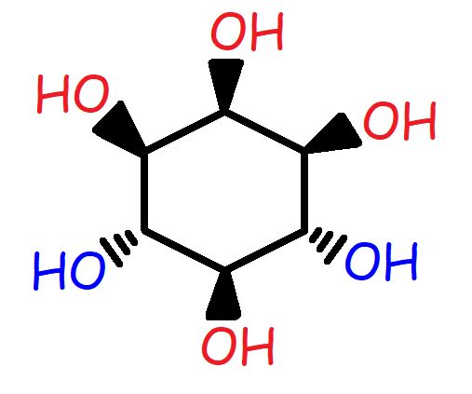

85. Perform a ring flip on the chair conformation shown below.

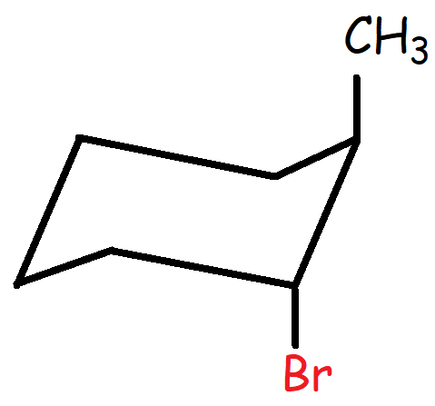

86. Convert the chair conformation into a bond line structure.

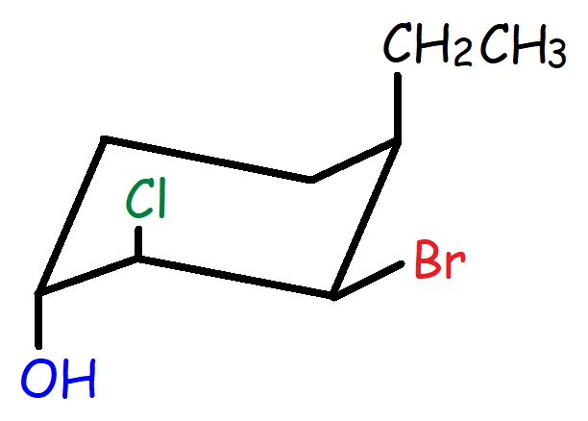

87. Decalin is a 10-carbon organic molecule containing two cyclohexane rings that are fused. The fused rings share two adjacent carbon atoms. Draw the chair conformation of cis and trans Decalin. Which isomer is more stable? Cis or Trans Decalin?

88. Convert the chair conformation into a Newman projection viewing it through the indicated bonds shown below.

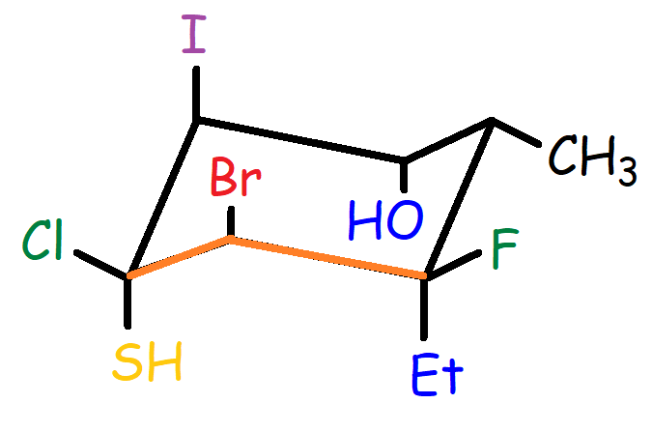

89. Rank the following compounds in order of increasing water solubility.

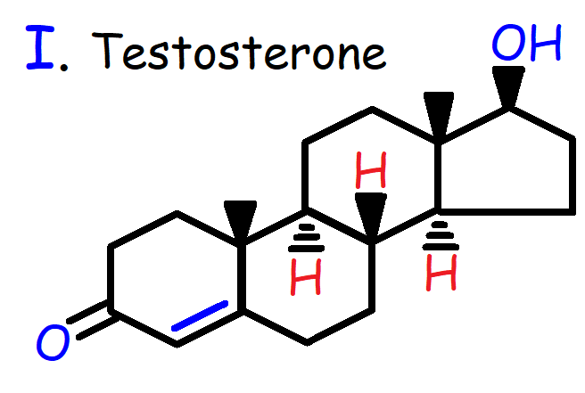

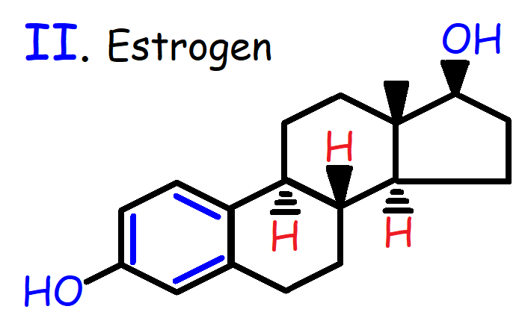

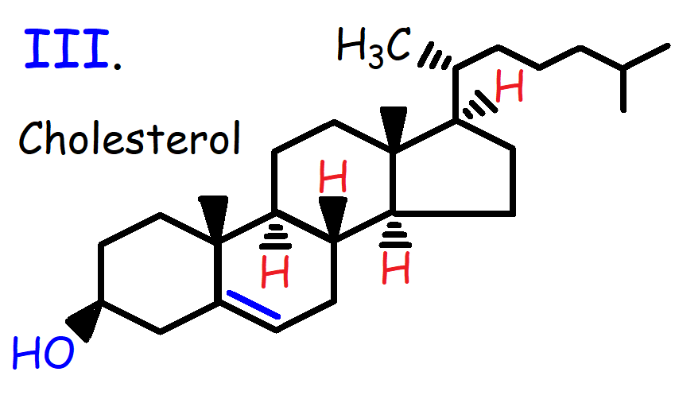

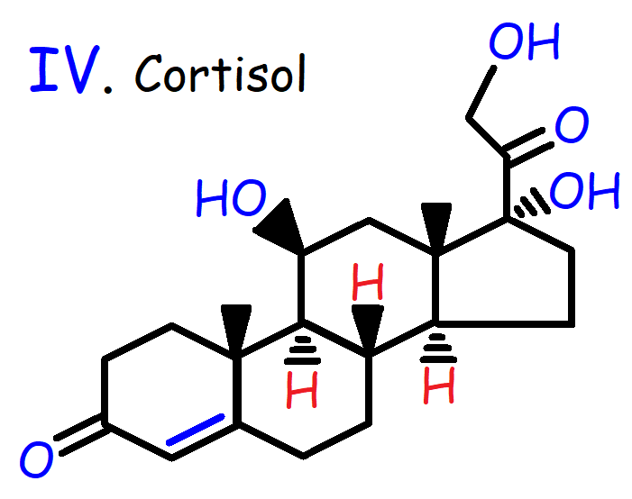

90. Carnosine is a dipeptide composed of the amino acids B-Alanine and Histidine. Carnosine is an antioxidant found in foods that is known to resist the effects of glycation. Rank the highlighted protons in Carnosine in order of increasing acidity.

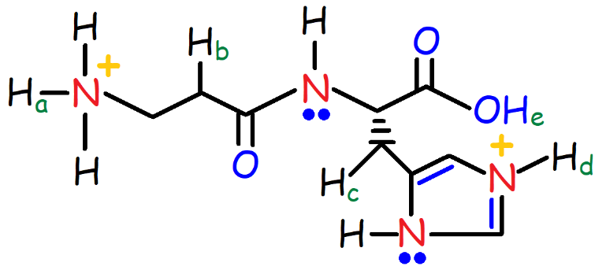

**Answers:**

1. B

2. I. Alcohol, Aromatic Ring, and Amide

II. Carboxylic Acid, Aromatic Ring, and Ester

III. Ketone and Aldehyde

IV. Ether, Nitrile, Alkene, and Internal Alkyne

3.

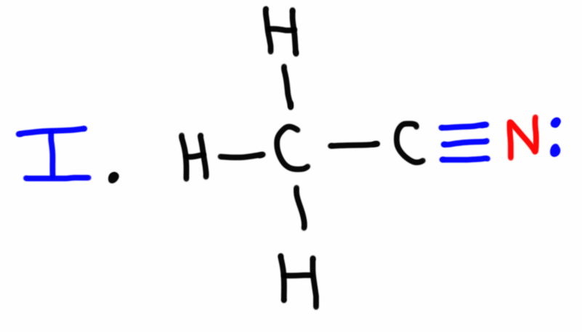

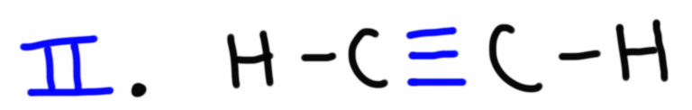

4. D

5. A

6. C

7. E

8. I. Primary Alcohol II. Secondary Alkyl Halide III. Tertiary Alcohol IV. Primary Amine

V. Primary Amine VI. Secondary Amine VII. Tertiary Benzylic Halide VIII. Tertiary Amine

IX. Primary Amine

9. C

10. C

11. 41 σ and 6 π bonds

12. C13H16N2O2

13. D

14. 1 = s, 2 = sp2, 3 = sp2, 4 = sp, 5 = sp3, and 6 = sp3.

15. C

16. I < II < III

17. III < II < I

18. 720 – 377 = 343 kJ/mol of π bond energy which is less than the σ bond energy of 377 kJ/mol. Therefore, the π bond is expected to be weaker than the σ bond.

19. Bond Strength: IV < III < II < I

Bond Length: I < II < III < IV

20. V > I > IV > II > III

21. I < II < III

22a. Tetrahedral, 109.50, sp3 hybridization.

22b. Trigonal Planar, 120o, sp2 hybridization.

22c. Trigonal Planar, 1200, sp2 hybridization.

22d. Linear, 1800, sp hybridization.

23a. Bent

23b. Tetrahedral

24. C

25. Structure B

26. 3

27a.

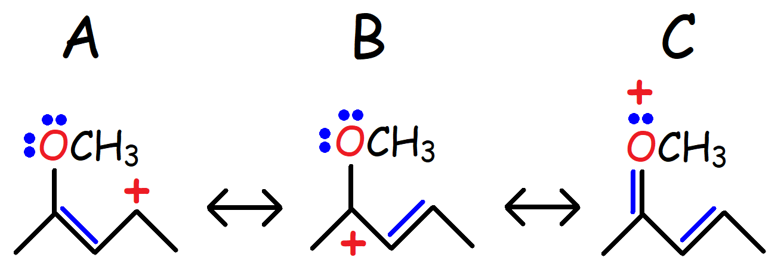

27b. Structure C is the major resonance contributor – it is the most stable structure due to the fact that all empty orbitals are filled with electrons.

27c.

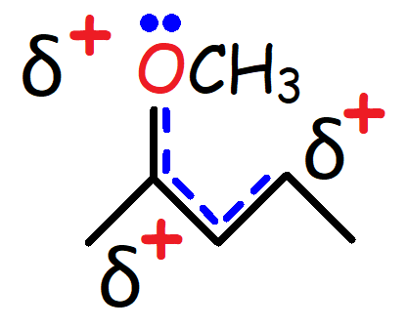

28a.

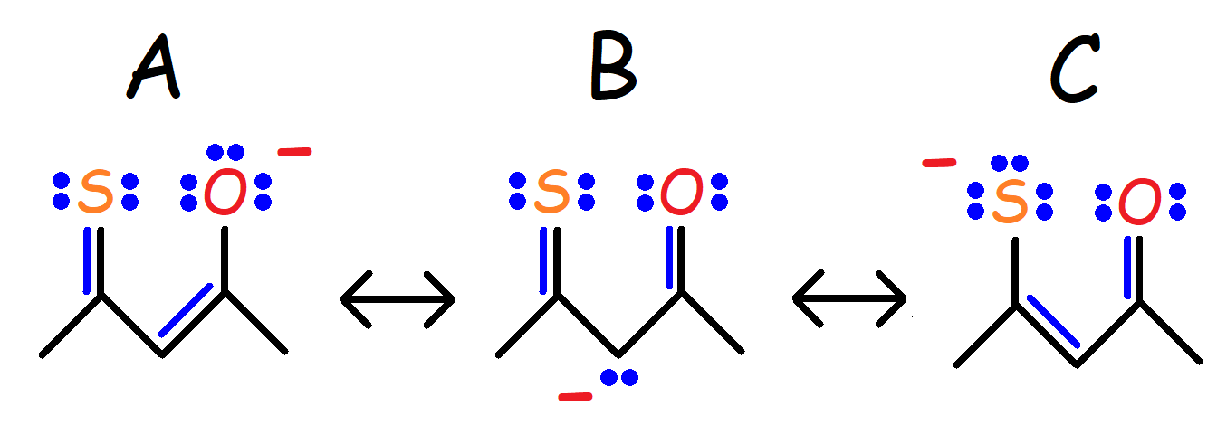

28b. Structure C is the major resonance contributor – it is the most stable structure due to the relatively large size of the Sulfur atom compared to the Oxygen and Carbon Atom. Larger atoms can stabilize a negative charge much better than smaller atoms.

28c.

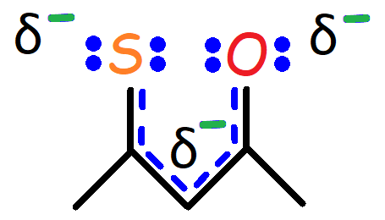

29. E

30. D

31. E

32. Proton a

33. II < IV < VI < III < I < V

34. III

35. E

36. The green proton is more acidic.

37. III < I < IV < II

38. Hc > Ha > Hb > Hd > He

39. I

40. E

41.

I. CH3CH2PH2 – Atomic Size

II. H3N+-CH2COOH – Inductive Effect & Electronegativity

III. CH3CH2CH**=**CH2 – Hybridization

IV. C6H5-SH – Electronegativity

V. CH3COCH2COCH3 – Electron Delocalization, Inductive Effect, and Electronegativity

VI. CH3CH2CH**=**CH2 – Electron Delocalization

42.

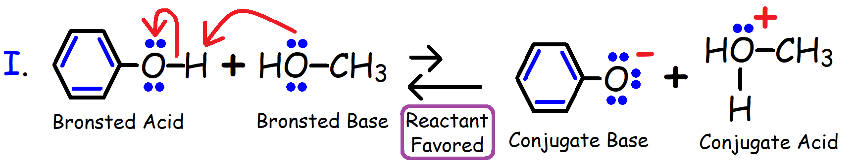

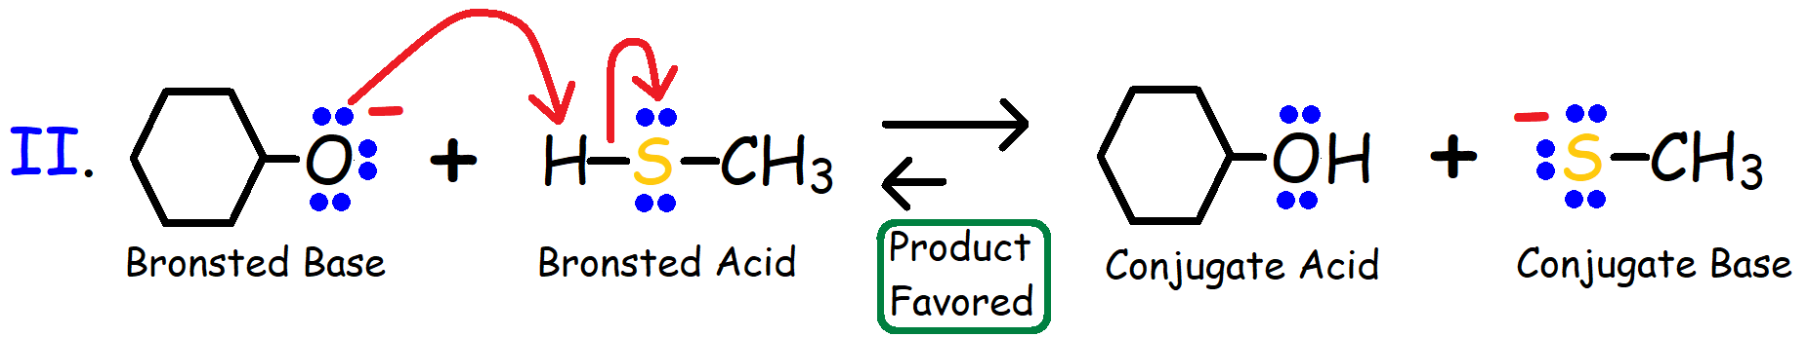

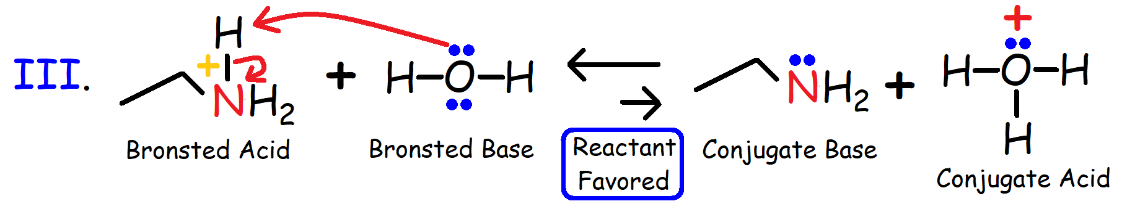

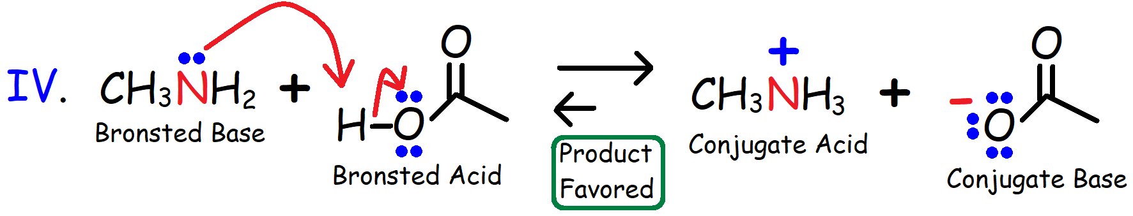

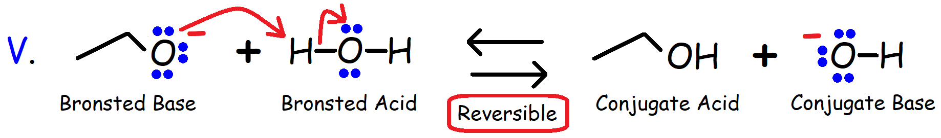

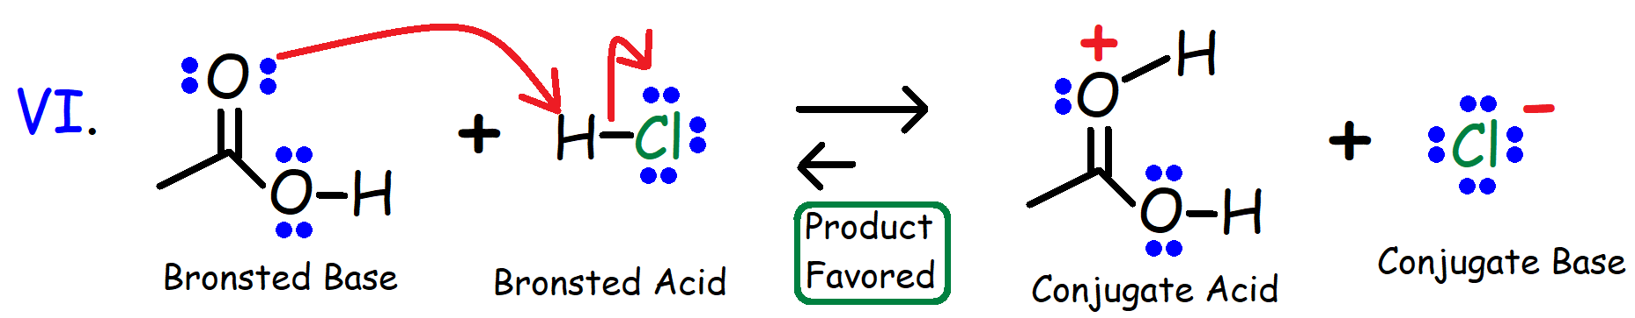

43.

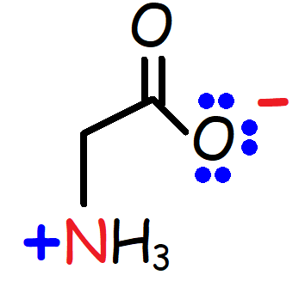

44. A

45. C

46. E

47. IHD = 12

48a. 1

48b. 1

48c. 1

48d. 4

49a. 32

49b. 30

50.

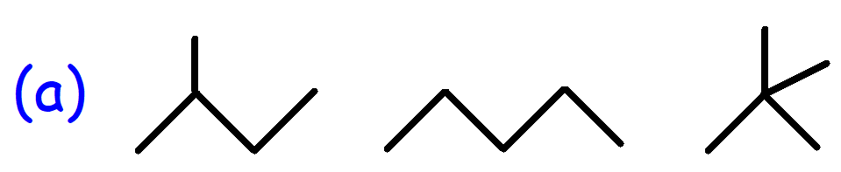

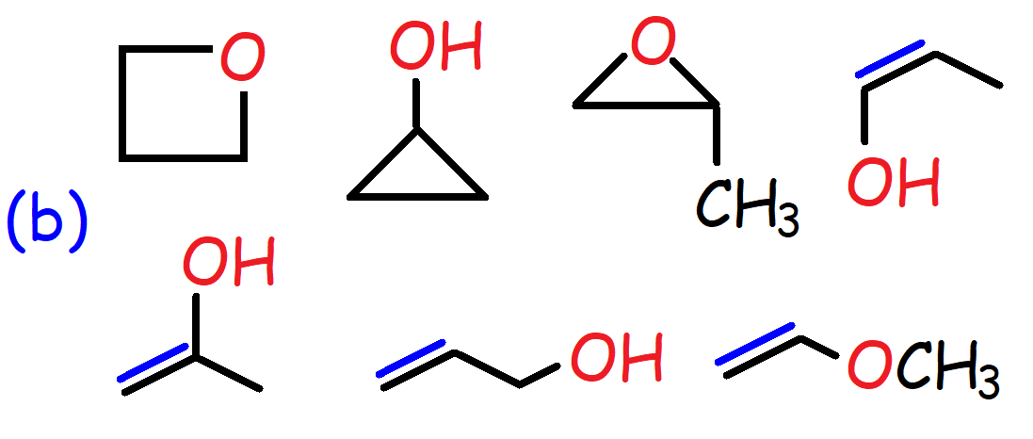

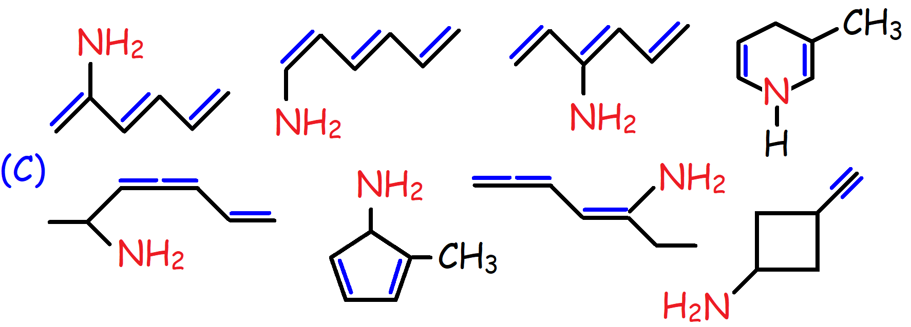

(There are many more structures that can be drawn for C6H10N)

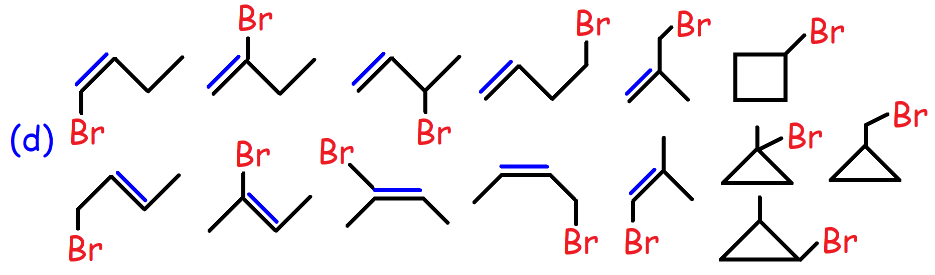

51. B

52. D

53. I < III < II < IV < V

54. F

55. C

56. It’s due to packing. Hydrocarbons with an even number of Carbon atoms can pack better when placed adjacent to each other leading to increased Van Der Waal Interactions.

57. B

58. I. Water-soluble II. Water-soluble III. Fat-soluble IV. Fat-soluble

59.

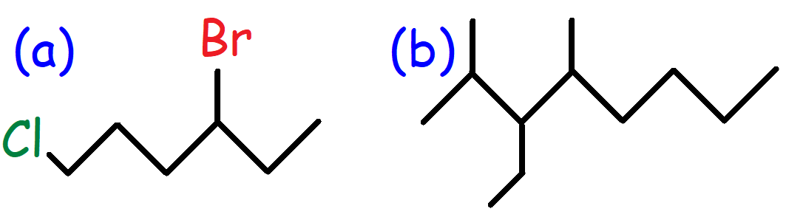

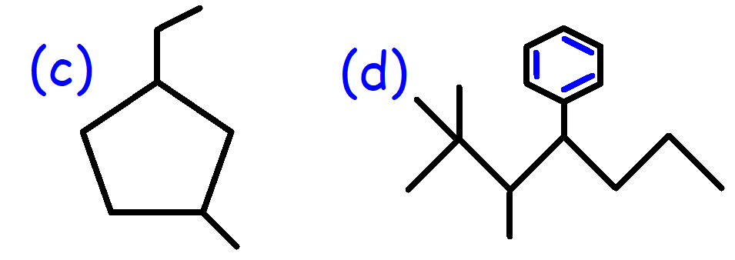

60a. 4-ethyl-5-methyldecane

60b. 3-ethyl-2-methylhexane

60c. 4-ethyl-2,3,3-trimethylheptane

60d. 4-ethyl-2-methyl-1-propylcyclohexane

60e. 5-(1,1-dimethylethyl)-3-ethyloctane

60f. 4-(2-methylpropyl)octane

61a. 3-bromo-4-fluoro-2-methylhexane

61b. 3-methyl-1-hexanol

61c. 4-bromo-2-chloro-1-methylcyclohexane

61d. 1-ethoxy-4-methylhexane

62a. Bicyclo[2.2.1]heptane

62b. 6-bromo-3-methylbicyclo[3.2.1]Octane

63. D

64a. The C-H bond has a sp2-s orbital overlap.

64b.

65.

66. D

67. 2,2,3,3-tetramethylbutane

68. E

69a.

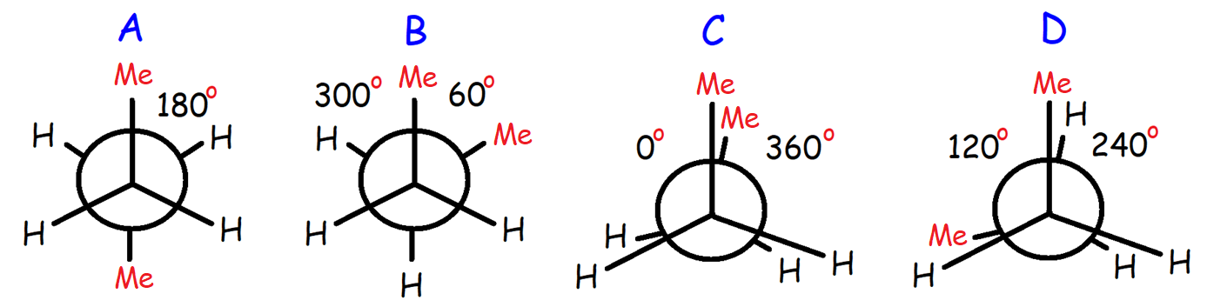

69b. Structure A is the most stable conformation.

69c.

70. 9.6 kJ/mol

71a.

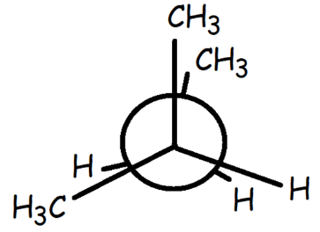

71b. 21 kJ/mol

72.

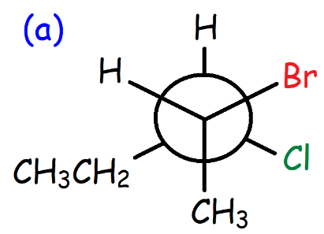

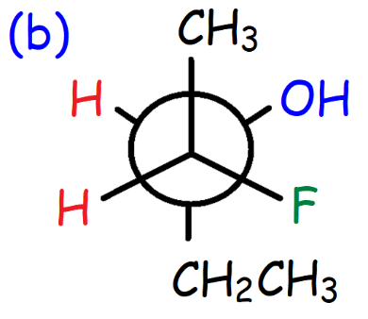

73. B

74. 5-bromo-4-chloro-5-ethyl-3-methyloctane

75. A

76. C

77. Cycloheptane

78. D

79.

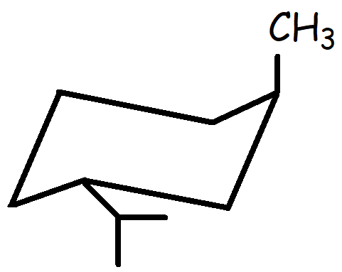

80.

I. Constitutional Isomers

II. Cis-Trans Isomers

III. Identical Compounds

IV. Constitutional Isomers

V. Constitutional Isomers

VI. Different Compounds

VII. Different Compounds

VIII. Conformers

81. D

82. D

83. 4-bromo-1-ethyl-2-methylcyclohexane

84.

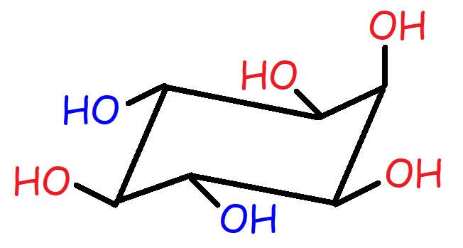

85.

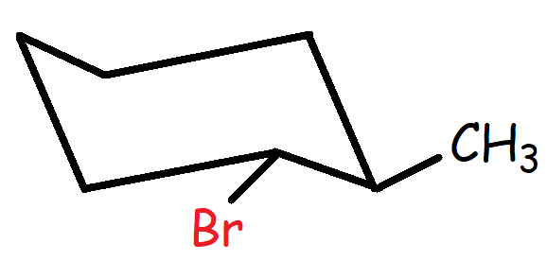

86.

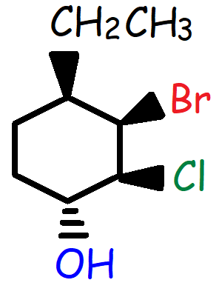

87a. Trans Decalin:

Cis Decalin:

87b. Trans Decalin is more stable than cis Decalin because the 2nd ring has two equatorial substituents. The 2nd ring for cis Decalin has one equatorial substituent and one axial substituent.

88.

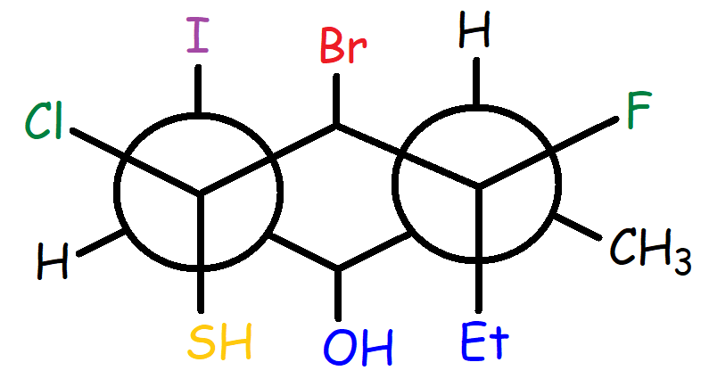

89. III < I < II < IV

90. HC < Hb < Ha < HD < He