AWOO-NDED
COMMISSION STORY
BY CHALDEACHANGE
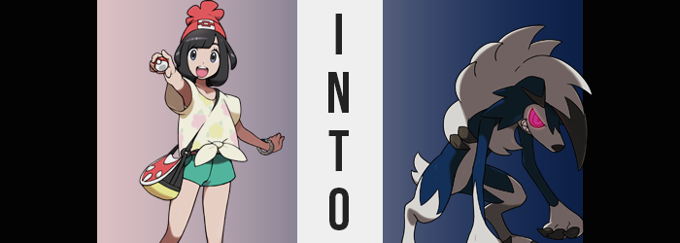

It was nice to have friends, wasn’t it?

It had been about a year now since Selene had become the first Champion of the Alola region, and ever since it had been nonstop challenge after challenge from those who had wished to claim her title. Life was really busy for her because of it, especially when she was only twelve years old now! But it was fulfilling, and she was always thankful about the friends that she had around to help her through the challenging times.

Hau was the one friend from her Pokémon journey that remained the most prominent light in her life. Of course there were girls like Mallow and Lana that checked in on her now and again, as did Hapu and Acerola, but when it came to other girl friends there was one that she couldn’t see. One that she had really missed. Lillie had opted to go with her mom to the Kanto region a year ago to help treat her after her Ultra Beast pollution incident, and while the two had been writing to each other?

It hadn’t really been the same.

That was why she had been so happy that Lillie had finally returned from her trip! Apparently Gladion of all people had pushed his little sister into returning to Alola to see her friends, saying he would watch over their mother in the meantime. Lillie planned on staying for half a year before switching with her brother again, which meant that they had plenty of time to catch up and make brand new memories together!

“I wasn’t expecting you to want to go training so soon after coming back, if I’m gonna be honest.” It had only been a couple of days since Lillie had returned, and her once quiet friend had asked Selene to go up into the mountains to help train her Clefairy. Selene had saw it as an opportunity to train too, of course, and a cute little Rockruff she had caught had recently evolved into a Midnight Form Lycanroc.

It was a good chance for them to work together, seeing as a Pokémon’s nature could change once they evolved. Sometimes they became more aggressive, other times they matured and became quieter. It really depended on the Pokémon in question, and Lycanroc had fairly volatile personalities in the first place.

Case in point? The two of them were talking as Lillie dressed a wound on Selene’s arm. A wound that she’d received from her own Lycanroc. It hadn’t struck her maliciously, it just didn’t seem to fully comprehend its own strength and speed just yet. “After everything that happened with mother, I realized I couldn’t stay the same scared girl I was, so…” Lillie pulled the bandaged around Selene’s arm tighter, prompting the patient to groan slightly from discomfort.

“Let’s just rest for the rest of the day, okay?”

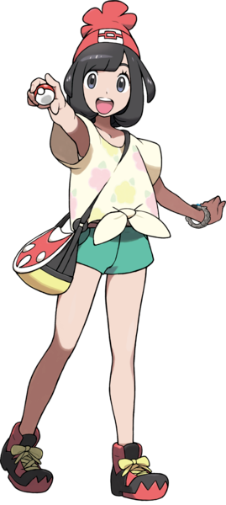
The rest of the day had been spent doing just that, and before Selene knew it, it was late in the night. She hadn’t been able to sleep and her wound had been throbbing, so she’d gone for a short walk away from the campsite she had set up with Lillie during the day. “I feel a little better now! It isn’t like me to be so restless though…” Honestly? She was a little worried about her Lycanroc. It had definitely been an accident, but even then? It was showing a lot more aggression than it had as a Rockruff. Maybe she should call Olivia in the morning and ask for advice? The Kahuna had raised plenty of Rockruff and evolved them into all three forms of Lycanrock.

Far enough away from the camp that Lillie likely wouldn’t have heard her even if she had stirred, Selene stared up at the night sky alongside a cliff. “A full moon? It’s pretty…” It was a very clear night, and that moon hung high in the sky. When it was like this, and when she was up so high? Selene couldn’t help but think how big the moon truly was. She had been named after the moon, after all. “It really is big though! In fact, have I ever seen it quite this large?”

Really, though? The moon wasn’t physically larger than normal. Even if though there were plenty of people and Pokémon across the Alola region looking up at the exact same moon, no one was seeing it at quite the same size as she was. Something in the back of her mind was prompting her to see it that way. The exact same way that a certain species of Pokémon perceived it. She couldn’t take her eyes off of it, and idly? She began to scratch at her wound beneath her bandages. Why was it so darn itchy?

She scratched, and she scratched, and she scratched some more. But she didn’t peel her gaze away from the moon that felt so near. “Is it glowing… red?” At this point, what the trainer was seeing was being influenced by changes in her mind and her vision. The moon certainly looked like it was glowing red from her perspective, but in truth? It was Selene’s own eyes that were glowing red.

Whether it was her irises, her pupils, or the sclera – it was glowing in crimson, producing light that could be observed from afar. Yet this seemed to change the colors of all of these areas into the color that was glowing, to the lines that separated these areas were all that remained black and gave an almost manic look with how they almost appeared to swirl.

Still clawing at her bandages, that descriptor was growing more literal. Because the nails across her fingers? They darkened in color to black, but also thickened and grew longer into almost cone-shaped claws. Claws that ultimately cut into the bandages and unbound them, white cloth falling to the ground beside her. What they exposed wasn’t a healing wound, however. What it revealed was a patch of dark blue fur that was now blowing in the cool, night breeze.

Selene continued to star at the crimson moon, eyes wider than ever. And yet the tops of those eyes? Well, her eyelids appeared to sag on top slightly to give the better impression that she had been entranced by the view. Almost like the moon had hypnotized her, despite the fact that the moon wasn’t at fault at all in this situation. While elsewhere on her body? More patches of dark blue fur began to arise.

It soon coated her arms and legs down to her thighs, as well as her back while hugging her hips. But so too did the color of her black head of hair begin to adapt highlights of the same color. The style of the Champion’s locks changed as well, fueled by growth that occurred as the color fully changed to dark blue. While still soft to the touch as a whole, individual hairs became coarser, and they formed a trio of spikes on either side of her head. But this head ultimately blended into the rest of her body as the blue crept up her neck. Begging the question: was the hair atop her head now fur as well?

Yes.

“Huh? Why can’t I… look awrrray?” The girl was conscientious enough to realize that something was wrong. That she couldn’t look away from the moon and did have a desire to do so, but with an almost growl welling up from within, she lacked the strength to do just that. In fact, her tongue began to poke out from between her lips and dangled loosely. A little too loosely. It was noticeably longer, and had grown several inches longer still since peeking out. Not only that but the texture of it was rougher, and while you couldn’t tell at a glance? It was much more durable as well.

Fur continued to spread across the girl’s flesh beneath her clothing, and while the blue had ceased its advent, what grew now was white. It encased her knees and below, her tummy, her chest, her hands, and even her pelvis. But it also grew across the entirety of her face… except one key area. Her nose.

On the contrary, Selene’s nose began to feel wet and its skin darkened to black. The scents of the mountain around her became more vivid in kind, but so too did the sounds courtesy of her ears. Because her ears had crept up the sides of her head beneath the new fur, growing larger and longer in the meantime. By the time they had halted on the top sides, they were shaped like triangles that had flopped forward with hard, gray trim. And they were very clearly the ears of an animal.

“Rrr… I’m… Grrr…” It became harder and harder for the child to think of anything but the moon in front of her, and at the same time? It was becoming harder to speak too. Plenty of her words were curling out as animalistic growls, and it took all of her concentration to croak out a single word. But as her lips thinned and darkened to black to section off her mouth from the soft fuzz that otherwise covered her face, it all began to pull forward.
With her damp, wet nose leading the charge, her entire face was stretched out towards the moon her gaze was fixated on. It twisted into the undeniable form of a muzzle, which in turn turned her eyes onto the sides of her head while the center of this vision was obscured by the new, six inch growth. Though at the same time, the new shape of this jaw paired with thinned lips revealed that the teeth within? Each was a razor sharp fang, best observed whenever her tongue flopped out mindlessly.

The girl’s posture began to slouch forward, and she began to sway from side to side involuntarily. From the next up she already looked the part of a beast, but her upper body also became heavier still thanks to white fur that fluffed up from her back. It was slicked forward and was more bountiful in amount than seemingly the rest of her body entirely – even resting between both of the ears on her head while a stone gray spike fell down past her nose in front. This was all extremely heavy. Like stone. But clearly she still had the strength to support it.
Even if it tore the back of her shirt completely in half so that she was now naked from the waist up. Even her hat had been pushed off and onto the ground.
“Grr… Rrr…” The moon was so full. So red. Did anything else matter? It was so beautiful! Such were the thoughts that kept racing through the monster’s head on repeat, her body becoming all the monstrous as they did. Her hands, for example? They grew mightier in size, practically tripling in girth at the cost of losing digits. Her thumbs and pinky fingers, new claws and all, merged into the fingers beside them as they became fatter. The claws made up more of each digit than they would have on any human, and each hand? Well, it was better left described as a paw. Paws that hung limply off of longer arms that just… dangled there.
And things weren’t any less dangerous when it came to her feet. They swelled to the point that new paws exploded through the containers that were her shoes, sharp, black claws of stone on the three digits that remained on either foot past her white fur. The backs of her heels lifted, and her knees bent backwards to tilt her posture into an even more prominent slouch. Another growl passed her lips not long after.
But her thighs? Already thicker from the blue and white fur that adorned them, they grew thicker and ultimately split her green shorts in the process. Her pelvis became exceptionally broad, and her sex was hidden under tufts of fur that grew more prominent around them just in time for the remnants of her shorts to fall off. Of course, they were helped by a short, fluffy white tail that sprouted from her tailbone.
Glowing red eyes finally blinked, and the red Selene perceived seemed to fade, bringing clarity to her mind. Why couldn’t she stand up straight? Why was she experiencing a sensory overload? These were all questions that bombarded her ego at once. Without thinking, she reached a paw up to her chest – finding a huge tuft of fur where her breasts had once been before they had disappeared into obscurity. “Rrow!?”

Looking down at the ground she saw scraps of her clothes. As well as her hat which she reached down to grab. But as clawed fingers wrapped around it? She realized that what she was looking at was not a human hand.
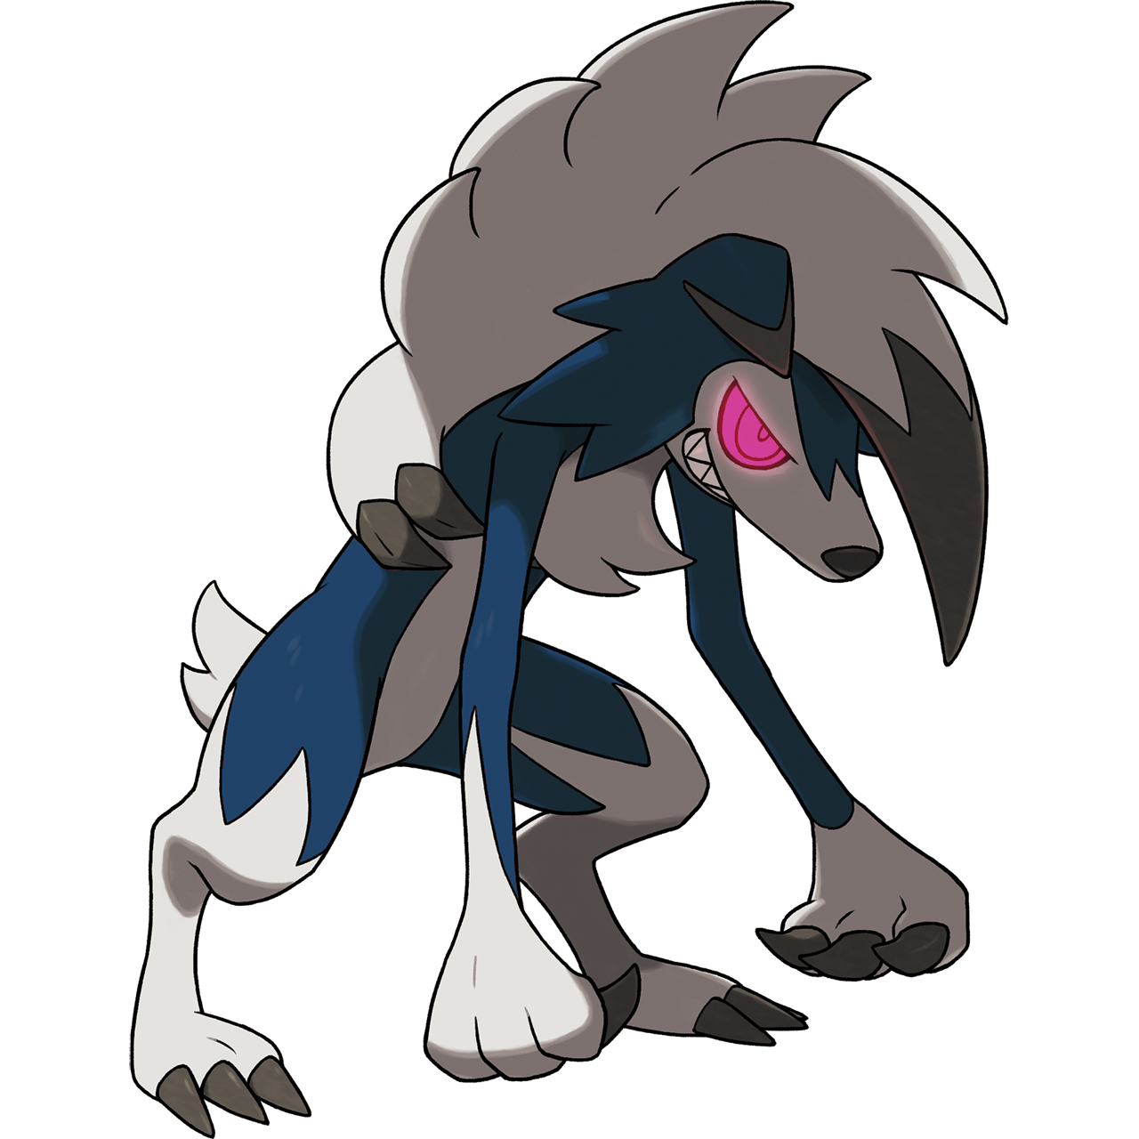
“Grrn…!?” Try as she might by this juncture, Selene just couldn’t manage to form any human words with her mouth, even though she knew how to speak them in the back of her mind. That ability had gradually waned throughout her transformation, and now it was completely gone. She once again stared down at the big, three fingered paws that hung down from slouched shoulders, now holding her hat in a panic. They were familiar. Like those of the Midnight Form Lycanroc she had just evolved, though its colors leaned into the realm of a shiny Pokémon.

So she was… a Lycanroc!? A Midnight form Lycanroc at that! How could this happen? Was it because of her wound? But no one had ever been transformed into a Lycanroc through an injury before! It just didn’t make sense! And even though she was still herself deep down? Her confusion turned into a growing agitation. Midnight form Lycanroc were known for their hostility, and it seemed that was a trait of herself now too.

No! I need to calm down! I need to calm down and find help! While she mentally calmed herself, her furry body found a different way to destress. Red, swirling eyes stared up at the huge moon once more, and despite it feeling too animalistic to do so? “AWOOOOOOO!” Selene howled up at the sky, tongue hanging loosely from between the sharp teeth of her jaw.

Horrified that she’d just howled at the moon like a wolf, the wolf bolted back down the mountain path. She needed to find something familiar, something helpful! Unknowingly, she was following the most comforting thing she could imagine. Lillie’s scent, as Lillie was the girl that Selene cared for the most – though she had never experienced her scent this keenly before.

“AH!?” Lillie naturally jumped awake as a Lycanroc came crashing through her tent door. At first she thought she was under attack, but the monster looked… distressed? It had lowered its head, even though it still appeared menacing with its red eyes, sharp claws, and sharper teeth. Not to mention it was a shiny!? But even though it was naked? Between its paws was something familiar. An accessory that didn’t belong there. A familiar hat, held like it was a precious item. “N-No way, you’re not Selene, are you?”

Even Lillie thought she was crazy for making such an assumption, but there was something about the Pokémon’s demeanor that felt like something she had seen before. Not to mention the hat. “Grrow…” Selene’s long tongue flopped about as she nodded. She hated it, but she could smell all of the food they had brought packed in the tent’s corner. It made her hungry. She was drooling like a beast. But now wasn’t the time for that.

And much to her surprise? Lillie hugged her! It felt nice. Comforting. Like everything would be okay, even if she was a monster. “It’s okay. We’ll figure something out!” Could they turn her back? There had to be a way! Because Selene was shiny, though? That meant that she would be hunted by collectors. Gently, she caressed the fur on the back of her friend’s neck. “Until then I’ll protect you, okay?”

She had to.

