NEW CORE
COMMISSION STORY
BY CHALDEACHANGE
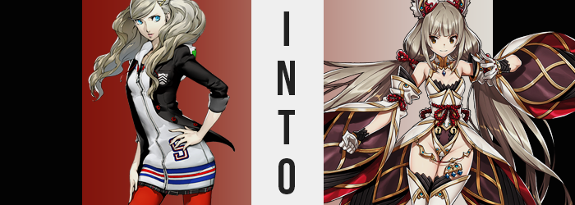

While not as much as her friend Futaba, Ann Takamaki fancied herself to be something of a gamer.

It was part of the reason she got on so well with the boys of the Phantom Thieves (well, their leader and Ryuji at least) even if it meant it was a little harder for her to get along with the most feminine of girls her age. Not that they’d done her any favors in that regard, pushing her away in the past because she looked and acted differently than everyone else.

In no small part, video games had more or less become something akin to the teen’s comfort food. On those days where she’d come home depressed, and there had been a lot of those, there had at least been games waiting for her. Each one had its own self-contained world and characters, and those characters were happy to have her along.

While her need for video games as an emotional crush had waned ever since she had met everyone else in the Phantom Thieves though, that didn’t mean that Ann didn’t still play. Between investigating the Metaverse, doing model work, and hanging out with friends, her time to do so had certainly waned. But where she could, she still made time.

Recently she had been playing a little-known gem called Xenoblade Chronicles 2. Well, it had apparently been very popular with certain crowds when it had first come out, but with most games that popularity had waned with time. But Ann? She had really gotten into it! She liked the world, the characters, and even the battle system.

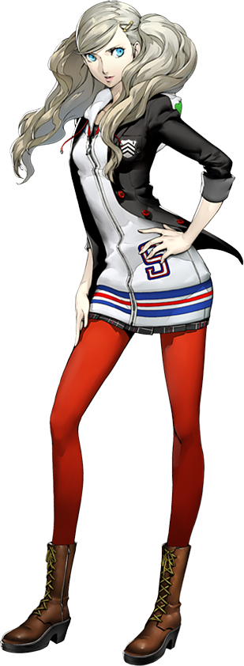
Of course, it was inevitable that she would reach a point in a JRPG where she needed to grind a little, and that was what she had chosen to do that evening. She’d reached a part in the game where a crazy secret about one of the main heroines, Nia, had been revealed. The teen was hooked, but being slightly under-leveled because she had rushed the last area had become burden for experiencing more of the story.

And so she had taken to the fields of the Titan she was current on to not only grind levels but check out the abilities of her newest Blade courtesy of the story. All had gone well, but before Ann realized it, her game had frozen mid-battle. “Hey! Not again…” Had this happened before? Yes, but not with Xenoblade Chronicles 2. It wasn’t strange for her Switch to freeze up – she just had to reset the console, and all would be well.

Ann got up from her couch, held down the power button, and—

ZAP!

She felt a jolt of electricity strike her finger and stepped back, but upon doing so she felt the soft crunch of grass beneath her feet. “What the…?” And then she realized. She was standing in the middle of a field populated by familiar people and monsters. Familiar because they were the very same game characters she had just seen on screen. “Wait. Rex? Morag? Mythra?”

They couldn’t answer her though. The world was entirely cast in monochrome aside from herself, and everything that was black and white was motionless. It was strange though. Where was Nia? Everyone she’d had active at the time was here except Nia. Even her inactive party members, which she could see off to the side.

Actually… Wasn’t she standing where Nia had been at the time the game froze?

“This definitely isn’t real, right? It’s totally gotta be a dream! Or maybe I really am in the Metaverse?” Ann was quite clearly very content with trying to wave this whole situation off as an impossibility, even if it felt more real that any dream could possibly feel. The world around her just looked so lifelike – even the characters! They looked like real people despite just being 3D models in a game! The only plausible explanations from her point of view were a dream, or this being the Metaverse. Because what else could it be, really!?

Even though she was doing her best to grapple with an uncertain reality, a moment to breathe a little wasn’t exactly being afforded to her through anyone’s (or anything’s) goodwill. Had she taken things more series and perhaps likened the situation to something like being isekai’d, then maybe she would have questioned things with a little more common sense. Like why she had been brought here, by chance? Or in the case that she wasn’t supposed to be here, what would happen to her as a result?

The answer to that question was already making itself apparent. The tips of Ann’s ears had felt a little toasty, and she hadn’t really paid much thought to it considering the surrealistic nature of it all. But there was a reason for it, and that reason was fur. A silver fuzz had not only spread across her ears, but the shapes of those ears themselves had become deformed. They were pulled to sharp points at the tips and appeared slightly longer in length. And they eventually grew longer and longer and longer still.

Just as miraculous as their changing length, mind you, was the fact that their positioning had begun to shift. Taking it inch by inch, they slipped up the sides of Ann’s head so that they eventually reached a point where they were parallel with each other on top, curved inner ears fanned out to the sides where tufts of white fur erupted inside. These ears, half a foot in height each, looked incredibly soft. They were even twitching of their own accord, although Ann played it off for some reason.

“I can’t really be in the game, can I?” She was still far too fixated on the plausibility of her situation to consider addressing something she hadn’t even stopped to notice. Not that the changes had really stopped for her to consider them. The silver from the fur atop her ears, for example, was spreading into the strands of her blonde hair. The shift in hue wasn’t actually all that significant, since her hair had been platinum blonde in the first place.

The length and look of it, on the other hand? Well, there was a much more dramatic shift in those areas. The natural perm that left her locks looking so fluffy and curly was ironed out without delay, and while at first the natural result of such a thing would leave the straightened hair looking a little longer, it became clear that even more length was growing from her scalp after the fact. It typically hung a few inches past the front of her shoulders, and yet when all was said and done it had not only fallen behind the teen, but it had spilled as far down as her ankles.

Ann blinked. The weight of it all was definitely off-putting. “Wait, was my hair always… like this?” She coughed a moment, for her voice had very briefly carried an unfamiliar accent. Grasping handfuls of her mane, she was left to simply stare down at the silver locks with a perplexed expression on her face, entirely stunned.

But, at least regarding her face, it was becoming increasingly difficult to make sense of her identity. That is to say that she was looking less and less Ann-like. It all began with her bright blue eyes, which quick showed an unusual sign of off-coloration as speckles of gold could be found sporadically amongst her irises. Now, some people had eyes that changed color naturally, but it certainly wasn’t something that happened like this.

The golden hue quickly became dominant, overwhelming every trace of the color of the sky while her lashes shortened ever so slightly. But this was not even the full extent of what transpired with her eyes, for their Japanese shapes widened and stretched in a way that appeared far more expressive and, in many ways, almost cat-like.

Her fuller eyes did well to compliment a facial structure that was becoming fuller in of itself. Ann’s cheeks became standouts, turning soft, round, and pokable – while her plump lips in turn thinner so that they were much less pronounced by comparison. Overall, her face had been robbed of its Eastern appeal entirely, and she better suited the profile of a Western, more Caucasian young woman.

Ann couldn’t really see this to comment, and instead her thinned lips were pursed as she stood there in shock at something else. She felt like she was forgetting not only something, but a lot of somethings. There were so many holes. Where was she born? How old was she? What was… “What’s my name again?” That accent from before was completely dominant now.

How could she forget her name? Her place of birth? Oh, but I’m a Blade so my place of birth isn’t really… Huh? A Blade? Like in that game? Game? This is the real world, it isn’t a game! But didn’t I come from the real world? Yeah, duh! Because I’m livin’ in it!

Memories that had once gone missing returned, but they didn’t at all match up with the memories that had been retained. This caused a clash of egos where Ann was left at a loss for what was real and what wasn’t. Despite this, the changes to her body’s design did not come to a halt. In fact, they fell further in line with the memories that were popping up where old ones had been lost.

Most of the remaining changes weren’t exactly to Ann’s benefit though. Not that any of them have really been arguably so. To begin with, her bra had emptied out slightly thanks to a minor collapse of her bosom that left her tits firmer at the cost of their size for one.

On the other hand, her ass remained just as big and perky as always, but while this was true, it was left to look even fuller thanks to the fact that her hips had involuntarily narrowed so that her skirt sat loosely upon them. That said, her ample thighs not only remained untouched but somehow looked even fuller than they ever had before. It was not a side effect of her hips being closer together, though.

It was instead a side effect of her height being reduced. It was only a couple of inches, but the amount didn’t change that Ann’s natural height fell away in slight. Well, barring her ears of course. By the time her height had slid away, something hard had emerged from the space just above the center of her chest. A crystal dyed a flurry of colors. The corrupted Core Crystal of a Flesh Eater.

But that should have been impossible! That was just an element in the game she was playing, she couldn’t have become something from that game! But was it a game? Everything she’d learned while playing didn’t feel like game knowledge any longer, it felt more like a life she’d lived. And while she’d forgotten her name, it had suddenly occurred to the girl that she could now remember. It was—

“AHAHAA! STOP IT! STOP IIIIIT!” Before she could confirm the name with herself, a sensation of great intensity forced her to giggle maniacally and cry for it to cease. She was being tickled! Not by a person, but the clothes she had been wearing were wriggling around her flesh and changing to better suit not only her new appearance, but her entirely new role.

What slid around her arms fanned out into a pair of elaborate, layered sleeved considering of browns, reds, and golds, while white gloves with black wrists found themselves enshrined around shrunken, unkempt fingers. Her thighs, on the other hand, were left entirely bare, with the lips of her pelvis exposed just as clearly. Silver, steel leggings with gold trim were wrapped around her legs otherwise, culminating in metallic, crimson boots with tall golden spikes on their tips.

When it came to her torso, what was concocted was a white raiment that resembled a kimono in how it was crafted, although its golden trim fanned out to the sides to expose her hips fully. The underside that flipped out into tails around her waist strongly resembled the inside os of her detached sleeves, and her subtle cleavage was left more or less on full display.

Otherwise, the maiden’s silver hair was pulled into two, large tails by crimson rope ties, and matching steel clasps found themselves at the bases of her ears to keep them from bending unnecessarily. Overall much of her body was exposed, and yet at the same time plenty of her body was not only covered, but at times unnecessarily armored. Hopefully she didn’t have to kick anyone with those spikes on her steel boots!

And then, finally, everything clicked.

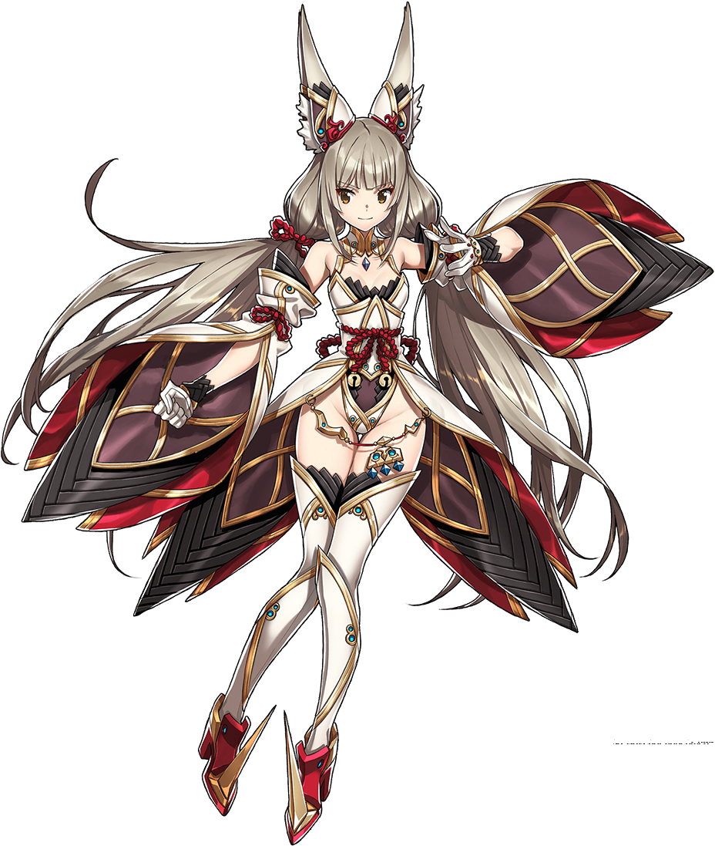
“Uh… Hey, Rex!? Mythra!? Why’s everyone all still? We’re in the middle of a battle after all!” The Flesh Eater Blade, Nia, looked around in a panic the very moment her sensibilities were returned to her. As if she had just been lifted from a daze, the truth of the world had become apparent to her – and that truth had no room in it for the personality known as ‘Ann Takamaki’. In fact she had forgotten all about her life as a Japanese teen. She’d forgotten about the Phantom Thieves, about school, about her world, and even the fact that the world she was in now was actually a video game.

Instead she was left bamboozled by the frozen state of the world. Her train of memories went from training with the others to the sudden realization that everything had just frozen. Was this some kind of technique that one of their foes possessed? Was it akin to Mythra’s ability to sense the flow of battle? Nia hardly understood, but it left her distraught.

“LET ME OUT OF HEEEEEEEEEEERE!”

Fists balled beside her, the maiden cried out with all her might not thinking that anything would come of it. But much to her delight (or perhaps her dismay) the monochrome world soon shattered so that both color and motion returned to her surroundings. The issue? It did so mid-scream, so everyone else in her group recoiled with shock at the sight of Nia screaming with all her might at what was supposedly random.

“Nia!?” Rex almost fell flat on his ass, seeing as she had been standing just inches from him. It took the cat-Blade a moment to realize just what had happened, for when she opened her eyes everything had returned to normal. But the moment it all set in, her face blushed a bright vermillion. Had motion really returned right as she’d been screaming?

She had no choice but to curse her luck on this matter. It was like time had frozen all over again, but in this case it was just her friends all awkwardly staring at her after the final monster fell. “Wh-What’s everyone lookin’ at me for, eh!? Can’t a girl just scream at the top of her lungs in battle. That’s just called a battle cry, right?”

If anything, she was hoping that her companions would buy this extremely lucrative explanation for what had just transpired. Deep down she knew it wasn’t really reasonable, but she still had hope!

…No one was really buying it, though.

