EINZBORN
COMMISSION STORY
BY CHALDEACHANGE
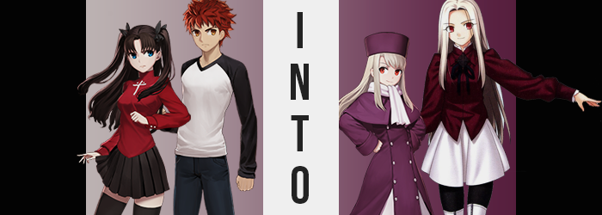

“I really don’t like that she continues to live all the way out here. What if something happens to her?”

“You worry too much, Emiya. She’s not a child. She’s fine.”

The Fifth Holy Grail War of Fuyuki City had come and gone, and in the end there hadn’t been much of note when it came to significant loss. Rin and Illya had both survived, but at the same time the truths behind Sakura Matou’s existence had not come to light. Even Illyasviel’s limited lifespan remained a secret, and she only hoped to live out her remaining days as normally as she possibly could.

While Illya came by the Emiya household now and again, sometimes sleeping overnight, she often returned to the Einzbern estate, which was out in the middle of the woods. It was far enough away from the city that Shirou was naturally concerned about its location and the relative safety of it all. After all, she Illya no longer had Berserker to keep her safe. Not to mention it was really annoying to go out and visit her, like Rin and himself had decided to do that day.

They weren’t using the usual path, either. A recent storm had knocked down some of the trees across it, making it impossible to traverse under normal circumstances. At the very least it was now spring, so it wasn’t as if they had to trudge through the snow. “Ugh, but I feel like we keep walking in circles.” Of course Rin would be the first one to complain about it.

“…It was your idea to come this way, though.” Simply for pointing out the obvious he was shot a glare from his twin-tailed friend. Well, he should have expected that! “How am I not supposed to be concerned? That storm caused so much damage so its not like she can easily get back to the city.” In a very typical Shirou Emiya fashion, he had become something of a caretaker to Illya. Not that the homunculus minded, seeing as she was still keeping the secret that they were actually siblings. To be doted on by her little brother? Well, she was afraid that would go away if he knew the truth!

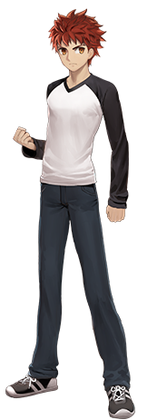
“Well…” Rin knew he had a point. Kind of. But she was much too stubborn to actually admit it. As they crossed a boundary of trees though, or at least Shirou did, she was ultimately afforded an easy way out of having to admit it. “Hey!? Wait, is this magecraft?” Leading the two of them, Shirou hadn’t realized what she had meant until he spun around and found himself face to face with some branches that had separated Rin and himself. Obviously there was something unnatural about their formation, but it also wasn’t dangerous.

“I’ll run around and meet you on the other side. One second!”

Apparently Rin had assumed the same thing, because she bolted off behind the brush and nearby trees without even giving Shirou a chance to reply. They already knew that the Einzberns had placed some traps outside of the estate, after all. But now that Shirou was left alone, he didn’t exactly know what to do. “Okay, guess I’ll stay here…?” He was in a clearing, so it wasn’t like he ran the risk of getting lost so long as he lingered.

Taking a few steps deeper into the clearing, though? He was shocked to suddenly find the ground lighting up with purple. “A magic circle!?” Crap, had he activated another one of the traps!? Maybe he should have been just a tad more cautious. Nonetheless, it had already activated – and it begun to feed on the young man’s protective feelings towards Illyasviel to cause something exceptionally strange.

“I feel a little… strange.” Shirou made no effort to move off of the circle, wholly believing that it was already too late. He also doubted the trap was going to be all that harmful, since they had heard from Illya herself that she had removed anything that could seriously hurt a regular human. To be fair to her, though, this trap wouldn’t actually hurt anyone. But she also didn’t know that it existed in the first place.

The boy’s body tingled, and he couldn’t exactly pinpoint any probable reason for it. He didn’t exactly feel different, not initially. Rather than being concerned about himself, in fact, his mind kept wandering back to how Illya was doing living all by herself out in the forest. But she isn’t living alone, is she? For a brief moment that thought crossed his mind, and he didn’t quite question it as much as he most definitely should have.

But there were side effects of the tingling. There were much more substantial ones later on, but Shirou could hardly be faulted for not taking note of what initially happened. After all, for a young man that was already on the cusp of physical maturity it wouldn’t be all that obvious if he grew a little older, which was exactly what was happening. It wasn’t enough to add much to his build, although he did grow a single inch taller. It was something more easily observed in the maturity portrayed by his facial features, so that he instead looked like a young man in his late twenties rather than a boy in his teens.

“Maybe I shouldn’t linger here.” Shirou’s worry for Illya was growing stronger, but he had a reason for staying didn’t he? “I need to wait for her though…” He spoke of a woman, and that woman most certainly should have been Rin, and yet he couldn’t remember exactly who it was that he stood in wait for. In fact, hadn’t he conveniently forgotten about the glowing magic circle he was standing in the middle of too? That wasn’t actually ignorance. He’d just become oblivious through the design of the spell affecting him.

The longer he lingered there, the more his body began to change. While he was older, he certainly wasn’t old enough now for the color of his hair to start bleaching. And yet that was exactly what was happening, with each and every strand of red atop his head eventually lightening to white – not the silver of old age, but a white as pure as the freshly fallen snow. It wasn’t a color isolated to the hair atop his head, either, because it became just as prominent in his brows and pubes.

The man’s skin paled to an almost ghostly white, and with both his hair and his skin the epitome of porcelain, it made the change in color that then plagued his eyes stand out all the more so. The bright amber of his irises steadily darkened, and yet a vibrancy persisted that saw any semblance of yellow fade away until there was naught but a deep, familiar red. Familiar because he had most certainly met someone with that eye color before – and that hair color. The very same girl he had been travelling to meet alongside ???? that day.

“Hmm…” He hummed to himself without thinking, not recognizing that his voice sounded much more effeminate than it had before. His Adam’s apple smoothed away, and little by little? His figure showed signs of thinning. The muscles he’d developed through hard work and plenty of fights seemed to thin away, but at the same time a newfound shapeliness was applied to his overall physique. His waistline pinched in to give him a curvier look, for example, and almost in tandem his hips appeared to pull several inches wider.

This was all preparatory, mind you, for the more severe of the alterations that Shirou would succumb to. The foundation had now been laid, and with a few inches peeled once more off of his height, his clothes were fairly baggy across his physique. This left ample room for things to, well, become more ample.

And ample they most certainly became. “Oh! What’s wrong with my clothes?” It appeared that he couldn’t quite process it though, because even though he was staring down at his chest, watching a modest bosom push forth against his shirt, it was in fact the shirt that he saw as the problem. Swollen nipples rubbed with newfound sensitivity against the cloth, inspiring a bit of arousal even as these breasts peaked at perky C-cups.

Not that this arousal made him hard. Quite the contrary, in fact, as his dick became flaccid with time. It grew smaller and smaller, so much so that it eventually disappeared between his legs. Or, perhaps more accurately stated, her legs. A pussy formed where a dick had once been, internal organs shifting appropriately to present her with a womb.

All that was needed now was a little flourish to the surrounding area. Her thighs and ass alike both swelled, making good use of the space afforded by her initial shrinkage. Thighs swelled enough that her pants were bound tightly around them, and boxers wedged in between her cheeks. But she didn’t pick at it or anything. In fact, her expression appeared to be rather glazed over while facial features were rearranged towards the feminine. To the point where they strongly resembled those of a certain homunculus while not being quite the same.

As the magic circle died out, one last burst of light saw the woman refashioned in a dark purple top over a white skirt and black tights. Along with her white boots there was something very Western about her ensemble, and since her face lacked any Japanese traits to it, it simply seemed normal.

It had been a seamless transformation, really. Shirou already cared plenty about Illyasviel, and fiending that adoration he had so easily been transformed into her actual mother, Irisviel von Einzbern. Not that Iri herself understood that such a transformation had happened in the first place. “Oh? Was I out gathering berries? Strange, why do I feel so groggy?” She couldn’t imagine why else she might be outside of the estate like this.

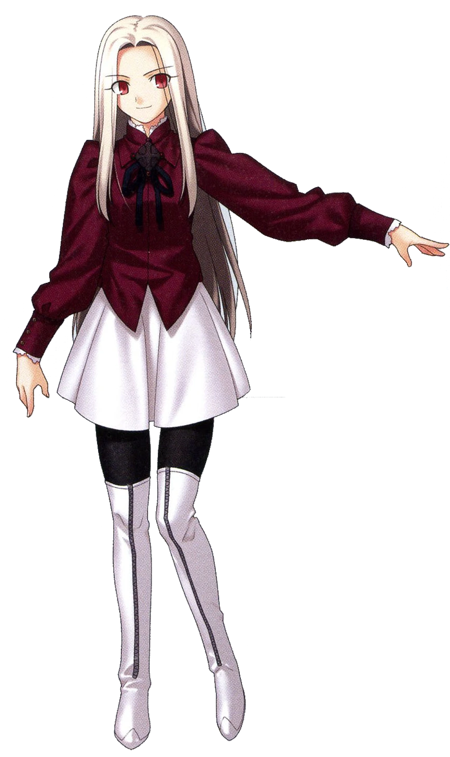
According to her memories as they existed now, after Kiritsugu’s death she had taken Illya and one other person out to Fuyuki to live a peaceful life. Since the estate already existed, it was an easy enough place to hole up together. Iri enjoyed living off the land more than she did braving the trip to town though, so it wasn’t odd to find her plucking fresh ingredients from the forest. “Hm… I should find her and head back home. I bet Illya is very hungry!”

But who was this mysterious extra person? Their name was on the tip of her tongue… If she could just recall, then she would certainly call their name with all of her might. After all, they were family.

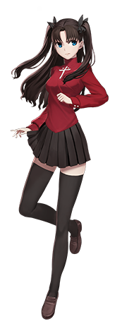
Rin was quick to realize her plan to just ‘loop around to Shirou’ wasn’t going to go as easily as she had originally hoped. Had this part of the forest always been this thick? Or had the trap they had activated before somehow made it difficult to navigate? “Maybe I should have just blown it away with magecraft in the first place…” But she was running low on gems, and she hadn’t been in the mood to waste a Gandr Shot on something she could just walk around. Apparently that had not been a good move.

“The exit must be around here. OIIII! EMIYA!? CAN YOU HEAR ME!?” Just in case she was turned around, she called out to him to see if she could pinpoint his position. But in a typical Shirou fashion, she received no reply. Unaware that the reason was because he was midst a trap himself, she just pouted and assumed he was ignoring her. “Great. Real helpful.”

Feeling a little agitated, she pushed forward. Or at least that had been her plan, but suddenly the ground lit up beneath her with red – prompting her to immediately jump back. “Another trap!?” Rin had immediately escaped its clutched, but not without the energy from the magic circle blasting through her leg as she had bound backwards. Unfortunately for her, this little bit of contact was not enough for her to escape the ill effects that were to come.

“Wait, crap! I got hit!” The Tohsaka heiress was much too experienced of a magus to not realize her folly, and her gaze immediately shot down towards the foot that had been hit. It was a little bit difficult with her bust in the way, but… Oh, wait! They weren’t obscuring her vision all that much anymore, how nic— “WHAT THE HELL!?”

Evidently her cleared vision was not something to celebrate; it simply took a moment for her to realize what she had actually just observed. That is, that her breasts had just lost all of their weight, and her favorite shirt had flattened without anything underneath to keep them supported. “N-No way, that did not just happen!” Hands immediately reached up to pat her chest, the only thing palms colliding with beneath her shirt being a bra that was presently containing next to nothing. Mind you, she didn’t notice that her perfectly manicured nails had been undone as well.

Much more pressed about her breasts than anything, further depletion of her mature, almost-womanly figure was not noted by the one suffering the effects herself. Rin’s thighs, perhaps her most desirable feature, thinned just as her chest had until legs were left lanky without much in the way of definition. And considering the areas were connected with one another, perhaps it was unsurprising that the perky cheeks of her ass shrunk in kind. There was no longer a single thing about her figure that could be considered conventionally attractive.

But hey, she still had a great personality! Which was what really mattered in the end.

Not that her eligibility as a bachelorette would really be of importance soon. “H-HEY! Wait a second!? What did that trap do, Illyaaaa!?” The woman’s voice grew shriller and shriller as she cried out, inevitably becoming similar in sound to that of the girl she was calling for. Of course, she wasn’t crying out like this without good reason – in fact it almost sounded as if she was falling.

Which she wasn’t actually doing, but the feeling was simulated by the fact that Rin shrunk with dramatic speed. Not in any consistent way, mind you. Her limbs and torso all shrunk separately from each other, causing her skirt to fall from narrowed hips and her leggings to peel off and droop downwards. Seen in her face, it wasn’t just that she was getting smaller. She was growing noticeably younger on top of it. Until her height was comparable to Illya, as was the perceived age seen in her facial features.

The nearby magic circle flashed, and the next Rin knew, her clothing issue had been solved… kind of. Her clothes now fit, but… “Aren’t these Illya’s winter clothes!? Does that mean I’m the same size as— Wait, my voice!?” Even though that voice had changed prior, it took her putting two and two together to actually notice. “Am I becoming Illya? No, how could I be my sis— Huh? I don’t have a sister…?”

Now dressed in Illya’s clothes, Rin’s hair hung beneath a purple hat and was no longer held up in twin-tails. It also appeared to be growing straighter and… lighter. Significantly lighter, for it eventually paled to a white comparable to Illyasviel’s own. Restyled, Rin noticed how her bangs were now swept to the left, and how longer locks framed the sides of her hair. “My hair is like Illya’s too!? Am I really becoming a copy of…?” Once again, calling herself a copy didn’t feel quite right.

Besides, Illya was technically older than her! It sucked being the younger sibling…

She shook her head. That didn’t… really make sense? Or did it? Her blue eyes glossed over a moment, head incapable of keeping up with memories that were changing to suit a new reality. And by the time they had completely been changed? Not only were her irises red, but the shapes of her eyes themselves were a little bigger and more expressive. Like she was still half-Japanese, but then also half-European as well. Cheeks softened and rearranged around the same time, until she was absolutely, undeniably, the spitting image of the girl she and Shirou had come to meet.

But she didn’t know who Shirou was anymore, either.


What had once been a frustration that she was helplessly becoming what she perceived to be a copy of Illya had eventually turned into something else now that her transformation was complete. “Why does mama always bring me everywhere? Is it because I’m the youngest!?” That was because while she did strongly resemble Illyasviel von Einzbern, that wasn’t actually the case. Iridia von Einzbern was her own person, a more recent homunculus that Iri had rescued from the clutches of her family.

While Iridia looked almost identical to Illya, it was only because of Illya’s own stunted grown. Illya was eighteen, but Iridia? She was twelve. She was the youngest, and she was always babied as a result. It didn’t help that her mama always dressed her up in her older sister’s hand me downs. Which were basically clothes that still fit her anyways.

Despite her complaints though? She perked up the moment she heard her name called.

“IRIDIA!? WHERE ARE YOU?” It was her mother, worried because the two of them had ended up separated. Despite how upset the young homunculus had been, she immediately smiled. Maybe she was just grumpy because they had been separated.

“COMING, MAMA!”

All that remained was for the two of them to return to Illya.

Illyasviel blinked. She had been waiting all afternoon for Shirou and Rin to come over like they said they would, but the people who had come in through the front foyer were not then. Confusing as it was, one of them resembled her late mother, and the other? A carbon copy of herself.

“…Huh? Who’re you?”

