Electric Potential - Worksheet

11 Free-Response Questions

Organic Chemistry Tutor

1. How much work is required to move a -500 μC charge across a potential difference of +300V?

2. 100J of work was done by an electric field on a +5C to accelerate it from point A to point B.
(a) What is the voltage across points A and B? (b) If the electric potential at point A is 50V, what is the electric potential at point B?

3. A positive charge is released from rest at point A as shown in the figure below. As it accelerates toward point B, (a) is the charge’s electric potential energy increasing or decreasing? (b) What about its kinetic energy? (c) Is the work done positive or negative? (d) Repeat parts (a) through (c) if the positive charge was initially moving to the left at point B.

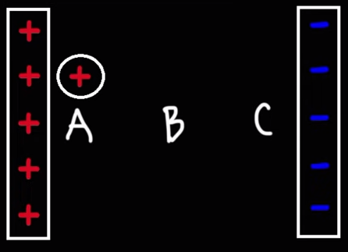

4. (a) How much work is required by an electric field to move a -50 μC charge from an electric potential of -50V to 250V? (b) If the charge accelerates from rest, what is the final speed if it has a mass of 0.01 grams?

5. A 300V battery is connected across two parallel plates that are separated by a distance of 50cm.
(a) What is the magnitude of the electric field? Calculate the electric potential at the following distances from the negatively charged plate: (b) 10cm (c) 15cm (d) 25 cm (e) 35 cm (f) 40 cm. (Assign an electric potential of 0V to the negatively charged plate).

6. 500V is applied across two parallel plates separated by a distance of 4 mm. (a) What is the magnitude of the electric field? (b) What is the magnitude of the electric force that will be exerted on a +200 μC charge? (c) Calculate the acceleration and final speed of a 0.1-gram charge as it moves from rest at the positively charged plate toward the negatively charged plate.

7. (a) What is the speed of a 500 eV electron? (b) What is the speed of a 27 MeV electron?

8. Calculate the electric potential generated by a +93.3 nC charge at a distance of 1m and 8m from the charge. (b) What is the electric potential produced by a -50 μC charge at a distance of 30 cm?

9. Calculate the electric potential at point P using the figure shown below:

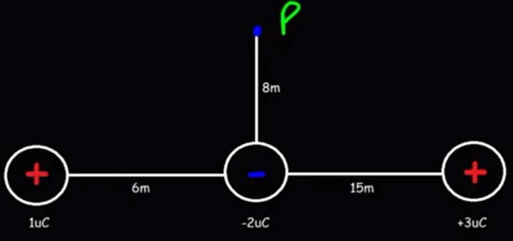

10. A -2 μC charge is 2 meters to the right of a
+1 μC charge. At what point along the x-axis relative to the positive charge will the electric potential be equal to zero?

11. Consider the electric dipole shown below consisting of a +10 μC and -10 μC charge separated by a distance of 0.01 mm. (a) Calculate the dipole moment of the electric dipole. (b) Calculate the potential at points A, B, C, and D.

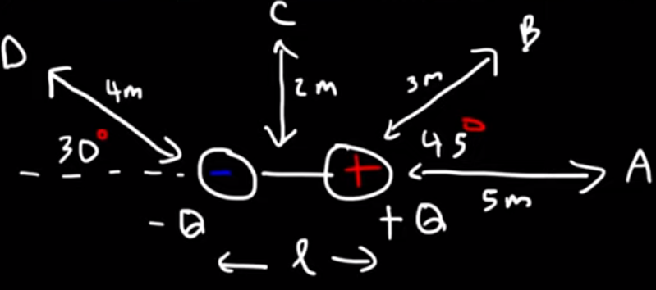

Answers:

1. 0.15 J
2a. -20 V
2b. +30 V
3a. The electric potential energy is decreasing.
3b. The kinetic energy is increasing.
3c. The work done on the charge is positive.
3d. As the positive charge moves to the left, the electric potential energy is increasing, the kinetic energy of the charge is decreasing, and the work done on the charge by the electric field is negative.
4a. 0.015 J
4b. 54.8 m/s
5a. 600 V/m or 600 N/C
5b. 60 V
5c. 90 V
5d. 150 V
5e. 210 V
5f. 240 V
6a. 1.25 x 10⁵ V/m
6b. 25 N
6c. Acceleration = 2.5 x 10⁵ m/s², final speed = 44.7 m/s.
7a. 1.33 x 10⁷ m/s
7b. 3.08 x 10⁹ m/s
8a. 840 V at 1 meter and 105V at 8 meters.
8b. -1.5 x 10⁶ V
9. +238 V
10. 0.67 m to the right of the positive charge.
11a. 1 x 10⁻¹⁰ C*m
11b. V_{A} = +0.036 V, V_{B} = +0.0707 V, V_{C} = 0 V, V_{D} = -0.0487 V.

