LESS AND MORE
COMMISSION STORY
BY CHALDEACHANGE


It had been a whirlwind first week of the new year.

Or at least that was how Yuuka had seen it. From her point of view she had definitely started the year off on the right foot. She had been falling behind on her training and the slightest bit of softness had begun to creep into her physical shape by the end of December (she’d definitely blame all of the holiday treats if pressed on it anyways). So in the end she had decided to sign up for a workout program in one of the facilities all of the schools shared.

She’d even seen Hasumi from Trinity signing up. “I guess she always is… kind of meaty.” Yuuka had remarked to herself quietly at the time, clearly making a remark about Hasumi’s figure – which was incredibly buxom when compared to her own, more petite form. Not that she had any problems with her body beyond the little bit of fat she’d put on from her festive dining.

Days before the workout program had been set to begin, however, there had been an incident. For some reason the laundromat that was shared between all of the schools was right next to one of the development labs, and that lab had exploded. Or, well, one wall had. No one had been injured, but an experimental substance that had been worked on within had been splattered both on the outer walls and the inside of the laundromat as some debris had crashed through the window.

This had damaged and dirtied the machines, and Yuuka’s clothes had been among those that had been there during the incident. There had been a few days of delay in getting them back as a result, but fortunately they arrived on the morning of the first workout program’s meeting. “Everything looks fine…” Going through the bag of clothing she’d received back, nothing seemed to be covered in experimental goop or anything like that. Her clothes all appeared to be accounted for too.

Until she grabbed what should have been her gym clothes.

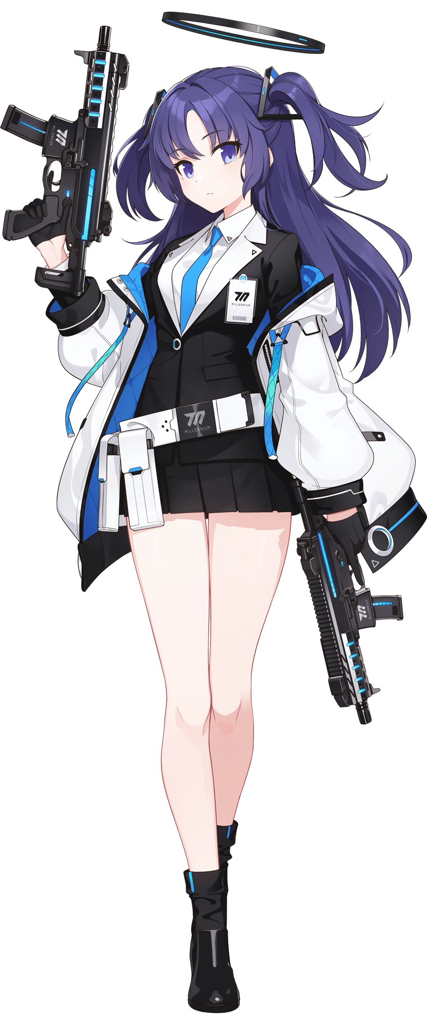
“Uhh…?” Removing them piece by piece, the girl would have been a fool to not recognize that they weren’t hers. Everything from the styles to the colors, and especially the fits of the gym attire she removed weren’t suited for her body. As a point of reference? The sports bra contained within must have been for a woman with boobs that were like ten times the size of her own! “I guess… maybe they got mixed up with someone else’s clothes? Wish they fit though.”

The outfit was folded up neatly and she held it all in her hands. The clothes looked more like Trinity General School’s style, didn’t they? It would have been polite to take them back to their real owner – and perhaps said owner would have hers to exchange. But did she really have the time? The workout program started in an hour! She gripped the clothes with frustration, enough that the material rubbed up against her fingers and an invisible substance that had clung to them rubbed into her skin.

The very same experimental substance that had contaminated the laundromat.

Yuuka had no idea that she had made contact with anything unusual, and in fact was carrying on like she normally did. She’d set them back down on her bed and had reached for her phone to text someone for help. But as she was typing? She noticed that her fingernails were clacking louder against the screen. No, not only that. “EHHHHH!?” Her fingernails had been painted black. Long and black. Her left eye twitched as she stared, her look of disbelief and her decision to drop her phone onto her bed out of shock both being understandable reactions.

Had she noticed that streaks of a similar black had begun to emerge midst her mane of black hair at that very moment? Well, she would have passed out! So it was a good thing that there was a delay spanning a few moments. “What happened to my nails? Are these even up to our uniform code? How do I get the paint off?” The girl’s panic was plain enough to see on her face. One’s nails didn’t just grow and turn black without them knowing!

But on the other hand? One’s hair also didn’t generally dye itself black as hers had. But it wasn’t until some of her bangs dangled so far across her eyes that she finally noticed – because it was all lengthening substantially. “M-My HAIR!?” Yuuka grabbed a handful of it. Between her black nails and now her black hair, which reached so far down that it was almost touching the floor, she almost wondered if she was being restyled into some sort of goth chick! Well… Sort of? Kind of?

Maybe?

The Millenium Science School student sharply tugged on some of this hair. “Ouch!” Well it definitely wasn’t a dream. But she didn’t understand how it could be happening or why for that matter. Had she done something that might have triggered this? She didn’t even really understand what this was though. In the meantime, her resting gaze passively narrowed beyond her notice and her lashes inched ever so slightly longer. This was to disguise a rather shocking change in eye color. From an ocean blue to a searing red. And yet her resting expression somehow seemed a little droopy and calm.

Calm? Did she feel calm? She’d been so surprised at first, but that surprise seemed to be calming… even though things were getting worse in a very dramatic way. Yuuka wasn’t a terribly tall girl and only stood at 5’1”. She didn’t have any insecurity about it. It was tall enough, especially with her sporty figure to consider. That delicate balance was disturbed both suddenly and dramatically.

“H-Huh…!?” The alarm in her voice was very much still there, but it felt a little calmer. Her voice came across as deeper too, perhaps a side effect of what had provoked her to even make a noise in the first place. She felt off-balance and her bed became farther and farther away from her resting gaze. Her short skirt proved to be a hindrance, lifting to expose her pure white panties whereas her button up white shirt came untucked to reveal her bellybutton. Arms reached out of her sleeves and socks felt too tight. All because— “I’m… growing?”

Or she had grown. By the time she’d mustered a (quieter than normal) verbal reaction she had sprung up nine whole inches. At 5’10” she towered well over the height she had once been, but hey, at least her hair wasn’t as close to the floor anymore! Not that she was in the mood to look for any bright sides. But Yuuka also wasn’t freaking out as much as she had been. She seemed much more compose, something helped by a face that was now leaner and, aside from her changed eyes, also now possessed full, puffy lips and a slightly larger nose.

“I need to see a mirror.” She had one in the bathroom that was adjoined with her dorm room, but getting to the bathroom was uncomfortable to say the least. Each step reminded her of just how much her clothes didn’t fit, and that feeling only worsened as her body’s figure was compromised. Specific to her underwear? They had felt tighter at her new height. But now she grappled with hips widening and her ass bloating a touch as she walked, underwear riding up her cheeks and forcing her to pick a wedgie when she walked. “Wait a— Woah!”

The (now) seventeen year old had leaned back to pick her wedgie and had realized, when doing so, that her ass was a little bigger – as were her thighs. And yet she couldn’t really react to that change properly. Her torso was yanked forward and she almost flew face first into her bathroom door. The cause? With the front two buttons of her shirt now on the ground it was fairly clear what had caused this instability. Her breasts had swelled so that either tit was larger than her head nearly instantaneously. Their weight was great, their shapes massive. It was actually their growth, seeing the endless sea of cleavage below her chin, that triggered an epiphany.

But that couldn’t be? How could she be— RIIIIIIIIIP! If any further proof had been needed to confirm her suspicions then there it was. “Wings…? Oh, so I really have been becoming…” On Yuuka’s back, just below her tailbone, two black feathered bird wings had torn through her old clothes. Their wingspan was likely as long as she was tall and their presence made sure that any outfit she put on would have to be done so inconveniently. Well that solved that problem.

And so, the black halo atop her head glowed crimson and developed four points.
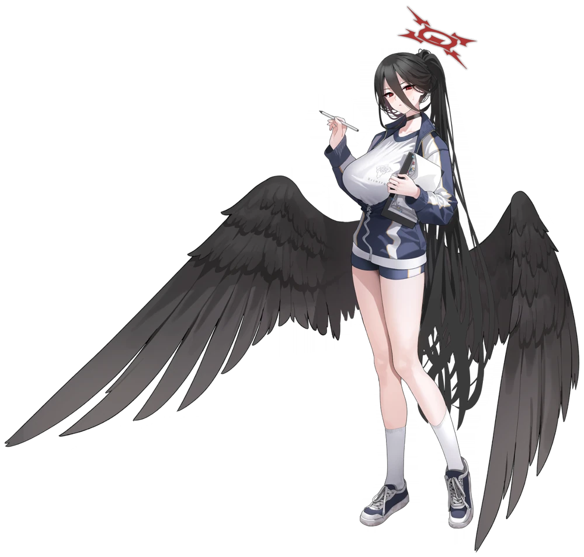
“I… suppose the fit of the clothes is no longer a problem, but…” The young woman had a different set of problems. And while related, they weren’t specifically the gigantic honkers that now covered most of her torso beneath her lifted shirt. Somehow Yuuka had become Hasumi Hanekawa from Trinity General School, huge boobs, thick thighs, and all. Even her physical habits and personality mirrored the winged woman. Defeated, she slid on the gym uniform piece by piece until she was appropriately clad.

The young woman sighed. “What am I supposed to do now? Should I… go to the first class?” She knew that the real Hasumi had signed up too, so then she would probably be there. It might be an awkward conversation to have but she had no other course of action to follow, right? The navy blue shorts, jacket, and white top all fit her bodacious form, but nothing else in her wardrobe would fit this new body of hers. So if she remained this way for an extended period of time…

Well, she didn’t want to think about that. She couldn’t live the rest of her life as Hasumi, right? Even though the physical benefits were, well, they were kind of nice. But she could only imagine those new tits of hers would severely impede her during operations. “…How does she move around with these without getting slapped in the face?” It was a good thought to keep in mind.

Especially since the sports bra didn’t seem to be helping very much!

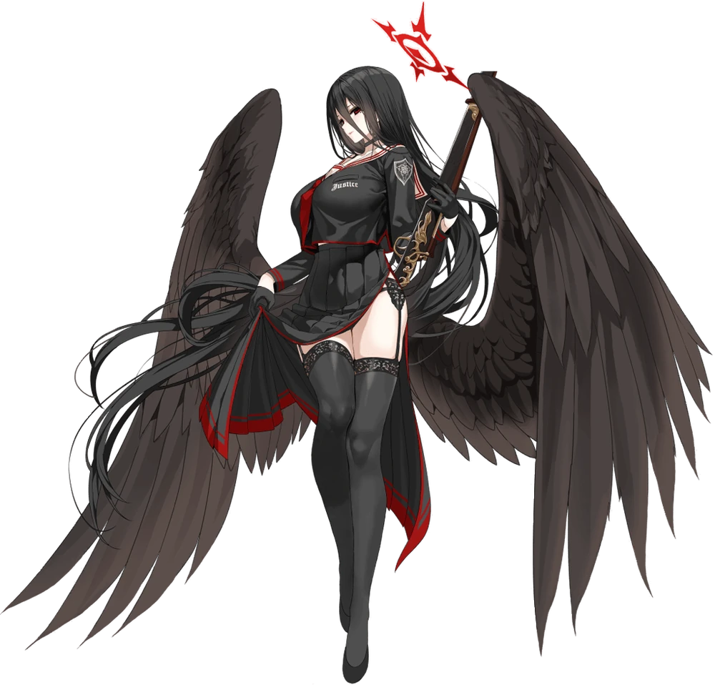
Elsewhere, in the dorms of Trinity General School, well away from the Millenium Science School dorms where Yuuka was dealing with a similar issue, the real Hasumi had just received her own laundry from the unfortunate laundromat. “About time…” Things played out for her in a very similar way, realistically. The gym clothes were buried at the very bottom of the bag, and when she eventually got to them, the dark-haired woman could do little other than raise her brow.

Between the blue shirt, jacket, and bloomers – not to mention the small sports bra and undergarments – there was little chance that any of these clothes would fit her considering her well above average figure. “There aren’t even holes for my wings…” Which, looking over her shoulder, would have been an issue considering how large they were. Setting aside that these were clearly the clothes that the girls of Millenium Science typically wore, there was just no way she could wear them.

But Yuuka’s wish for the clothes to fit across the city had resonated with the substance that was bound to Yuuka’s original gym clothes as well. And some of that had gotten into Hasumi’s skin, ultimately dealing her a similar yet reversed fate.

Unlike Yuuka, who had developed wings at the end of her transformation, Hasumi was tragically struck with the reverse effect. “…Hm?” From her perspective her wings had felt stiff all of a sudden, but it wasn’t until she looked down that she realized just what was truly amiss. “Erm?” Those wings had already halved in size and, given a few more seconds, they had become all but nubs upon her lower back before disappearing entirely. A hand that was now missing its black nails reached behind to pat the slits in her top where they usually came out from. “There’s nothing there?”

Her wings shouldn’t have just disappeared. And she assumed that under normal circumstances it would have hurt to have them removed in the first place. But there had been no discomfort. In fact she felt strangely light. Hasumi didn’t immediately understand why that feeling was far more widespread than just her lower back, but from a visual perspective it was certainly easy to observe. After all, the school uniform top that had been specially fitted to accommodate her gigantic knockers was sagging and continued to sag further, only the wires of her bra pushing that top forward as the tits within diminished into much more reasonable B-cups.

It wasn’t until her red eyes lowered that— “My CHEST!?” It definitely wasn’t in the young woman’s nature to cry out so shrilly and yet she was visibly far more panicked than expected. Especially when she realized the feeling of her undergarment not fitting properly extended to her panties as well. The excess junk in her trunk had become far more compact and those savings had also been shared with her thighs. They were still soft, it was just that they no longer reached the same pinnacles that they once had in all of their glory. Not that Hasumi placed much worth in how buxom she was. That was just the figure she’d grown naturally.

She wasn’t certain how much she liked having it taken away unnaturally though. That said, her loss of figure had proven to be a significant distraction that pulled her attention away from the neck up. A large portion of this was changes to her hair. Not only did its length shorten to just above her smaller ass, but the color had shifted to a rich blue that would have been immediately familiar if she’d seen it paired with the new style in a mirror – what with her bangs now parted the way they were.

In a similar vein her face appeared younger? Perhaps that was a deceiving thing to say since she was becoming a girl that was sixteen, only a year younger than herself. But Hasumi’s face was very mature for her age. On the other hand, her cheeks became a touch rounder and her lips narrowed. When you paired this with eyes that were wider and more expressive that now showed blue irises and you got a more immature, cute impression about that appearance of hers.

“W-Wait a second! My hair—!? MY VOICE!?” And her attitude. The girl sounded shriller and she was absolutely far more expressive now. She was the spitting image of the student of another school that she knew aside from one key difference. She was still standing at 5’10”. Nine entire inches of height needed to be lose before her physical transformation was complete and that came with due time.

Due immediate time. “Hey!” The girl almost yipped like a dog, forced to stabilize her balance against the bed she’d set the gym uniform down on. “I’m getting smaller!?” And so the inches peeled off of her, much of her body soon swallowed by her now very oversized uniform top. Her leggings were tied to her underwear with a garter belt and yet with no leg nor thighs thick enough to support those leggings any longer they peeled down, pulling underwear down to her ankles along with them. Not that it really mattered, because once she bottomed out at 5’1” her shirt covered her pelvis even with her skirt slipping next.

About as free as she could be now, she bolted over to her full length mirror with a speed she’d never used before. This body was so much more limber than the one she knew, even while leaving a trail of her old clothes behind her as she ran. Staring at the mirror she couldn’t exactly deny the truth that she was looking at. She was the spitting image of her.

Even her halo had changed into a metallic, black one.

“…So I’m Yuuka?” Hasumi was a far more reserved person, so it made sense that once transformed, the new Hasumi would have a calmed reaction to her transformation. On the other hand? Yuuka had a fierier temperament and so now that the real Hasumi was Yuuka Hayase, that fiery personality was now her own. Her shrill cry of shock had completely shattered the teen’s usual composure. What clothes weren’t still hanging off of her were spread out in a trail on the floor behind her. “I guess that means I need to put those on, huh?” She both cast her gaze back and began to walk over to the gym clothing on her bed.

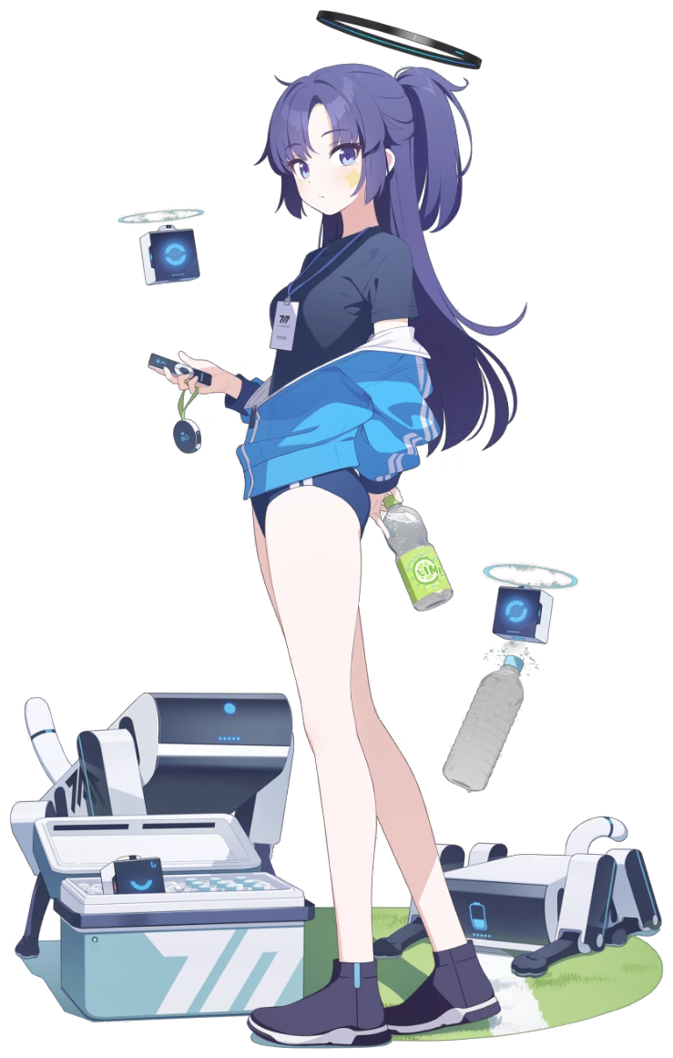
And so the new Yuuka begrudgingly got dressed, a little in awe of how much easier it was to move around in this new body of hers. It made sense. Yuuka’s boobs and ass were so much smaller than Hasumi’s, snugly fitting into the sports bra, blue t-shirt, sky blue sweater, and bloomers. There wasn’t as much weight to swing around, and that meant that every little movement was just that much more comfortable. “I could get used to this. Huh.” But that was probably the wrong attitude to have.

What was she supposed to do about this? Find the real Yuuka, probably. Not that she was aware that the real Yuuka had turned into her and vice versa. It would likely make for a very confusing and alarming first encounter. Come to think of it, hadn’t she seen a movie like this? Freaky Friday or something? “Does any of that help here though? I don’t know how this even happened in the first place!” It seemed like she really would have to skulk out of the Trinity dorms as a girl from the Millennium Science School. She was definitely going to get some looks. Especially if any of her friends saw her.

But not as many looks as she and the new Hasumi would get when they’d eventually find each other outside of the workout program’s meeting room. People would be very, very confused about that encounter.

