DANGANRONPA: SOCIAL EXPERIMENT
CHAPTER 5: RUN AWAY MODEL
BY CHALDEACHANGE
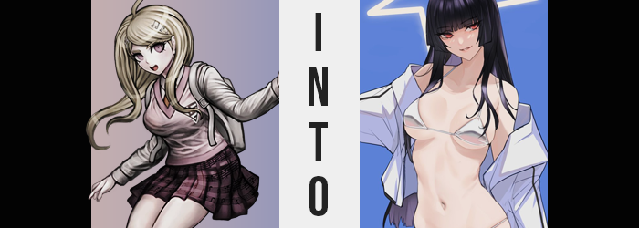

Kaede Akamatsu was certain that she had died back then, and it had been a death that she had deserved. In trying to kill the mastermind of the killing game that they had all been trapped within, she had accidentally taken an innocent life. Because she had been prepared to kill their captor to save everyone else, she had inadvertently kicked off the game in all of its terrifying glory.

She was supposed to be dead, and yet here she was in another game like the killing one. Many of the faces were unfamiliar to her, but there was one. Shuichi Saehara was present, and he had also been present in her killing game. Did that mean he had survived? Or was he like her, a phantom that had no business existing? The pianist couldn’t be sure, but she didn’t get a chance to ask him either.

Because she had run away.

When their introduction meeting had concluded, it was Kaede who had been the first to slip out. She was scared of having to face Shuichi after what she had done, and wasn’t sure how he could possibly forgive her – despite the fact that in reality she had absolutely nothing to worry about. Nonetheless, she was quick to escape into the resort area, and she eventually found herself in a very, very big indoor pool.

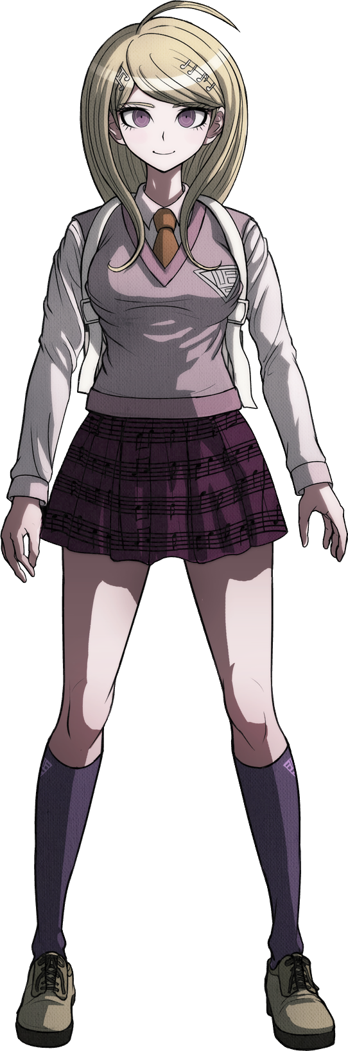
“I guess even with the ocean right there, some people would prefer to swim somewhere safer, huh?” Trying to distract herself from her negative thoughts, she considered the resort that was being used as the setting for this… transformation game, was it? She really didn’t understand what that meant, but it didn’t sound as dangerous as a killing game, right? She didn’t feel as anxious about the game itself, because the punishment didn’t appear to be death.

She traced the edge of the pool by walking alongside it. The water looked inviting, but she had never really been much of a swimmer. Or an athlete, really. Being the piano freak that she was, she hardly spared any time for hobbies that didn’t further this part of her life. “At least this will be the last place Shuichi will look for me… probably.” Kaede knew there was a music wing, so he would probably go looking for her there first.

SPLASH!

“UWAH!?” The young woman’s peaceful walk around the pool was suddenly interrupted by a splash in the water nearby that absolutely drenched her with water, though. It soaked her down to the bone and provoked a little panic in the girl, but when the water stilled from the splash? There was no one in it. Nor did it seem anything had fallen inside. Then what had caused the splash, exactly? Nothing. It was a trap set by the mastermind to claim yet another victim. Because the only victor of this game would be the mastermind themselves.

Her clothes soaking wet, the words she blurted out surprised even Kaede herself. “What the fuck just happened!?” It wasn’t like her to curse, especially not so unnecessarily like that, but she hadn’t been able to keep it down as she attempted to wring some of the water out of her clothing. She had felt so much rage all of a sudden, and while she had initially thought it weird? She ended up leaning into it more and more as time wore on. As if she had simply accepted it as part of her personality.

Nonetheless, more was transpiring here than a simple, if not extreme attitude adjustment. Kaede’s very figure had apparently been compromised, and thanks to how her uniform was sticking to her with how wet it was? It was much easier to see as much versus how little it likely would have been visible were she dry, because her clothes were now clinging to her skin.

It was initially the most notable around her chest. Kaede had a rather sizable bust for a young woman of her age, at least one that was larger than average. But her wet uniform seemed to be tightening around that chest, for the chest itself was shrinking a cup size or two. Little by little those breasts were reduced, while nipples became a little smaller to match. But on the other hand? These breasts were also perkier than before, and they pushed upwards against her clothing without and sort of sagging to speak of.

The obvious contortion of her body was not isolated to her breasts alone, though. Her top ultimately separated from her pleated skirt, showing off her bare tummy because she had promptly sprouted up several inches. This change had knocked her slightly off balance, but the young woman just cursed under her breath and continued to attempt to dry herself off while doing so.

With her tummy exposed as it was, it was easy now to see how it was changing. While her belly had always been a little bit soft, it was now tightening and firming up so that there wasn’t an excess bit of fat anywhere whatsoever. Her bellybutton deepened as a result, while at the sides of her skirt? Kaede’s hips pulled wider, presenting her with a broader gait.

A gait that was quickly made good use of. “Shit!” The woman cursed again, this time almost biting her tongue in how she hissed while doing so. She’d almost taken a spill into the pool because, from her perspective, her legs had suddenly spasmed. The truth was that the widened hips had forced her legs to adjust, all while her thighs thinner so that they were still evidently feminine, but they were just the slightest bit more muscular than they had been before.

The same could be said about her ass, but it had inflated slightly to accommodate for her widened hips. Parted as her cheeks had become, they had initially seemed flatter thanks to that. But they grew plumper with weight given time, helping to stretch out her already uncomfortable panties so that they were flossing between her butt cheeks. While in the front? Those panties had become so tight that her pubes were sticking out from around the sides. Albeit in a black color that was a far cry from Kaede’s natural blonde.

Having given up on wringing out her soaked clothes, the woman began to violently flail about to try and dry herself off in another manner. Her clothes felt heavy and uncomfortable, and she wanted them off. While flailing about, her hair was naturally bouncing her and there – yet in doing so it exhibited a change that was first implied by her pubes. That is to say that the color of her locks was darkening to a raven black.

Not only that, but the length of these locks began to grow at an exponential rate. They slithered almost like snakes, the new lengths dry despite how the rest of her hair was still soaking wet while spilling as far down as her ass behind her. Almost impossibly straight, her bangs were ultimately styled into a hime cut that completely disguised her forehead and put emphasis on her eyes.

Eyes that were once wide and bright-eyed, but were now narrowed and prone to display distaste. Their rounded shapes had not only become more dramatically narrowed, but lashes danced much longer than normal. A crimson color had even manifested in her irises, rounding out a look that was just as menacing as her personality had slowly been becoming.

Of course, it wasn’t her eyes alone that were altered when it came to her face. Overall, those facial features became more shorter and narrower. Her chin was pulled closer to lips that were now more pronounced, but that chin was also sharper. Her nose was petite, and her brows were pencil thin beneath her hair. She looked like an entirely different woman, one who was free of any of the plainness that Kaede’s normally exhibited. She had become a natural beauty through and through, and that gave her a confidence of the likes she had never felt before.

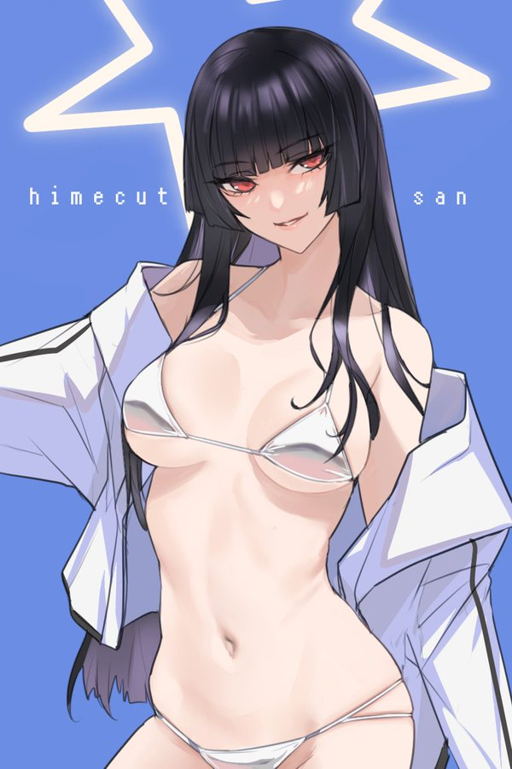
“Ugh, what’s with this tacky school uniform I’m wearing? Not only am I soaked, but it’s been years since I graduated high school.” The black-haired beauty scoffed at her current state of dress, the repulsed look on her face a far cry from any expression Kaede had even made in her life. Gone was her sweet and innocent look, and in its place was a serious and judgmental resting expression.

Kuro Takagami was a college student and a model. She was always dressed in the latest fashions and was popular because of how hot she was. Plenty of people were into her doll-like complexion paired with her mean streak, and that streak wasn’t for show. She was arrogant, smug, and rude – even to her peers and managers. Believing she was top shit, she seldom showed moments of lowering herself to others.

She wasted no time stripping down even though the pool was a public space. Kuro threw the soaked clothing on the floor around her. Well, everything except her underwear… which wasn’t even underwear anymore but a white bikini with small cups that hardly covered much of her breasts at all. Swimsuit modeling was her bread and butter, after all, and she was always pushing the envelope of what was or wasn’t appropriate.

“That’s better. Now I look as fucking hot as I should.” Flipping her raven hair over her shoulder, she rested hands on the bones of her hips and looked around triumphantly. She looked hot, but where were her adoring fans? Where was the cameras? “Some photoshoot trip this is. What’s the point without anyone to fawn over me?”

