DARK TV WORLD
BIWEEKLY STORY #86
BY CHALDEACHANGE
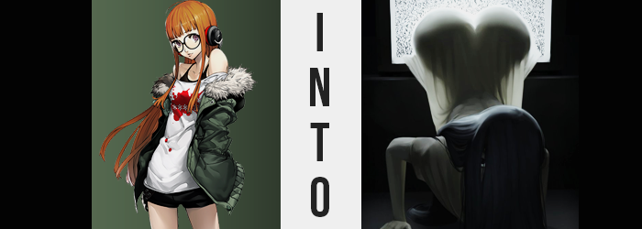

If there was something that Futaba Sakura had come to enjoy lately, it was exploring old, American movies. Subtitled, of course! Maybe it was a strange thing to be fascinated by, but it had all come about due to an online trend on the Japanese side of the internet after some influencers had done a deep dive into Western media – and specifically the bastardization of some tales that were inspired or directly taken from Japanese movies.

These movies spanned all genres from action to kaiju to horror, and it was the lattermost example that inspired the strangest rip-offs. It seemed that the American media had loved to take popular Japanese horror ideas in the 2000s and localize them, which had led to some truly intriguing takes that weren’t bad so much as they were unnecessary. The Grudge was one of the most infamous of these properties, but there was another that was probably just as, if not more so.

The Ring.

A popular Japanese horror movie based on a Japanese novel that had been just as popular. A movie about a video tape that, once seen, triggers an awful chain of events that guarantees any viewers will die in seven days at the hands of a vengeful spirit named Sadako. Hollywood wanted to make this their own, and so the American spin-off with the vengeful spirit, Samara, had been born.


“And I’ve finally got a copy of the VHS!” Futaba had been forced to scour the internet in search of a copy, and eventually just bought one from an American on eBay for a price that was likely a little exuberant. But watching movies from that era was best experienced on the original VHS copies. Perhaps she was more of a cinephile than she had believed herself to be at first? Regardless, it had finally come! And after flicking off all of the lights – and her computer to boot – she popped it into the VHS player beneath the CRT television huddled in the corner of her room.

And yes, she had purchased that TV just to watch VHSs on it!

It was still the middle of the day, but the teen’s room was pretty dark nonetheless thanks to the special curtains she had purchased for the single window her bedroom had. Popcorn? She’d make some partway into the movie, but for now she’d just lay on her bed and watch mindlessly for a bit. Or, at least, that had been the plan. After pressing play and beginning to navigate back to her bed, however?

“Huh?” There was a strange feeling. Suction? It felt like it was pulling her back towards the TV, which wasn’t even playing the movie. It was just a bunch of static! “Don’t tell me this thing is a dud!?” It was. Kind of. But it was more like the girl had purchased a cursed VHS. Just not in the exact same sense that the VHS in the movie was.

Putting aside the pulling sensation briefly, the hacker simply glared at the static on the TV. She was going to have to return it, huh? But it was such a pain in the ass to return stuff online! Her complaints were so mundane, and yet she didn’t immediately take notice of the something exceptional that had begun when it came to her own body. Well, it didn’t really take her that long to notice. Her body felt kind of cold? Which had forced her to look downward. And upon doing so? She could see something very—

“WHAT THE HELL!?” The cry the girl made was certainly not a subdued one, and since she was home alone it would ultimately fall upon deaf ears. She had been shocked because a trail had formed between the staticky television screen and herself – a trail of color, of all things. She blinked several times, unable to believe her eyes, but she couldn’t deny what she was looking at. All of the color was being sapped not only from her outfit, but from her own flesh and hair. “Th-This is impossible!?”

Since she was home she wasn’t wearing her jacket, but the red from her shirt was yanked away until her shirt was entirely white, while the blacks were pulled from her tank top, shorts, and thigh highs so that they were a bleached white as well. If that color was isolated to her clothing alone, then maybe it wouldn’t have been that bad. But her body temperature was reaching an ice cold, and by the time it reached this point?

Her skin had become just as white as her clothes, the girl shivering from the lack of heat being produced by her body. “Wh-Wh-Why am I so cold, too!?” Arms wrapped around her chest, huddling for warmth, you could even make out the girl’s veins. Her heart was still beating technically, but there was something very off about its rhythm, and it wasn’t pumping warm blood like it should.

So how was she alive?

Was she alive?

Whether or not she was, the television had yet to finish with its monochromization of the teen. The orange dye from her hair was pulled out next, leaving her hair even blacker than it was meant to be naturally. And there was also the matter of the mauve in her eyes, once more turning to a black. One that seemingly saw her irises roll unnaturally upwards “Aa… Whaaat is haaaapening to me?”

Her body felt stiffer and stiffer, and through chattering lips she ultimately found her words coming out with a distorted cry that hung off of her As. Was she scared? Most certainly, but there was also something else deep down. Something that was forcing an acceptance of what was happening, regardless of how impossible of bizarre it had all been.

With her gaze fixated on the static-producing television, she just couldn’t seem to pull her attention away from it. There was something almost soothing about the light it radiated, even if it had just stolen all of the color – and all of the good health – from her body. The longer she stared, it was almost like her thoughts became simpler. Not like she was becoming more childish, but more like she was becoming more instinctual?

Her glasses dropped from her eyes and fell onto the floor, revealing that she no longer required them to see clearly. Distracted by the static as she was, she also didn’t notice how her outfit thinned and merged together into a loose, white dress with short sleeves and material so thin that you could make out the silhouette of her naked body with the TV light shining through it.

“This aaaaaa…” With her voice little more than a croak, it deepened dramatically while the next steps unfolded. Her dress, evidently much too big for her body and soiled by strange patches of dirt and stains, revealed the following transformation splendidly. Because the young maiden’s body? It began to expand in every facet imaginable as her perceived age blossomed up into her late twenties.

The fact that her age was changing was easily perceived in her face. While it looked quite fatigued now, with extremely dark patches beneath eyes that somehow looked even more Japanese than ever, the pale skin of it all rearranged itself so that it all had a more mature look. This was exemplified in lips that swelled to succulent heights, and yet their blueish tint and cracked aesthetic spoke to the seemingly lifeless aesthetic her body was giving off overall.

Not that it mattered how her face appeared, because her dark black hair had started growing exponentially. As it fell, it gained a frayed and messy quality that added to her over unkempt visage. Split ends, oily strands – all the more apparent as it fell past her ass and even over her face. In the end she could only see the TV through parted strands across her right eye, and that eye looked even more disturbing in its hidden state. Her tongue, blue and slightly longer than normal, licked at her lips before another croak creaked out.

Futaba’s posture had already begun to look strange, what with her limbs stiff as they were. Yet the next change? It immediately forced her down unnaturally onto all fours without even so much of a whimper from the victim. The mass of her bosom had suddenly begun to expand, and despite how cold they were, the sensitivity of each tit and nipple was for some reason amplified tenfold. She was already shuddering from the cold, but now she was also shuddering from arousal as her nipples rubbed up against her gown as tits grew. Before long they were not only G-cups, but their mass kept her body pinned down while nipples rubbed up against the floor.

“Aaaaaroused…” There was an unsettling clicking sound to her distorted voice now as this word was croaked out. She felt horny, which was weird considering all of the other sensations she was feeling simultaneously. Sickly fingertips with chewed nails dug into her rug as the sensation grew, her cold pussy twitching while the bush of black above it grew wilder. While Futaba had not perceived it, she had even grown several inches in height over the past few moments.

Though, with her rear end in the air, the final reconfiguration was quite blatantly noted through her dress. The cheeks of Futaba’s rump began to swell gratuitously, blue veins even more apparent against them as the dress molded and wedged itself between the raised cheeks. They jiggled as they blossomed, each half of her ass as big as her head – and this naturally widened her hips as well, not to mention filling her thighs with the same excellence when it came to this cold, yet tender meat. If she were to crawl across the floor eerily for some reason, that rump would most certainly bounce enticingly.

“Aaaaa?” Try as she might to speak in a human tongue, the only sound that escaped Futaba’s lips was a demonic groaning that was just as eerie as her appearance overall. Lowered down on all fours, her limbs bent unnaturally and the long, black hair that covered her eyes seemed worn and frayed. Yet while she resembled Sadako from the original movie, the light from the TV filtering through her impossibly thin, white dress revealed the inconsistencies that made this unlikely.

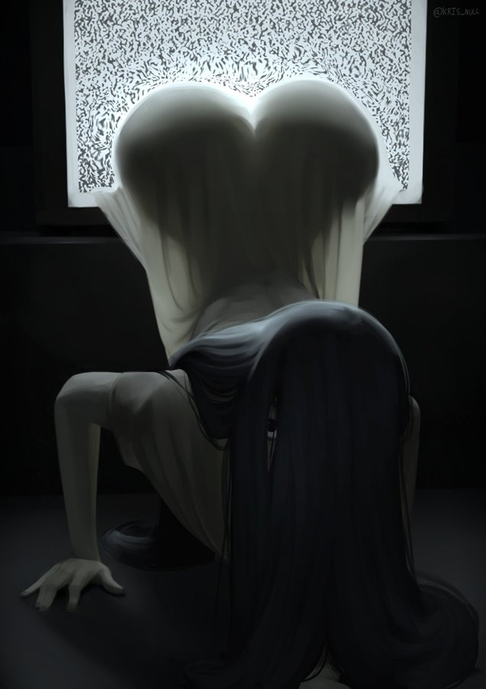
Her figure was much too pronounced. With hips wide and childbearing, and an ass that was raised into the air with a plumpness that could be considered divine. Even her tits were bombastic, their porcelain white, undead skin pulled taut around these fun bags. So while she resembled a vengeful spirit? That wasn’t quite what she was.

What was this that Futaba felt? A hunger? No, not quite. It was more like a need. A burning from within. A blue tongue licked at her thickened lips beneath her hair as her body began to crawl uncomfortably back towards the television. “AAAA…” More unholy sounds escaped from her lips, and what was left of her mind slowly became washed away by this strange instinct. A desire. To be pleasured, of all things. She wanted to mate. To fuck. To mount anything she could find. It was a desire much more powerful than memories of her old identity.

So rather than a vengeful spirit, she had become a lustful spirit. Would she stop her hunt once she found a suitable target? No, she would just drain them of their essence and move onto the next after corrupting them into a lustful spirit like her. But for her to find such a target, someone first had to watch her tape. A tape that would depict her emerging from a decrepit bed, where she would then crawl out of the TV and fuck their brains out. Such was her curse. Her purpose.

And to those ends, she crawled into the TV to wait for such a day.

Hopefully Ann didn’t run the tape when she was supposed to come over later that day.

