HIP HIP HOORAY!
COMMISSION STORY
BY CHALDEACHANGE
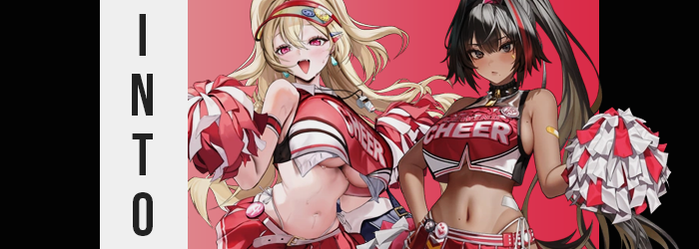

“That’s right! It’s time for the Nekomata Olympics! Everyone’s favorite magical sporting event! …Even though it’s the first time it’s ever been hosted!”

Speakers blared throughout a large but vacant arena in a location that otherwise resembled Feudal Japan. While most would assume that this place existed in the familiar would that we all lived in at a glance, however? This wasn’t actually the case. It was a pocket dimension crafted by a real oddity, a supernatural existence born not in any traditional sense, but through superstitions and a pen. Hisa the Nekomata was such a powerful being that creating a realm like this was child’s play.

Which was fitting enough, seeing as she often took the form of a child.

Her red hair bounced about within a broadcasting booth in the arena as she saw to it that her preparations were complete, not in the form of a child in this particular case for a change. Hisa appeared to have chosen the form of a twenty year old woman, even though her reddish pink cat ears, and the two matching tails behind her made it clear that she wasn’t a human woman.

“Mm… I still need competitors and an audience. Those are easy enough to fashion. But as I’ll be competing, I suppose I’ll also need some fans of my own. No, not just fans… I’ll need some support on the field for the events, too?” There was a specific role when it came to sporting events that could do just that. But as for the candidates… “Well, I suppose I was going to use them in some way in the end. This might be more fun than having them compete!”

“I don’t like the looks of this.” This was all the commentary that Joseph could muster initially at the sight of changed surroundings. He was fairly certain he had just stepped into his own bathroom, right? But the moment he passed through that doorway he had ended up in a completely different place altogether. It almost looked like a changing room you might find in a modern college, but not for his sex. “This is a women’s changing room, right? Why— How did I end up here?”

He had a hunch. Joseph wasn’t unaware of Hisa’s shenanigans one bit, even if she flippantly erased his memories of her now and again. This had her name all over it, and the fact that she didn’t outright erase those memories meant that she didn’t see it as necessary to be entertaining. “She must like be up to something.” At first the man didn’t catch it, but after it hit his ear wrong, he gave it pause. “…Like?”

Awareness didn’t matter if the personality changed quickly, in the end.

“Is she already doing something silly to me!? Ah!? My voice!” As he had coughed up that sentence, the pitch of his voice had gradually risen higher and higher almost as if he’d been inhaling helium as he spoke. But that wasn’t the case, even though he reached a hand up to gently rub at his throat – without even noticing that this hand was rubbing against a smoother surface devoid of its Adam’s Apple. “Ow!?” And things only worsened once something sharp began to dug into his skin. It forces Joseph to pull his hand away to examine his fingertips.

“Oh…” The realization he had after the fact was twofold. The first? Well, what had been digging into his neck had been his own fingernails. They were several inches longer than he knew them to be and were painted a hot pink. The fingers they were affixed to also seemed to be a little smaller, and while he almost wondered if it had been a trick of his imagination, it almost seemed like he could see his palms thinning a little bit. “But why my skin tooooooo~!?”

The man pouted in a way that felt similar to how a teenaged girl might, and that was only enhanced as they promptly swelled into bloated, kissable pillows upon his face that were sooner painted with pink gloss. Why was he reacted in such a silly, girlish way? Well, the personality changes were being enacted quickly to bury his ability to fight back. He was far more interested in how the skin around his fingers had been lightening from olive to white – and how that trend was spreading throughout all of his body’s flesh.

Aside from his nipples, anyways. Those turned pink instead, but also began to appear a tad puffy and swollen. He could feel them rubbing up against his shirt, and that prompted him to look down to— “AH!?” His cry was immediate. How could it not be? A pair of A-cup breasts had pushed forward beneath his shirt! …Oddly at the expense of roughly an inch off of his waist line. “I have titties!? I knew it! I’m being turned into a girl by… by…?”

Why couldn’t she remember who she was thinking of?

“AHN!?” To be fair, Joseph had mentioned a changing of her sex aloud. It just so happened that doing so had ultimately willed it into existence. But the combination of her dick shrinking and sliding back into her body along with the feeling of moist, sensitive lips curving up into what inevitably became a womb did far more harm than that. She’d moaned from an overwhelming amount of arousal. An arousal that had caused her brain to blank out. “Whoa…” By the time she had pulled herself together? She couldn’t remember Hisa at all, and her old life felt more and more like a dream.

That said, the transformation she was experiencing still had plenty of work to do. Her dark hair showed plenty of signs of this, with a platinum blonde dyeing its way throughout the entirety of her hair (including a well-trimmed bush of pubes above her new pussy). Any hair atop her head that was dyed then lengthened with the vengeance, cascading out behind her in a long, silky mass that reached her thighs and framed her face. Even her eyebrows, although also thinner, took on this same color.

“I feel like I’m totally forgetting something important…” It felt like it was on the tip of her tongue, but she wasn’t able to make the final push she needed to get there. The last light of her old self was close to being extinguished, and there was visual proof of that in how her eyes had begun to glow pink and swell until they took up a little more of her face. They were more feminine – as much of a leaner face became – and lashes were both long and enhanced with mascara. “Ouch!” Joseph’s ears even ended up pierced!

It was becoming clearer and clearer that ‘Joseph’ was hardly a name that fit her any longer, however. She didn’t look at all like the person she had been, and as her height began to dip down towards 5’5”? It became even more obvious. It was almost like the height that she lost was being funneled into her figure. There was just simply more of her the farther away she became from her original, roughly six foot height.

Not that anywhere unpleasant was… amplified. For a woman, that weight she gained could only be seen as positive. Her thighs thickened for one, pant legs in turn tightening around them until they were at risk of forming tears. But there was also the matter of her ass. Her cheeks bubbled out behind her, boxers inevitably munched on my both her cheeks and her pussy as ass cleavage lipped over the waistline. And yet, in the end? Both of these changes paled in comparison to the heft upon her chest.

The sensitive A-cups that she had grown previously ballooned forth, and that was even an overexaggerating. Her shirt was hoisted up until her entire, now-toned tummy was bare and even then could only just barely hide the J-cups that stretched their fabric. They were impossibly large, drawing the question of how the human body could properly sustain them. But that was just it…

Internally her body wasn’t human anymore. It was the body of a robotic NIKKE.

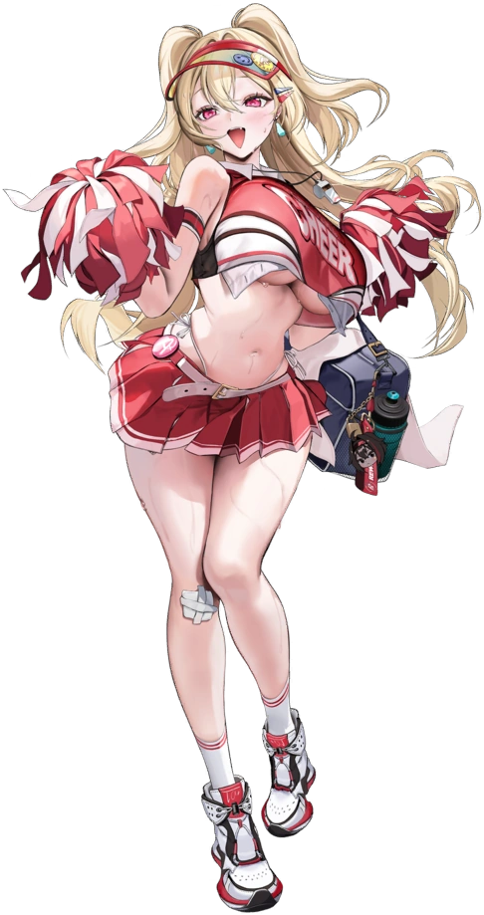
The discomfort her changes conveyed through her clothing were ultimately brief as cloth was dyed and shifted. The woman’s torso was still largely bare so that her midriff and underboob were exposed, but by a pink and white cheerleader top that matched a pleated skirt (above which you could see the straps of a thong clinging onto her hips) and running shoes. A vison appeared around hair that now had been styled into two high pigtails, while green earring filled the new holes on the sides of her head.

“Whoa! I’m gonna be late for practice if I don’t head out quick!” As Clay understood things now, she had an obligation to meet with the rest of the members of Rewind Squad for their cheerleading practice. The big breasted blonde’s chest heaved up and down with each of her breaths, and they bounced as she took several steps towards the door. “I bet Bay is already, like, out there!” Clay could be a little clumsy at times (a fact that wasn’t helped by her ridiculously sexy abundance), but she was a hard worker that had earned her place in the squad.

When she opened the door to the changing room to head out to the field, however? She hadn’t expected a much smaller girl to run into her. “H-Huh!? Poli? Is something the matter!?” The silver-haired girl that was dressed in a similar cheerleading outfit had been in such a rush, it wasn’t really like her.

“Claaaaay! I made a mistaaaaake! I wasn’t supposed to change too! And we weren’t supposed to be sent into the game too!”

“…Eh?”

What was she talking about?

What had begun as a normal day from my perspective had quickly been led astray as my own location had been altered without my consent. It was the sort of thing that would have been entirely outlandish to any other person out there, but to me? Well, Hisa was my creation – even though she preferred to call herself my ‘daughter’. And since I was one of her favorite victims it was pretty frequent that I ended up playing a victim to her plans.

“Something feels off about this though. She’s usually a little more hands on…” Maybe it was nothing in the end, but to suddenly be dropped in the middle of what seemed to be a track field without any context or even a bit of mocking didn’t realistically suit her usual methods. “She’d be a bad Coach, leaving me out here without any real direction.” …Coach? Since when did I have a coach?

And why, pray tell, did I sound so intense all of a sudden?

“…Craaaap.” She’d already gotten me. “So I’m becoming someone who needs a coach? Something sports related? That’s new… Like a track girl, or maybe rugby?” I had tossed out a few potential ideas, but none of them were really on the mark whatsoever. I was at least right that I was becoming a woman… because Hisa was far too gay for her own good. “And— Oh!?” My voice squeaked in tandem with a very powerful sucking feeling.

Well, that was the best way I could describe it in the moment, but it wasn’t really the right term. It simply felt that was because my excess body waste was fading away, almost like it was being ‘sucked’. But there was no way to know where it was going, not the body hair of mine that was shaved away in the process so that everything beneath my chin was entirely hairless. But the same couldn’t be said about above my chin.

My short, dark hair darkened until it was basically black and, from that point on, seemed to flourish in length as if to make up for the lack of hair that I possessed now otherwise. Bangs swung down so that I could see him, some even raised into curtains of sorts while the hair in the back grew silkier and thigh lengthened. “Oh, my hair… And my voice!?” That chirp from before hadn’t been a mere accident seemingly, as it was now clearly much higher while I ran a hand through raven locks.

Raven locks that somehow felt… familiar. “My memories are already…?” Changing in a way that was forcing me to accept what was happening. My brows furrowed as I came to terms with this reality, but those brows were both thinner and hoisted above a pair of eyes that were now a dark silvery color. They appeared more and more effeminate in shapes and makeup application, but realistically? You could say the same about my entire face as my nose shrunk, lips engorged, and cheeks thinned. Before long I was a proper beauty. The kind people would stare at… in the face…

And that made me a little anxious.

That anxiety was quick to consume me. “Why does being stared at make me feel so freaked out?” Was it part of the whatchamacallit from the whoseamathingy? Wait, what words had I wanted to use there!? I threw my hands up in a panic and something that should have caught my attention hadn’t. Namely that my fingers were slender, my nails were long, and bright red paint had been spread across them. But there was also the matter of my skin tone. It was usually so pale, but melanin had been building and slowly darkening it into a rather notable tan. As if part of my skin change? Several beauty marks appeared on the side of my belly button, inner thigh, the left side of my chest, and underneath my left lip.

“Whoa! Hey! Getting smaller does not…? Huh? Smaller? Isn’t this my usual height though?” I had been onto something for a moment, but in the end my drop down to 5’4” from a height comparable to Joseph’s own went handwaved. Just as handwaved as the fact that my body thickened much like his had in the places that you would have expected. I was destined to become a sexy woman – no, a sexy NIKKE – just like Clay.

But maybe sexy in a different way. I didn’t gain a figure that was quite as bombastic as the blonde’s, but it wasn’t really something to scoff at either. Case in point? My tanned thighs bloated so suddenly and to such a thickness that tears formed in my pants, while a swelling of my ass into a pleasant peach shape contributed to wedging my hips farther away from each other and tightening my boxers so that they practically crushed my dick (more on that later).

Simultaneously? My chest grew from absolutely nothing to a pair of G-cups in just a few short moments of gradual growth. Each second that ticked saw more weight pumped into them, which forced the mounds to bloat into orbs, then melons, and so forth with a hearty bounce each time. It all lifted my shirt and pushed me to look down, but… “What’s up with these clothes, anyways? I shouldn’t wear stuff like this to practice.”

I looked up blinked a single time and was immediately possessed with a curiosity about my outfit. Did something just change? Of course I couldn’t actually tell, but it had changed. Gone were my oversized men’s attire, replaced by a cheerleader outfit that matched Clay’s with some minor differences. I wore black leggings for one, though it came up to my thigh on the right and only my knee on the left… and they had holes in them. I simultaneously had a choker around my neck, my hair had been pulled into a ponytail, and a single streak of red had been dyed into my leftmost bangs.

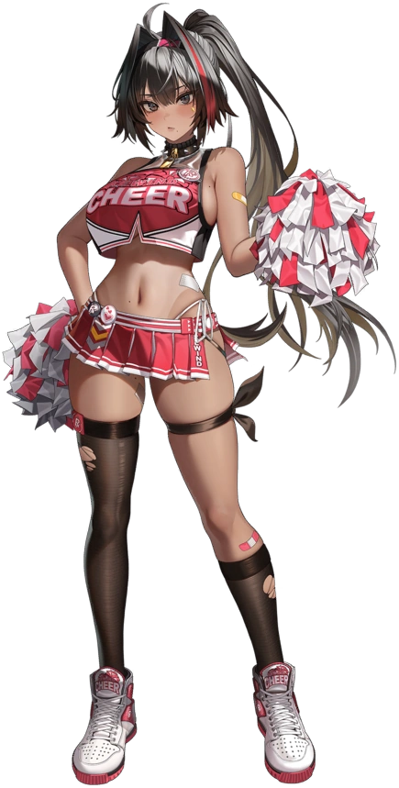
There was also a thong visible clinging to my hips from underneath the hot pink skirt, which was relevant to the only part of my body that had yet to change. Needless to say? A man’s dick did not fit into a thong, even though it was a little more comfortable than having boxers grinding into it because my ass was too big. “AHN!” I immediately blushed as I, too, let out a load moan thanks to my changing sex – still completely hairless even after becoming a pussy.

Somehow this moan helped me understand why I was so on edge all of a sudden. “My scopophobia? Why is that acting up right now? There isn’t even anyone here to look at me right now!” That phobia caused problems when it came to looking at others directly in the eye, and after suddenly moaning how could I ever do that? It was a terrible phobia for a cheerleader to have, right? But as the captain of Rewind cheerleading squad, Bay, I always worked past it! It was my dream to spread joy with my spirited cheers all across the Ark!

Obviously, my previous name, Axel, no longer held any meaning to me. I couldn’t remember a single thing about those days, my memories replaced entirely by those of the tanned, well-endowed NIKKE that was looking around as if I was looking for something. And I was. “Wait. Where are Bay and Poli, come to think of it? They’re late for practice…” Since I was the captain, I was naturally responsible for their actions.

Well, Poli wasn’t exactly part of Rewind. It was more like she was… filling in.

“OIIIIII! BAAAAAAAY!” The sound of a familiar voice in the distance caused me to spin around to see a familiar sight. The voice’s source was Clay, running while pulling Poli along behind her. Because the stride of her run was so big, her tits were bouncing excessively from the motion. Not like I could complain about that, though. I wasn’t lacking in that department either and since we were cheerleaders, well… It definitely served as an advantage of sorts. “Poli’s been saying some really weird stuff! Like she wasn’t supposed to ‘change’, but she’s filling in today, right? She’s supposed to be dressed that way!”

I spared a glance down to the smaller woman once the two of them had caught up. “Yeah, you volunteered to help us out, right? Are you getting cold feet, Poli?” I knelt down and held out a hand for her to take encouragingly. She seemed to shy away from it for whatever reason, however. Something must have really shaken her up! Something that I couldn’t really comprehend.

“No! I’m not supposed to be Poli! And you’re not supposed to be in NIKKE!”

“In NIKKE? But we are NIKKE? Seriously Poli, is this some kind of prank!?” Clay laughed it off and gave her a little hug. Neither of us could recognize that she was actually Hisa because we had no memories of her. From our point of view, Poli was just acting a little peculiar. “Do you need your personal data checked? I wonder if it’s a virus…” The suggestion prompted a shake of the silver-haired maiden’s head then. So, what else could I do in a position like this? As leader, I suppose I could…

“Let’s just start practice, how about that!? I’m sure once you get your body moving whatever’s bothering you will clear right up!” And in the end? This had worked. But none of us realized that Poli forgetting what had been bothering her meant we’d be trapped in these new lives forever.

But that didn’t really matter, did it?

