679

1. Documents 101 – Basics of 18 USC §§ 793(e) and (f)

-high-level conversation with Kel McClanahan and we didn’t go back over the basics because a bunch of people wrote in to say “I thought you made a big deal about commingling, with the Trump documents being next to his passport?” And that’s true, but it’s true because of the only fact that matters.

**Trump still doesn’t want to give them back**.

So, let’s be clear.

18 USC § 793(f) applies to Trump

<https://www.law.cornell.edu/uscode/text/18/793>

**Whoever, being entrusted with or having lawful possession or control of any document**, writing, code book, signal book, sketch, photograph, photographic negative, blueprint, plan, map, model, instrument, appliance, note, or information, **relating to the national defense**, (1) through gross negligence permits the same to be removed from its proper place of custody or delivered to anyone in violation of his trust, or to be lost, stolen, abstracted, or destroyed, or (2) **having knowledge that the same has been illegally removed from its proper place of custody or delivered to anyone in violation of its trust, or lost, or stolen, abstracted, or destroyed, and fails to make prompt report of such loss, theft, abstraction, or destruction to his superior officer—**

**Shall be fined under this title or imprisoned not more than ten years, or both**.

That first clause -- § 793(e) applies when you *don’t* have authorized possession; that could be Biden if it was after Jan. 20th. So it’s either (e) or (f). But under both you have the same elements and you have to prove all three:

-(1) you have documents relating to the national defense

-(2) you know that they’ve been taken from where they belong

-**(3) you don’t return them**

Both have that same element.

So let’s check in with Biden.

1. Yes – unequivocally, he had documents related to the national defense
2. Unsure if he knew they’d been taken from where they belong – the degree of commingling *does* suggest this
3. uh

-so yes, commingling relates to proving that the documents are not where they’re supposed to be; element (2). But so long as Biden doesn’t secretly have other documents that he’s refused to turn over, you can’t prove (3).

-Trump still defending what he did

<https://www.wonkette.com/trump-just-took-those-docs-as-umm-cool-keepsakes-we-re-cool-right>

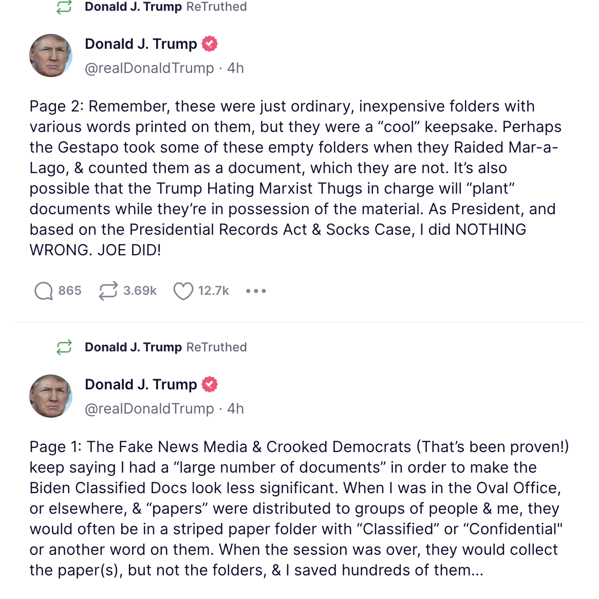

The “socks” case. Holy shit did I need help with this. I searched Westlaw for “Socks” the way he spelled it, no luck. Then I thought, okay, maybe it was S-O-X. No dice.

I’ll spare you guessing, the case is *Judicial Watch v. NARA*, a 2012 Amy Berman Jackson decision.

<https://storage.courtlistener.com/recap/gov.uscourts.dcd.144698/gov.uscourts.dcd.144698.13.0.pdf>

So, bottom line for Uncle Frank

**Joe gave them back**

**Trump STILL defends stiffing NARA, then a subpoena, and then a search warrant**

1. Updates
2. LOL Grape Job, Norm

<https://appellateinquiry.jud.ct.gov/DocumentDisplayer.aspx?AppId=2&DocId=bbS6%2f%2b2VrEG2olwWTxxyyg%3d%3d>

1. Liz Was Wrong: Pattis Sanctions stayed

<https://civilinquiry.jud.ct.gov/DocumentInquiry/DocumentInquiry.aspx?DocumentNo=24306145>

Norm’s application

<https://appellateinquiry.jud.ct.gov/DocumentDisplayer.aspx?AppId=2&DocId=FFFgOmup5xAsvRQUIgli%2bg%3d%3d>

Appellate order

<https://appellateinquiry.jud.ct.gov/DocumentDisplayer.aspx?AppId=2&DocId=FFFgOmup5xAsvRQUIgli%2bg%3d%3d>

1. Reynal Sanctioned twice in Texas

<https://openargs.com/wp-content/uploads/TX-Sanctions-Reynal.pdf>

680

1. SCOTUS

Bombshell story in the NYT

<https://www.nytimes.com/2022/11/19/us/supreme-court-leak-abortion-roe-wade.html?smid=tw-nytimes&smtyp=cur>

so what a crazy random happenstance

<https://www.supremecourt.gov/publicinfo/press/Dobbs_Public_Report_January_19_2023.pdf>

HOLY SHIT YOU LYING PIECE OF SHIT

<https://www.politico.com/news/2022/10/26/justice-alito-abortion-decision-disclosure-00063491>

1. More lightning round
2. But zero times in CT

<https://civilinquiry.jud.ct.gov/DocumentInquiry/DocumentInquiry.aspx?DocumentNo=24306145>

1. Dersh remains a lying liar who lies

<https://s3.documentcloud.org/documents/23574073/1-ca-cv-22-0388-az-republican-party.pdf>

681

1. Fireball!

<https://appellateinquiry.jud.ct.gov/DocumentDisplayer.aspx?AppId=2&DocId=bbS6%2f%2b2VrEG2olwWTxxyyg%3d%3d>

1. Rules Package Greatest Hits

HR5

<https://www.congress.gov/bill/118th-congress/house-resolution/5/text>

Analysis

<https://docs.house.gov/billsthisweek/20230109/118-Rules-of-the-House-of-Representatives-SxS-V2.pdf>

681 ALT

RFK LOLsuit

<https://storage.courtlistener.com/recap/gov.uscourts.txnd.371829/gov.uscourts.txnd.371829.1.0.pdf>

Liz backgrounder

<https://www.wonkette.com/antivaxx-loons-rfk-jr-jim-hoft-other-idiots-sue-news-outlets-for-booting-them-off-twitter>

His lawyers

<https://jwhowardattorneys.com/>

*AP v. US* (1945)

<https://scholar.google.com/scholar_case?case=12116214944985887583>