GAMING NIGHT
OCTOBER 2022 BIG STORY
BY CHALDEACHANGE
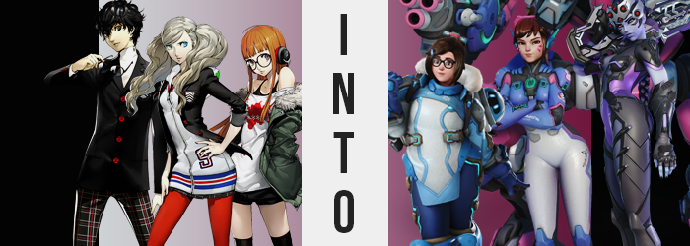

“Eugh… I just know this is going to be rough.”

“Don’t be like that, Futaba-chan! It’ll be fiiiine!”

“…Yeah, let’s see.”

Three very different voices with three very different levels of enthusiasm spoke over the voice channel of the Discord server the Phantom Thieves had been using as of late. Ever since Joker had managed to save up enough to buy a decent computer it had become fairly standard for them to have a PC gaming night at least once per week. The games they played varied and ranged from cooperative play to multiplayer online games. It was all usually just for a spot of fun, nothing to stress about.

But this week? Ann had suggested something terrifying. A spot of competitive Overwatch 2, and without a full team at that. Maybe this didn’t sound all that imposing, but it really was. Overwatch was a team-based game where success could only be found in collaborating properly with your teammates, and in competitive it mattered more than anywhere else. The fact that they only had three out of the five players needed meant that they’d be relying on randoms to fill in the blanks.

…Which meant they were pretty much screwed.

And their very first game essentially reinforced that. Before you got ranked in the game you first had to do placement matches, which meant you were tossed about like a salad through games of various rankings or something. No one really knew how it worked, the whole system was just one big enigma. A frustrating one, as their game demonstrated. They were getting absolutely curbstomped.
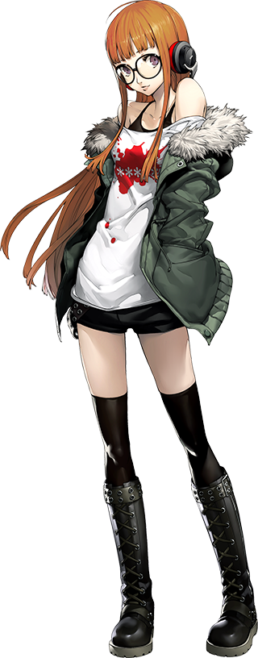
“Maybe we should wait for Ryuji to get off work after all?” Futaba, in her room by herself, was the first to suggest a solution. Their friend was going to play with them later, yet he had a shift first. In her mind it would have been easier to simply wait. “Or maybe if my stupid co-DPS would SWITCH TO A SNIPER LIKE WIDOWMAKER!” Because the other team had a talented sniper, and aside from a dive DPS the only other counterplay was another sniper.

A key mechanic in the game was the ability to freely switch characters during the game to better match up against the enemy’s strategy, and while their Reaper, with the name ‘BetterThnU’ was getting kills, he wasn’t exactly helping with the enemy backline as well as he should have been. The issue was that Futaba had broadcasted that comment over the team chat, so he definitely heard it. And he typed in the text chat ‘Why don’t YOU become Widowmaker?’!

“Hah!? Me!?” She immediately barked back, not noticing that she was no longer able to broadcast her voice to her friends. “I’m doing just fine as Soldier, thank you very… Huh?” That was a little weird. Why did she feel so tingly all of a sudden? But for what it was worth, she only felt that way for a moment before the feeling went away… along with most feelings.

Futaba was much too angry at the other player in her lobby to even notice as she tried to get her computer to select off of the character the select screen had forced her to hover over, Widowmaker, for her to initially notice that something was actually very wrong when it came to her ability to feel, the rate at which her heart was beating… and the color of her skin.

All of these things correlated with one another, technically, and as her skin changed so too did her anger begin to find calm. But the teen wasn’t exactly looking at her skin in the first place to see that something was awry. To see that not only her fingertips had turned blue, but that the change in color had begun to seep into her fingers, palms, and had been progressing up her body from her feet as well. It didn’t take long before her entire body was this sort of unhealthy blue that would have normally been indicative of the onset of death… if not for the fact that something was still keeping her alive.

“I guess… emotions won’t make me play better.” The girl wasn’t rationalizing her gameplay in order to calm herself, but rather the stillness on her emotional palette was resulting in this sudden change of attitude. “How else am I going to kill all of ze targets?” Had she just used a very overdramatic French accent for a moment there? If she had, Futaba hadn’t noticed it.

All the while, it wasn’t her skin alone that was undergoing a change in color. Her orange locks, dyed of course, seemed to darken as that dye was washed away. But underneath wasn’t exactly the plain black that should have been there, and rather a dark tinged with purple that was slightly brighter near her scalp than the length that fell to her bum while she remained seated at her desk chair.

Not even her eyes were spared, for the lighter purple that was so typical of her irises lit up with gold. But this was hardly the only change to the girl’s gaze. The shapes of those eyes narrowed, but her eyelids opened up in size so that you could see more of those eyes, giving them a more European look rather than Japanese.

This supposed change in Futaba’s racial background quickly spread to the rest of her face, which lengthened overall. With cheeks raised and thinner, in turn it highlighted the fact that her purple lips swelled to something much more gratuitous, not to mention the new, sharp hook upon her nose. Rather than simply leave her with a more European aesthetic, though? It looked like the face of a woman in her thirties plastered onto the body of a teenager.

Although that wasn’t the case for long.

“Huh? Wait a minute, what is wrong with zis? Am I growing taller? Even my voice sounds wrong?” And it came in a way that was difficult for the victim to now ignore. All at once her body had begun to rise in her desk chair, knees shooting up as legs gained length while her head easily surpassed the recommended height for staring at a computer monitor. Of course, the fact that her voice was deeper and born an unmistakably thick, French accent was just as much of an issue.

The girl attempted to sit up part of the way into her sudden growth burst, only to find herself getting stuck on the side of the chair. Calm due to the changes that had afflicted her previously, she could only stare down with utter confusion as it became clear what the issue was. Her hips and ass had gotten stuck between the arm rests because they were abundantly larger than they had ever been.

Her shorts could hardly contain them as is, and yet it all grew larger still before her very eyes. Were her hips widening because of the swell of her ass, or were they widening, and her ass was growing after them? It was hard to differentiate, but either way her hips had well surpassed her shoulders in width and her butt’s bloat had risen her sitting position several inches. The thickness of her thighs did not help things as the grew to match her ass, and in the end her shorts were not only unbuttoned by on the verge of exploding off of her.

“Get… free!” It took all of her strength for the woman to finally unwedge her ass from the chair, but in doing so she did tear her shorts and underwear off to expose an adult pussy with a bush of dark hair just above it. The curvature of her blue ass was left on full display, while farther north? Well, while her breasts grew beneath a top that had been hoisted to show off her whole bellybutton, the C-cups they inherited were nowhere near as excessive as how ridiculous her lower half had become. “Could it be? Am I truly…?”

She didn’t want to believe what she had become. That this body was hers, that this lack of emotion was hers, and that this newfound disregard for human life was hers, and yet…

“It seems zat I have become Widowmaker.” Her French accent think, the tall and blue-skinned woman glared down at the computer she had been using and the chair she had just barely managed to squeeze her engorged ass out of. While memories of Futaba remained, everything about the character she had become from personality, to mannerisms, to appearance were now her own alongside additional memories. Her emotional reaction to the transformation she had been subjected to had been diluted by Widowmaker’s own emotional dysfunction.

But she had no clothes that fit.

It was hard to feel very strongly about it when she didn’t feel much about anything at all. Such was the nature of the murderous Talon operative that she had now become. Yet she couldn’t help but spit out some surprise when her computer screen began to glow. “What!?” For the light glowed so strongly that it consumed her entire bedroom, and when it eventually faded?

The woman was gone.

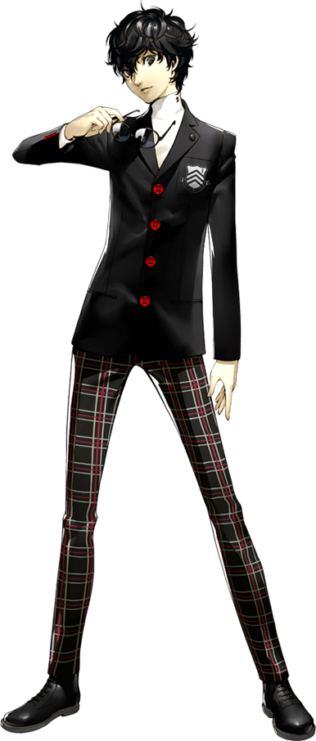
“That could have gone better.” Joker slouched in the chair he had set up along with his computer in his attic bedroom at Leblanc. The first placement match he’d had with Ann and Futaba had not gone well, and there had been some air of mystery in the middle of it, too. Futaba had gotten into an argument with one of their teammates and shortly after had went radio silent. She was still in their party and had even picked her character, but she hadn’t said anything since.

“Is Futaba-chan really that mad?”

Ann did have a point. Futaba was not immune to gamer rage. She was probably sparing them her words, seeing as that player was still in their group. She had even chosen Widowmaker again after switching last match before strangely afking for a minute or so. Her gameplay had improved a lot after that minute, though. Hopefully she wasn’t hacking.

The next game didn’t start any better than the last, though. Joker and Ann were both playing healers, and Futaba seemed to be playing better than ever. But that Reaper again… This time, not even he could avoid saying something to him. “Why don’t you pick a different DPS? You’re not getting the kills we need, really…” Once again, though, BetterThnU had a smarmy reply. ‘If it’s a big deal you play DPS then!’

“Dude, that imposs… Huh?” You couldn’t switch from healer to DPS mid-game, everyone knew this. Yet the game had taken him back to the character select screen? And BetterThnU was playing a healer? Maybe he was the hacker here! …But why couldn’t Joker select a character? It was just stuck over Mei’s portrait. “Why can’t I change to a different character?” Even if he had been forced to be DPS, why Mei?

He raised an eye at the game’s menu, but it wasn’t exclusively for this reason. Why was he having such a hard time reading the character names? They were in Japanese, because of course they were, but it was almost like… he wasn’t as fluent as he had been? No, that had to be impossible. Although it did serve as a competent enough distraction.

For what? Well, a sudden dip in the boy’s height could have been observed had he been paying attention. It was just a few inches down to 5’3”, but it changed the angle at which he viewed his computer monitor while likewise leaving his school uniform just a touch looser around the arms, torso, and legs than it had been before.

He pushed up his glasses all of a sudden. “And what’s wrong with my eyes?” Truthfully the lenses on his glasses were fake and he’d never really needed a prescription, yet now everything was all blurry. It didn’t matter if he was wearing them or not. Yet this actually spoke to a change that had been affecting his eyes. While their colors didn’t change much aside from becoming just a touch browner, in terms of their shapes they swelled just a touch while his eyelids became a touch more angular. He was left still looking Asian, but he rather than Japanese he appeared Chinese.

Which was the same language that was swirling around in his head along with an enhanced understanding of English as well.

“嗯？Something’s really wrong here!” While usually so calm, Joker’s sudden surprise was called out with much more energy than was normally typical for him. He felt all tingly and he couldn’t piece together why, and wasn’t his point of view a little lower? There was also the matter of how he had to keep blowing his bangs out of his eyes, for his hair had not only grown to his shoulders but had also lightened so that it was a light brown instead of black.

Despite having shrunk slightly though, the boy’s body had begun to grow in different areas. His chest, for example? It was a touch puffier at first, but before long that puffiness exploded into a full pair of D-cup breasts that popped the top two buttons off his uniform jacket and forced both hands to grab what had emerged. “I have breasts!?”

He clammed his mouth shut no sooner than he had cried this out though, for even his voice sounded wrong? It was too high, and much too like a woman’s. But then again, considering the very sensitive orbs he had fastened to his chest now…

The state of his face had moved towards a much more feminine persuasion as well, but not before first swelling so that it was rounder and fuller. One might even describe the look of his face as ‘chubby’, yet it sported a feminine beauty as well. Chinese eyes took a turn for the girlish by design, while his lips swelled up and nose pushed inward to a button shape. But rather than look just like a Chinese woman, he looked more like one in her thirties… at least physically.

“No way! This cannot be real, can it? It’s a little… exciting?” He hardly wanted to believe what he was saying, but he also couldn’t really help it. This earnest desire to learn more about what was happening to him was undeniable, and it brought shrunken hands with longer nails down to his thighs after he stood up. The reason for this was that he could feel them bloating, and they quickly became so thick that the legs of his pants tightened around them and even began to tear as soft, fatty tissue pushed through the new holes.

He couldn’t even hide the “Wow!” that came in a gasp as the back of his pants suffered a similar fate thanks to his ass blowing up, but this curiosity did not even wane in the face of a more dramatic shift. “And I’m a woman down there as now, too? How interesting!” Gone were her cock and balls, and instead a woman’s pussy had developed beneath pants and boxers that were cameltoeing the hell out of it with how tight they had become.

Other than this, the remaining changes were made exclusively to the woman’s build. Being a woman in her thirties as she now was, her skin couldn’t be as tight and healthy as it was in her teens. And so she became just a touch softer on the whole, with arms and her torso bloating a touch. She even developed a tummy bump that, while not excessive, still held an appeal of its own. It just pushed the base of her jacket out a bit.

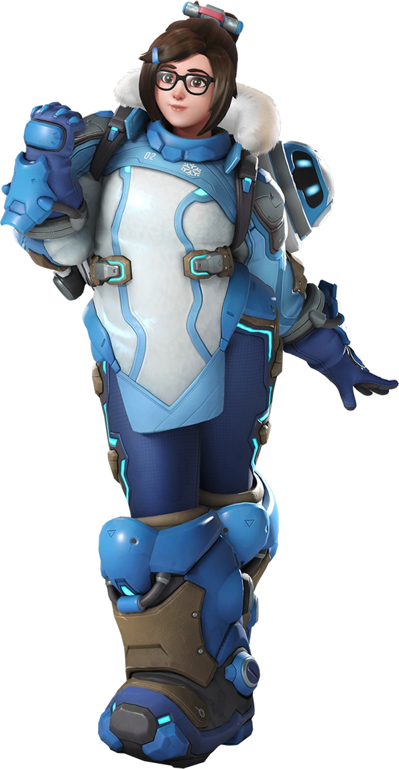
“Whoa! This is fascinating! I can’t believe I’m actually Mei!” Deep down the middle-aged Chinese woman knew that she shouldn’t have been excited about the situation she was now in. She wasn’t actually Mei, but she kind of was at the same time? Pushing up her glasses, she couldn’t help but mentally take note of how different everything felt. She was older, shorter, a little fuller figured… but not in a bad way! Well, maybe in a bad way in a ‘what the heck was she supposed to wear?’ sense.

It was Mei’s natural enthusiasm, now her own, which kept her so peppy. Hard to take issue with her situation when it was so fascinating, right? “But what about the game? Wait… Could this be what happened to Futaba? Is she Widowmaker?” The woman had plenty of questions, but unfortunately was not allotted the time to seek answers before her screen began to glow brightly. So brightly that it completely enveloped the attic and once it faded?

The room was empty.

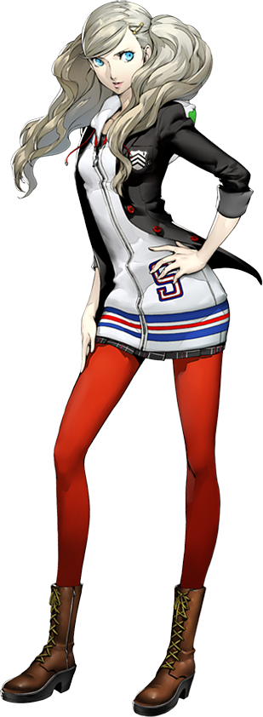
“Switch off tank! You’re terrible at this!” By the time the third placement game came around, Ann was extremely frustrated. She was fairly certain this BetterThnU guy was hacking because he had changed roles in the middle of the game. But he had also seemingly made Futaba and Joker so upset that they hadn’t been talking to her in chat! Of course, she was missing the key context regarding where they had actually gone. In fact they were literally in the game now, forced to act out the roles of the characters they had become.

…At the behest of the player she was now scolding.

But he really did suck at playing tank. Two minutes in and they hadn’t managed to make a solid push at all! The only silver lining was that Futaba and Joker seemed to be playing better than ever. Had those two been practicing Widowmaker and Mei? Since when!? Again though, that player had a smarmy response. ‘OK! If you can do better, play tank then!’

“Pfft, if I… could…?” Wait, she had been kicked back to the player select screen? On the tank role? “How the hell did you do that!? Hacker!” She hardly noticed that her character select was hovering over D.Va, though. What was she supposed to do here, report him? Her friends were still playing, and they needed a tank. But on the cusp of just sighing and picking the hero anyways? A strange and tingling warmth stopped her from clicking, and instead she withdrew herself from her computer entirely.

“I’m out! Something weird is going on here!” There was some bad mojo going on here, so much so that she was wondering if she should call Joker and Futaba on their phones to make sure they were okay. Of course, the almost playful way that she had started that comment hadn’t quite escaped her notice, but Ann had no reason to worry about anything that weird going on just yet. Even though there would soon be signs of it.

Although, to be fair? When it came to her build there wouldn’t be anything as dramatic as to what had happened with her friends in the first place. No adjustments were made to Ann’s height at all because she was already the perfect height. And when it came to her breasts? It was a similar situation. If anything her zip-up hoodie and the bra she wore underneath were only a touch tighter from the meager amount of expansion that her bosom received.

And yet as her age began to reflect an age that placed her in her twenties rather than her teens, the one area where her physique did receive a dramatic change began to become much more obvious thanks to the bright red tights that the Japanese teen wore. Because they were struggling to contain her thighs, which were very blatantly swelling in size.

Not that there was anything wrong with Ann’s thighs as they were, but she didn’t exactly have a lot of thickness to her despite being very beautiful and conventionally attractive for a girl of her age. Yet the weight that saw her thighs expand bore a mature appeal that came with reaching proper adulthood, their overall width practically doubling so that the cloth of the tight eventually ripped and slipped.

Yet while they were yanked down by the swell of her thighs, they soon got caught on the burgeoning weight of her ass. “H-Hey!? What’s going on with my tights? Uh… My thighs? My ass!? 안 돼!” Hands traced the shape of a rump that now pushed out the back of her skirt, its size practically having tripled while her panties found themselves embedded uncomfortably between her ass cheeks. She’d hardly noticed how she had blurted out her surprise in Korean.

Then again, there was a notable reason as to what that language had left her lips in the end. Sparing a glance at her already aged face made it more or less obvious. Her rounded Japanese eyes had pinched inward so that their shapes were more akin to almonds (albeit without compromising her femininity as lashes lengthened in kind). But their colors shifted from bright blue to a brown around the same time.

Having been half-Japanese and half-American, the changes that plagued her facial structure in the end were made even more obvious. Her chin rounded and her nose shrunk, yet plumper lips demonstrated a seemingly permanent smirk that could not be erased no matter how hard she tried. “I don’t know what’s up, but I feel like I could hard carry right now!” That smirk, evidently, came with a growing arrogance in her overall personality. Thinking of the game she had been playing, she could stop thinking about how she’d totally pwn all those n00bs!

“What’s up with my voice though? I sound like some sorta celeb!” Well, more like a gaming celebrity. She was speaking a lot more casually than normal, and gamer-specific terms kept popping up in her sentences and thoughts. Pink marking soon spread across her cheeks, looking like painted-on whiskers to elicit the impression of some sort of rabbit.

Ann more or less understood what was happening to her now, and she wasn’t really upset about it? She felt empowered, actually. But it still wasn’t quite complete… up until a dark brown color washed through her blonde hair, both shortening and straightening it so it barely reached past her shoulders. With that it was complete.

“Are you for real!? I’m totally D.Va right now!?” From the bubbly, gamer personality to the skin tight pilot bodysuit, she was utterly and completely in the shoes of South Korean pro-gamer and MEKA pilot, Hana Song aka D.Va. The girl herself could hardly believe it, hands exploring her body with a great deal of glee. D.Va had always been Ann’s favorite character, so to pair that with Hana’s own personality… “Now that’s a GGs if I’ve ever seen one!”

Well, she was already getting way too into it.

“But wait, what about the game!? I’m not gonna lose! Kick up the BPM!” She quickly scooted back into her chair once she was satisfied, perky bum slightly lifted while she leaned forward. Unfortunately for her she didn’t get to participate from a gamer’s point of view. Because the screen soon glowed and the pilot disappeared, leaving her computer unmanned… but the game populated with a player in her place, nonetheless. It had simply become a little more real.

