ISEKAI CROSS 4
BIWEEKLY STORY #58
BY CHALDEACHANGE
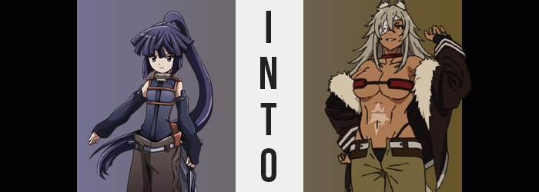

Things had been extremely quiet in Akiba as of late, not that Akatsuki was complaining about that. After the Catastrophe hit and all of the players of the world Elder Tale had been drawn into the game world itself, it felt like one thing after the next had gone wrong. That there was always some issue to be solved, or some battle to be fought.

The world of Elder Tale was a replication of the real world, at least in terms of map. The game world was a fantasy one regardless, and many of its systems had been enacted in this new reality. It had all made for an exceedingly difficult introductory period, when everyone who had been brought into the world didn’t have the foggiest idea what was happening. So it was certainly nice to have some peace.

Akatsuki, the assassin affiliated with Log Horizon, had been living that day to its fullest. A shopping trip with some of the other girls had decorated her morning, and in the afternoon, she had done some training exercises with other guilds associated with Akiba’s Round Table.

In the evening, though? She had opted to do some solo questing on the outskirts of the city. With the barrier removed after the Akiba Raid incident, sometimes monsters slipped in and needed to be repelled. This had resulted in the creation of a number of new quests, some of which brought about unique rewards.

“Hm… The Sword King’s Eyepatch? ‘An accessory worn by one of the few women talented enough to earn the title of Sword King’…” She read the flavor text of the white, leather accessory aloud to herself, wondering if it would be fine to equip since its stats were high and it was compatible with her current class. Flavor text had been coming to life within this world recently, so it was important not to equip anything that could cause harm. This didn’t sound like one of those things.

So, out of curiosity, Akatsuki strapped it over her right eye. “As I thought, the parameters are good, but it doesn’t matter if my vision is impaired this much.” Deeming it a waste, she instead decided to unequip it and bring it back to the guild for someone else to wear. The issue? It wouldn’t unequip… even if she attempted to remove it with her own two hands. “What the-!?”

Again and again, Akatsuki tried to grip and pull the accessory free, but each attempt led to the same issue. Her fingers couldn’t hook beneath it, neither the patch proper nor the strap that bound it to her head. “Is there something about this eyepatch that’s slippery? That’s unusual if so…” It certainly was a strange phenomenon, but not one that she was planning on getting anxious about just yet. Surely someone back in Akiba would know a means to remove it, and she didn’t feel like it was doing much more than merely being stuck to her.

Of course, feeling and seeing were two completely different things, and the flavor text of the eyepatch did have some unusual properties laced within it. Those that would see the wearer becoming the Sword King it mentioned, without fail. The beginning of these effects could be perceived, plain as day, in Akatsuki’s exposed eye. A menacing crimson swirled among its usual purple, irreparable tainting its color and leaving the young woman’s resting expression far sterner than intended.

“I suppose I should go ask my lord what he thinks I should do.” The change going unnoticed, Akatsuki began to run back to Akiba at high speed, the wind pulling her hair so that it trailed out of her eyes. But this? It only worked in the favor of the eyepatch’s influence.

Starting at the base of Akatsuki’s long ponytail, a sandy brown color had begun to tease the purplish blue it sported normally. It looked to affect only the tips of a few strands at first, but before long the entire base of the tail had been affected. Inch by inch, it crept up the ponytail’s length. But miraculously? It appeared to be more than a simple color change. Hair that was neatly combed grew unkempt once the color was altered, fanning out wildly in all directions and, exploding every which way against her back once the brown reached her hair tie and it was strangely deleted.

Wild by style, but fluffy and voluminous to the touch, it fanned out even more once it seeped into the top of her head. The noodle-like appearance of Akatsuki’s bangs came undone, fanning out like the red of her hair, and the almost traditional ninja-like appeal her entire head of hair sported had seemingly come to an end. Rather, it was a mane that better matched a beast dancing out behind her.

Even Akatsuki’s movements as she ran through the trees towards Akiba was becoming more instinctual and less polished, occasionally bringing herself down to all fours to leap from a branch before correcting her posture to something more human during the next one. Though, this animal-like behavior came with supporting traits, and one was wriggling free of her pants.

Small at first, a tail done up in brown fur matching the color of the hair atop her head wiggled free, escaping like a rope until it was several feet long and swishing from side to side behind her. The first indication that Akatsuki was becoming something more than human. The second? As she continued to run, her ears slid gradually up to the top of her head, taking triangular shapes as brown fur spread across them. All in all, they appeared quite feline, almost like a tiger’s. Her movements had become similar as well.

“Hm? Did I always run like this? I’m moving so fast, it must be true, right?” Akatsuki spared a moment of confusion for her movements, as she’d regressed to solely jumping from tree to tree on hands and feet alike. It felt far freer and more natural, and she loved the way the wind moved through her hair… this bliss had to be natural, right?

According to her complexion? It wasn’t.

Speckles of a natural tan had begun to appear amidst her porcelain skin. They seemed like freckles, showing up in patches on her face, bare shoulders, and hands. But they grew and grew, connecting with one another seamless both wherever they were visible as well as beneath her clothes. Within a matter of moments it was clear that they weren’t freckles nor scars but were uniting as a brand new skin tone for the woman, a mocha tan that contrasted well with her lighter colored hair.

And then? Akatsuki began to grow. It was subtle, almost intentionally so that she wouldn’t take notice more than necessary. Her spine and limbs elongated bit by bit, yet strangely enough the fit of her tiny outfit was never tested. Rather, it stretched to adjust to her growing height even as she rose up to an astounding 5’8”. Considering Akatsuki had always been extremely short for her size, this was nothing short of awe-inspiring. Though the woman herself? Caught up in her run on all fours, she’d hardly taken notice though.

Rather, running felt better than ever. While she was jumping from tree to tree before, now she was skipping over every other tree. She honestly felt stronger than she ever had, and it was reflected in her muscles. Sleeves and pantlegs, adjusted to fit her new height, tightened as her tanned limbs swelled with muscles.

But something else swelled, and it finally knocked the woman off balance. She fell to the ground but caught herself in a roll before standing upright once more. “What!?” Her voice came out as a deep growl, at least when compared to her usual one that matched her smaller physique. Now that said physique was larger now however, perhaps it made sense?

As she stood, Akatsuki grew more complexed. Was her point of view typically so high? What had kicked her off balance? No… She could recall the answer to the latter question, and her hands moved to grab the cheeks of her ass. They were far fuller, their definition certainly not lost beneath the once baggy pants, and she could feel them growing fuller still. Not just with fat, but with a firm muscle more in line with what now decorated her limbs.

Their growing size parted her hips, which in turn narrowed a waistline sporting a tummy rippling with strength. It couldn’t be made out with her top still fitting correctly, but the skin around her bellybutton lightened once more, quality rough to the touch. Fanning out to various points, it resembled a scar and certainly wasn’t a return to her usual skin tone.

“Is something wrong with my ass?” Of course, Akatsuki wasn’t bothered by that. Rather, she was confused about why she was gripping her buns. She felt like she’d begun squeezing them for some reason in particular, but the reasoning had more or less slipped away. Even as her thighs bulged to match the fit of her pantlegs, she was more or less confused and, ultimately, brought her hands back to her widened hips. “Huh. Felt like I was doin’ something important.” The woman’s verbiage, for better or for worse, had become much gruffer.

Rather, looking around, she felt even more lost. In the literal sense. This place both looked familiar and didn’t at the exact same time. Her arms ended up crossed beneath her chest just in time for her bosom to bloom with the same gusto that her ass had. Her chest was already rippling, new muscles dense and defined, but her pectorals still carried her lackluster bosom atop them.

At least until that bosom began to jiggle. Her tiny breasts began to bounce all on their own, and slowly but surely new weight found itself pushing the skin that contained them both larger and wider. They pushed against the fabric of her top as they swelled into the C-cup realm, but as was the constant that top stretched to accommodate them readily, though they never became accommodating enough that they weren’t still incredibly tight. Rather, the front of her ninja top unzipped itself and the top band of red snapped free so that her ample cleavage could find exposure.

They continued to grow even after the fact, more and more of her tanned flesh on display while her ensemble brought about even more exposure. Her belly was left on full display, for example, top hoisted above her bellybutton even with the clothing stretching to fix. Rather, it seemed the spirit of the attire was being retained while the new tastes of the changing woman were reflected upon them. By the time her F-cups had come into full form, much of them were on display from the top and the bottom, an upside down V cut out from below.
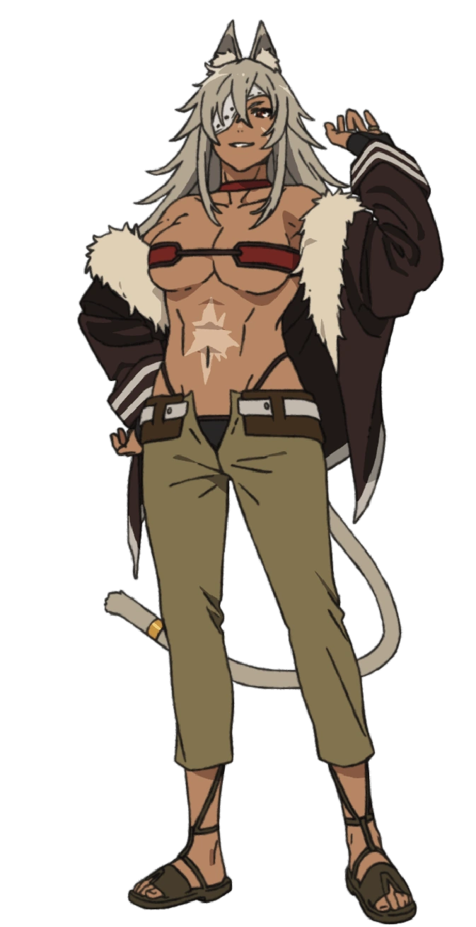
Even her pants were subjected to stylistic changes, becoming tight shorts that showed off most of her rippling legs. A cut intended to intimidate with the sight of her raw strength alone, but the waistline of their design likewise showed off a little of her ass’ cleavage. All in all, it certainly wasn’t something Akatsuki would ever be caught dead wearing.

Then again, she didn’t look like Akatsuki at all. What of her mental state?

The scowl on her face made good use of features that had been altered, such as large, glossy lips and a weathered complexion. Her one visible eye showed agitation, but this was more or less its resting state now. In real time, a scar ended up manifesting itself beneath her left eye, almost matching the big one upon her now exposed belly.

“What world is this? For what reason was I brought here?” Strong and proud, the Sword King Ghislaine Dedoldia, swordswoman of the beast race, looked around at her surroundings as if she had just arrived. Her memories felt inconsistent – for one, was she meant to be this tall? Something in the back of her mind suggested she had once been much, much shorter. Surely this was only a memory of her childhood? No adult woman possessed a height so lacking, and certainly not one sharing the title she held.

Her surroundings were so incredibly unfamiliar, with ruined buildings of unfamiliar design littered amongst vines and trees. Even the scents here were unfamiliar. This was not the world she belonged in. Ghislaine did not and would not panic though. She was extremely talented and incredibly experienced. She would take this situation in stride, just as she took every situation.

The ears atop her head twitched in response to a sound nearby, and a sharp sniff of her nose caught the scent of the cause. A monster of some sort, clearly seeing the beast woman as some sort of prey. “Hmm, are you foolish? Can you not sense just how strong I am?” Trying to speak with monsters like this was pointless, but she could not help but mock it as she took a readied stance.

“Even without a weapon, I’ll pound you into the dirt!”

She’d figure out her situation after the fact.

