Title: Transported

Chapter 1: Intro
Page 1

The comic opens with a regular looking guy in his mid to late 20s walking past a park late at night. You see suburbia approaching on the side Rico is walking towards and a city on the side he's walking away from. The city is slightly futuristic to imply a near future but it's still mostly quiet with a few lights on and neon accents lit up to display that this is a small city that shuts down when the workers go home for the night.

Rico is walking down the park path fiddling with his phone. He looks completely disinterested or bored despite the near future fanciness of his phone, so the audience knows that the technology is normal for the time but he still has the "stare at your phone to pass time" mindset of an unfulfilled person with a boring job. Rico wears simple clothing (slacks, sneakers, regular shirt under a hoodie) so his job probably isn't too fancy but everything is nice and clean, so he's likely a middle class worker with an office job or low level business dealings. As he flicks at the phone, one star in the sky flashes a slight blue and is larger and brighter than the rest.

Rico is still staring at his phone, but he's now confused/annoyed squinting at the bright glare on the holographic screen (text and images has a slight sense of depth and exist above the screen). He's unaware that a bright blue light from the sky is aimed at him and this is what's causing the glare. The background behind him is washed out with the far background slightly more visible so we know the beam is aimed specifically at him.

Rico is being ungracefully sucked into the air, rotating slightly so his legs are coming up and causing him to spin splayed out. Everything loose, like his hair, shoelaces, or hood, is pointing upwards or flapping around like he's caught in a vacuum. Despite this, his phone is seen dropping down to the ground and nothing loose on the ground is being sucked up either. Rico is looking around in bewilderment but nobody else is around him.

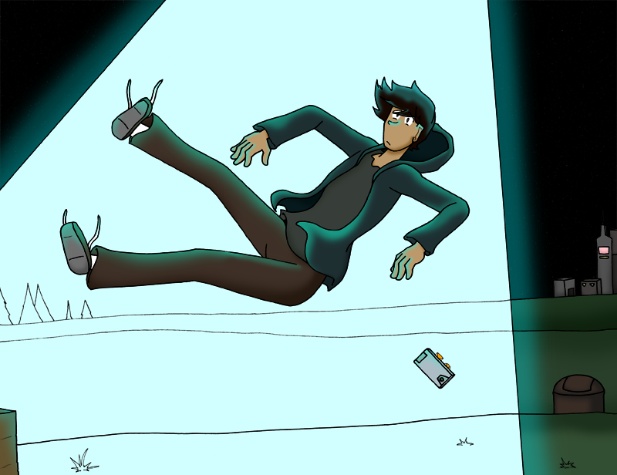

Page 2

Rico is sprawled out on a metal floor with an iris gate sealing closed under him. His hair and clothing are disheveled so we know this is the outcome of him being sucked into the air. He's slightly gasping, not sure what's going on and not quite acclimated to where he now is. Rico's eyes are still somewhat panicked and darting, a bit drained by the order.

A low shot from Rico's perspective on the floor looking up. Two tall, lanky beige-gray aliens in red and gold robes are looking down at him with blank expressions. They look a little like the typical "Gray" but with stretched bodies and hints of being unnatural/manufactured like their fingers don't attach to their hands but still float in a regular configuration.

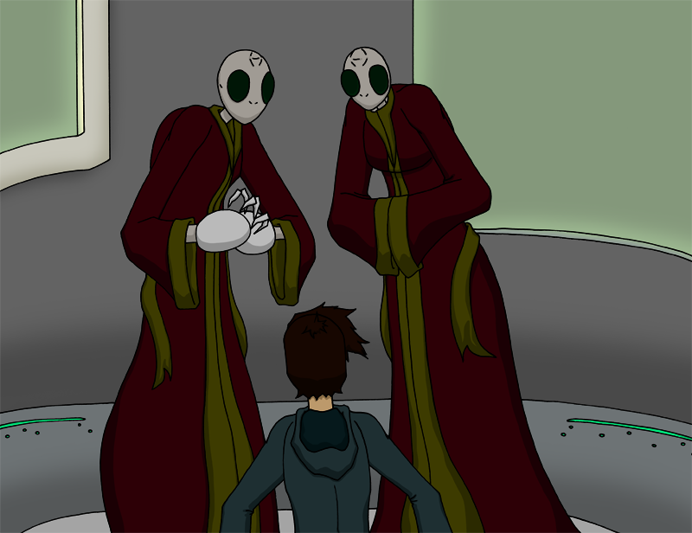

Rico sits gawking at the aliens. He remains on the floor, just barely pushing himself up off the ground. The aliens stare down at him. Neither side says anything or moves.

One of the aliens turns to the other, leans in close, and whispers, "I think we got a stupid one."

Page 3

Rico recovers and immediately switches to shock and anger. He throws his arms out and shouts, "Hey!" at the aliens. They don't overtly react.

Rico rants while angrily pointing a finger at the aliens, the absurdity and newness of his situation completely thrown out the window and causing him to ignore the gravity of the situation. He chastises the aliens for abducting him, taking him away from his home, and just generally stealing people. His ramblings gives hints that while Rico probably didn't REALLY believe in aliens or the supernatural before, he's willing to accept that it does exist so if there are aliens, they've probably been abducting humans for a while.

One of the aliens cuts him off, holding its arms in the air, dramatically gesturing with a raised clenched fist. It looks regal and majestic, beaming, "Silence!"

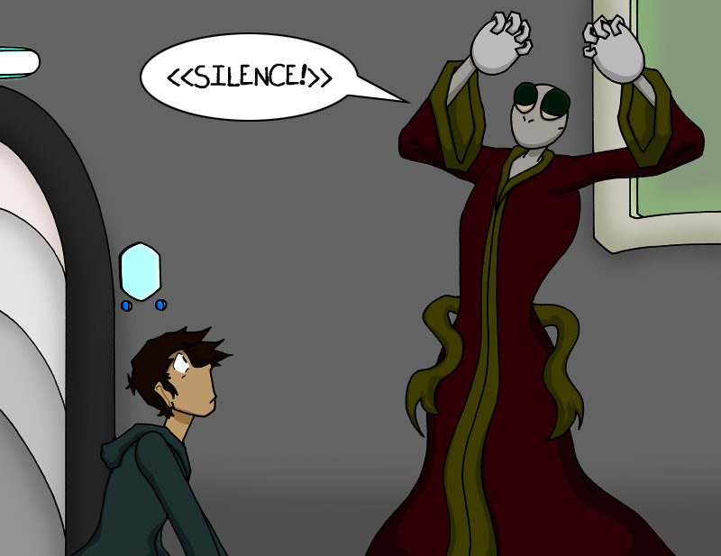

The other alien, without airs, bends down towards Rico with more of an exasperated shrug. "Serious, be quiet. You're annoying." Rico is more perplexed and confused than his former anger.

Page 4

One of the aliens gestures back to Rico, who is now sitting cross-legged on the ground, a mixture of pouting, anger, and general grumpiness on his face. Still with an imposing air, the alien beckons, "You have been collected for a grand purpose, creature."

The alien dramatically motions behind the group to a viewing screen that descends from the ceiling. The mechanism is mechanical and unfolds with metal railings, nothing about it is futuristic or grand to match the sci-fi setting.

The screen flickers to life with a mixture of static and a glow powering up from the center of the screen spreading to the edges. As the static dissipates and the picture tunes in, a black and white screen is visible as text animates into view, the letters waving and shaking until it forms unmistakably retro sci-fi B movie text claiming "Mars Demands Women!"

Rico curiously watches as the movie opens with a scene of a poorly costumed actor in an over-sized brain-like monster head fitted with lightning rod looking attachments chases after a young woman inexplicably in a nightgown. It's immediately obvious this is a schlock fest of a movie.

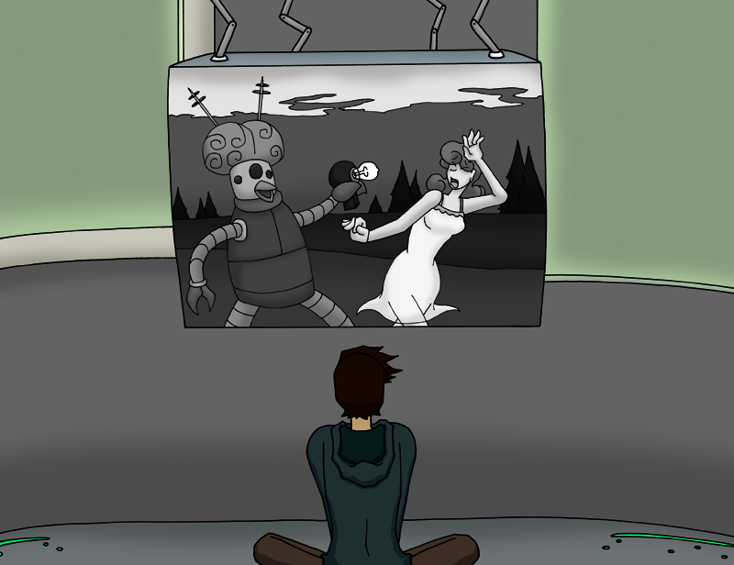

Page 5

As the movie continues to play on the screen, Rico looks over to the two aliens, who are nodding intently to the screen. Rico shrugs and hooks a thumb at the display, "I... I don't get it."

The alien stands imposingly over Rico, gesturing with grandeur at the movie. "Through great peril and scientific advancement beyond your comprehension, we have received your transmission messages warning of us the terror that will befall us without your gifts!"

The alien leans in, squinting, and now sinister as its shadow is amplified by the screen and cast over Rico. "We have come to collect."

Rico leans back and points at the screen. He furrows his brow, all menace from his captors ignored. "It's just a dumb old movie."

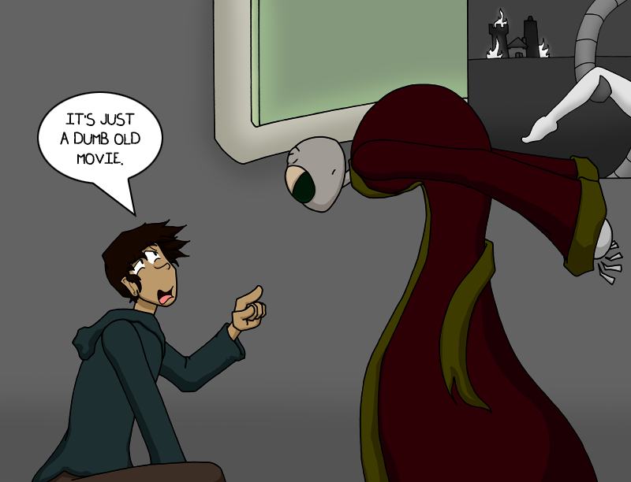

Page 6

Rico has finally risen. He stands slightly slumped, a disaffected posture, and barely comes up to the aliens' torsos. While the aliens still glare down at him, Rico waves his arms at the viewing screen, "That's not real."

The second alien now looms large, as the previous one nods sagely in the back. The alien's eyes are furrowed, large wrinkles and folds appearing on its forehead. "Of course it's not real. Yet! Our world does not suffer at this time! But your ancestors somehow knew of a coming plight."

The alien leans in even closer, shielding Rico from the lighting above him. The alien's eyes even seem to change to a menacing deep red, swirling as it stares down Rico. The alien speaks curtly and quietly, "Hand them over."

Rico has backed up enough to get the alien out of his face. His body and expression are a mix of confusion and creeping terror. He gesticulates wildly and shouts, "Hand what over?!". The aliens are masking their flustering by nodding their bodies back and forth rapidly and have puffed their torsos out to appear more grandiose.

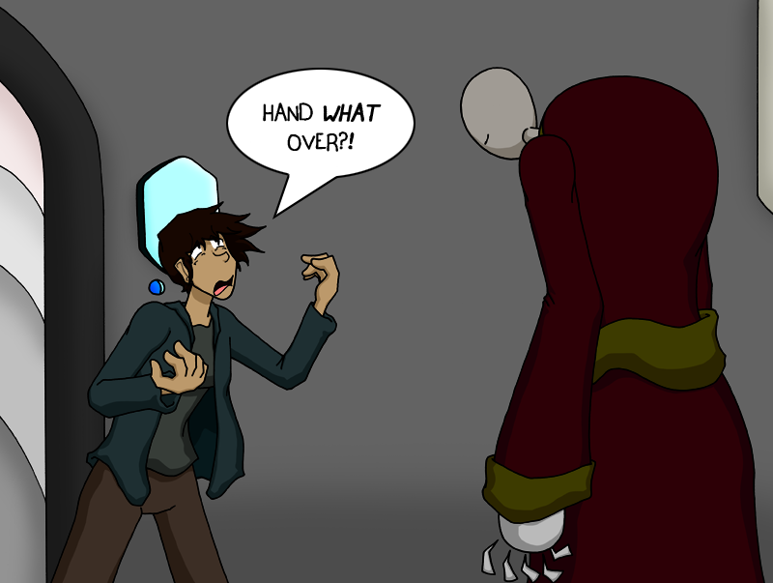

Page 7

The aliens have quickly turned frustrated with Rico. They gesture wildly and pointedly to their video screen and the movie. Just barely holding itself back from shaking or slapping Rico, one alien shouts at him, "The creatures! From the video message. That will save Mars!"

Rico, now having lost any fear or awe he once had for the aliens, shares in their mixture of confusion, annoyance, and inklings of anger. He stares the alien down with raised eyebrows, "Women?"

The aliens seem relieved and thrilled to have finally broken through with their daft abductee. Now happy, the alien gestures again to the movie. " Yes, yes! That is how they were referred in your kind's warnings."

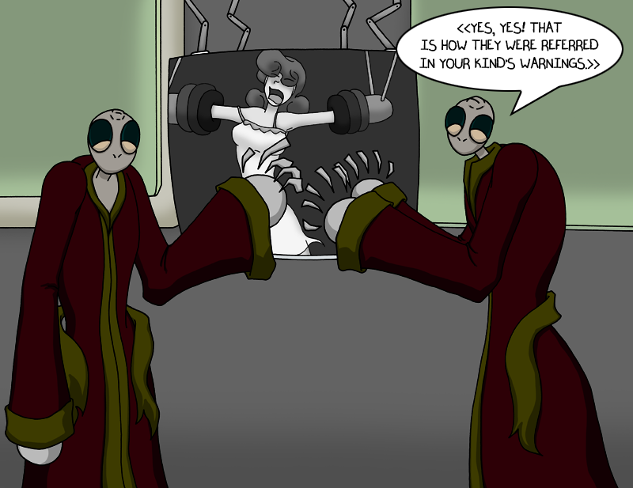

Rico is back to being worried, but more for their sanity and what that could mean for his safety. He decides to answer safely, maybe with a hint of dejection in his voice, and burbles out, "I... don't have any... women."

Page 8

The aliens have had it with Rico's insolence. Puffing themselves up grandly once more, they point menacingly back and force between the movie and Rico. "If you refuse to help us and give us your others, you will toil in their place, Insolent One!"

Rico now realizes that the alien's lack of understanding/stupidity could be a bigger threat to him than their rage. His eyes dart back and forth for an escape or something to placate them, but he settles on saying, "...I'm not a woman."

The two aliens are hit hard by this revelation. The way they look back and forth at each other and scan between the movie and Rico shows that they are thoroughly confused by the statement and what it entails. Their silence seems more menacing than their earlier outburst.

Rico hazards again, "I'm a man." The aliens, now deflated, have lost all airs of grandeur. They shrug back to each other. Rico's words clearly have no meaning to them but they understand he is speaking words that mean their plan is in jeopardy.

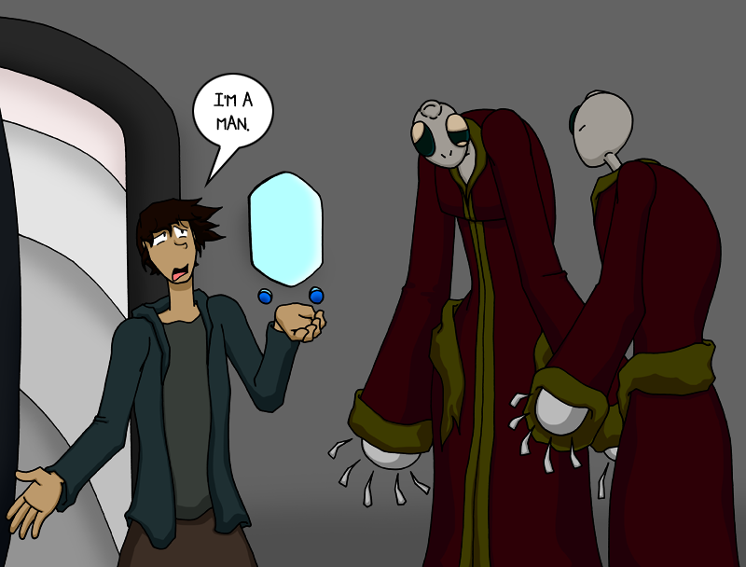

Page 9

In a silent panel, Rico is motioning to crudely drawn sketches he has made on a whiteboard-like holographic screen and the aliens are glaring intently at it. Poor drawn male and female humans dot the board with arrows strategically pointing around and at them as Rico lectures.

Rico explains the core concept of males vs females to the aliens, to whom this is an entirely novel concept. He has pulled upon the best health class taught by a gym teacher public education knowledge he has on sex characteristics and secondary characteristics to explain the drawings.

Rico points back at the movie, now paused on a frame of the female lead swooning at the menace of the creature, whose costume has clearly been jostled apart and there are glimpses of the actor underneath. Rico then gestures back at himself. The aliens sit rapt but squint and squirm to grasp the differences their abductee is explaining.

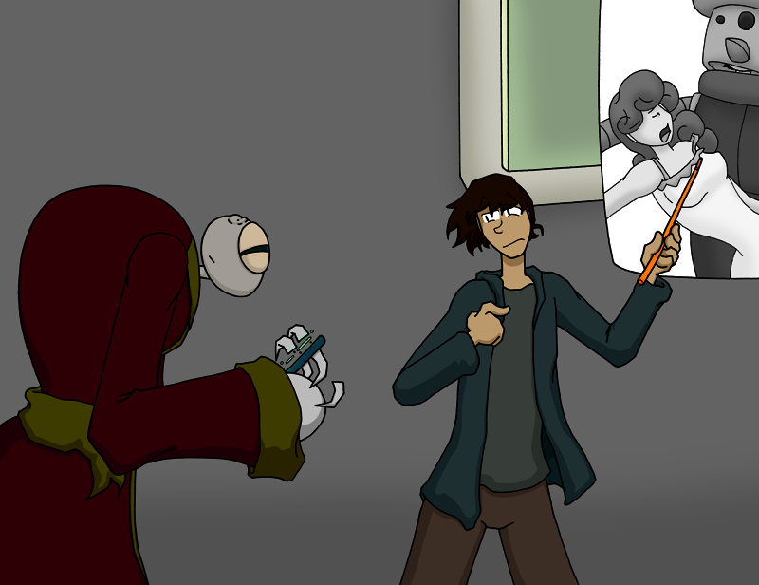

Rico audibly sighs in frustration as he erases the display and starts his pictures over again now extra simplified for the aliens' benefits.

Page 10

Having forsaken the pictures and diagrams, Rico rambles, semi-educatedly, on XY versus XX chromosomes. He starts trailing off about hormones and chemicals to hide his lack of real in-depth scientific knowledge.

The aliens finally perk up, the confusion is washed from their faces, and they are clearly absorbing what Rico is awkwardly putting out to them. He continues the best he can now that he sees interest and comprehension on their faces for the first time.

The aliens turn away from Rico and quickly and animatedly discuss amongst themselves, leaving Rico standing confused at the display he has been lecturing at.

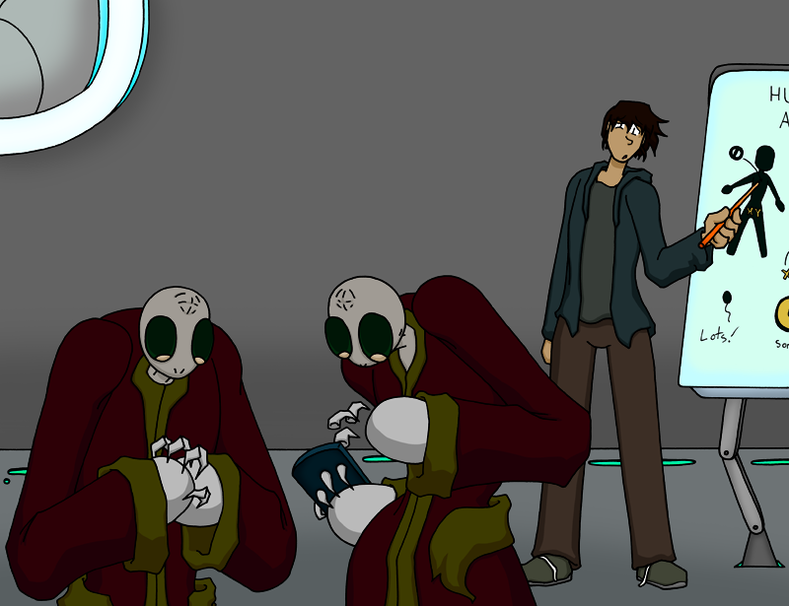

The aliens turn back to Rico and finally seem pleased with him. Talking at him rather than too him, they exclaim, "Your foolish ramblings would have been expedited if the discussion had begun with the issues of chemicals and biology." The non-speaking alien is happily rocking back and forth, its digits drumming in the air. Science has finally won them over.

Page 11

As the aliens chatter and flutter among themselves, Rico seems happy they finally figured it out. He slumps forward a little and sets down what he was using to draw on the display, relieved this ridiculousness is almost over, for him at least. Maybe Earth will have issues, but it's out of Rico's hands now.

Rico looks toward the iris and hole he was sucked up through and asks the now approaching aliens, "Can you drop me off at home? You know, I can catch a cab so if you just get me near-"

Rico is cut off by the aliens jamming a large sphere into his mouth. It's a whitish-gray with glowing blue spots on it and it unnaturally distorts his jaw and bulges his cheeks as the aliens cavalierly cram it into his mouth in a comically gross but not disgusting way.

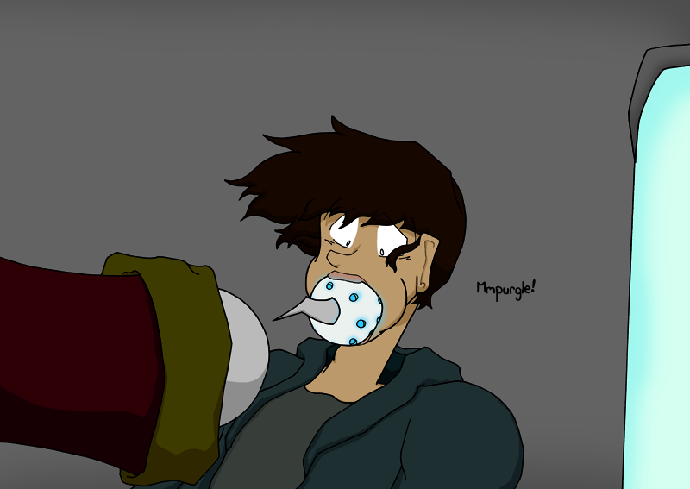

Rico gags and hacks as you visibly see the orb bulge down his throat. He's so stunned that he can't do anything but lightly spin his arms as he chokes down the device. The aliens look on without concern.

Page 12

A machine arm unfolds from above the same as the movie display did, all metal and sharp edged mechanisms, and aims itself at Rico. He's barely recovered from swallowing the sphere so he doesn't notice the device or react to it.

The arm's head is filled with a number of thin needles that are coated with a series of small blue orbs. The multi-pronged needles are jabbed into Rico's arms and the orbs pump into him rhythmically, flowing into his skin as if it wasn't even there.

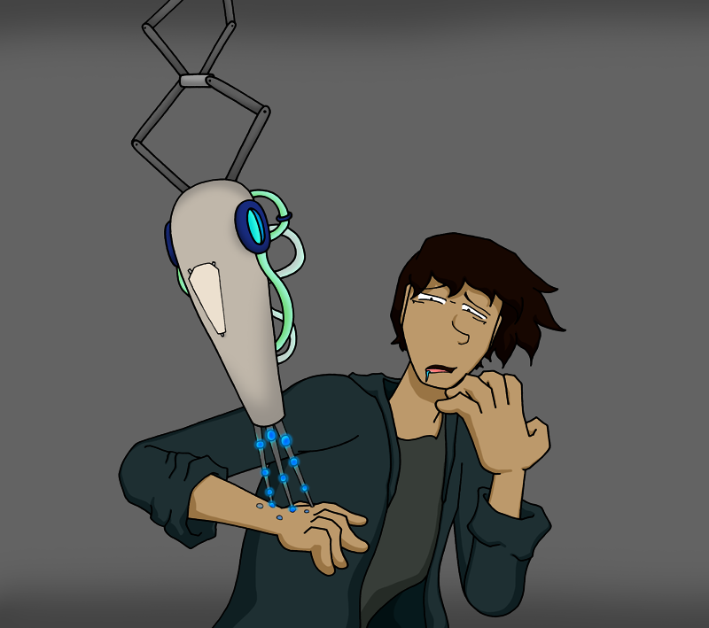

The aliens are happily working away at a computer-esq device, ignoring their abductee's confused shouts and pleas. They animatedly discuss a series of numbers and symbols to each other. It's clear that while technology may not be their strong suit or their tech was developed long ago, they are masters of whatever they are discussing.

The aliens continue to discuss/bicker over their readouts while Rico is being prodded and injected in the background. A series of different arms and injectors have descended from above and are all aimed and on target. Rico is being knocked around, but it's for comedic purposes.

Page 13

Now free of the injections, Rico struggles to drag himself over to the aliens. He's not visibly hurt, but he's definitely groggy and weakened. Slight blue glows pulse off-sync from under his skin. The aliens don't visibly react to his presence.

Rico steadies himself with an arm up on their console and tries to speak. As he's about to protest, without looking, one of the aliens places a face mask on him. The mask is clear and plastic-y, covers his nose and lower face, and has molded a seal around him. There's a tube running from the bottom of a panel on the console up to the mask.

Rico's eyes go wide at the mask. He reels back but can't go far because the tube is connected to an enormous vat at the back of the aliens' computer. The canister is filling with a thick goop from the aliens' machine. The material looks purple but it has an iridescent sheen that makes it look like it changes colors as it sloshes around. As the vat fills, a pump starts moving the goop up into the tube.

The tube bulges as an uneven stream of the goop pumps up to Rico. He clamps his mouth shut as the goo quickly fills the mask, but the machine keeps pumping. Running out of air, Rico gasps and is forced to suck down the goop.

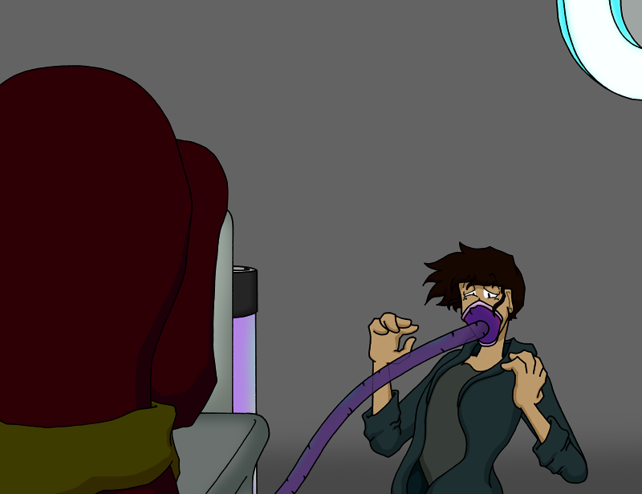

Page 14

Dazed, Rico tugs at the hose, struggling to remove it, but the hose and mask stay put as the machine continues to pump the goop into him and he has no choice but to keep swallowing it. The aliens show no concern for him and continue to work on their device.

Rico's body is starting to change, causing him to stop pulling on the hose. His skin grows tight and tingles all over before Rico notices the bulges pushing out from his chest. Soon, his body pulses in rhythm with the gulps of the liquid. His jacket is pushed to the side as the bulges grow larger.

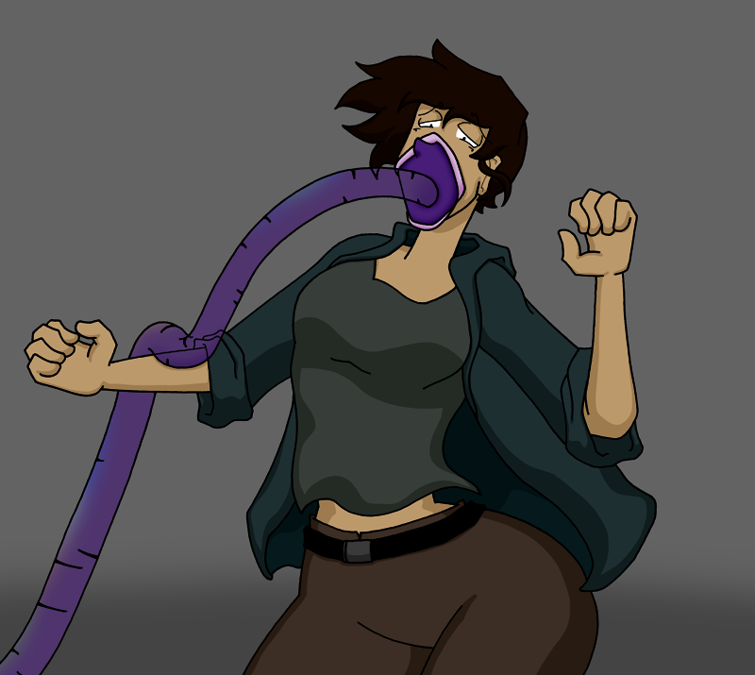

Rico is growing weak from this process and the strain it is causing him but he goes back to yanking on the hose in desperation. He meekly kicks at the canister, his form unsteady and his balance off as his body continues to expand and twist.

The shock of the changes and the drain on his body are finally too much and Rico collapses forward. The aliens continue to not pay attention to their abductee, now face down before them.

Page 15

Rico slowly comes to inside a clear cell or tube in an all-white glowing room. It's so white that it shines out the details of everything outside the tube and Rico squints his eyes. He's suspended in his tube, almost floating, but his body is numb and doesn't immediately react or move, like he just woke up from days of sleeping.

Rico notices his body now and panics. Looking down, he sees a woman's body, similar to the movie star's from earlier. She's thin yet curvy, but not overly so. His face is recognizably his own and his hairstyle has not changed. The body is adorned with what appears to be a full body cheerleading outfit, inspired by events of the film.

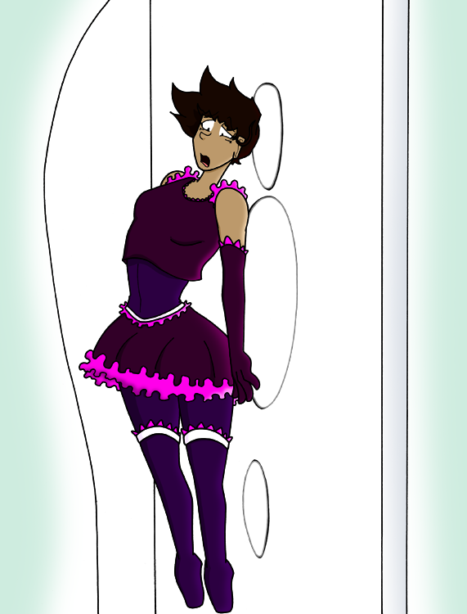

He quietly gasps at his new body at first but quickly turns to anger and annoyance at how stupid the outfit is more than anything. It's frilly and stereotypically feminine in a way no person would actually design and it draws the eyes to his new figure.

Outside the white glow of Rico's cell and beyond his focus, the two aliens are watching on and looking rather pleased with themselves. The excitedly bob and drum their fingers in the air. Bio-engineering is their forte and they are content with their results.

Page 16

The scene jumps forward a little to a montage of Rico being put through tests that just seem to reenact scenes from the aliens' intercepted movies. Rico stumbles in the body and outfit as he tries to escape creatures engineered to be like bad B movie monsters come to life.

The tests seem designed without purpose and reflect little more than the starlets' roles as swooning damsels, helpless against the monsters from their movies.

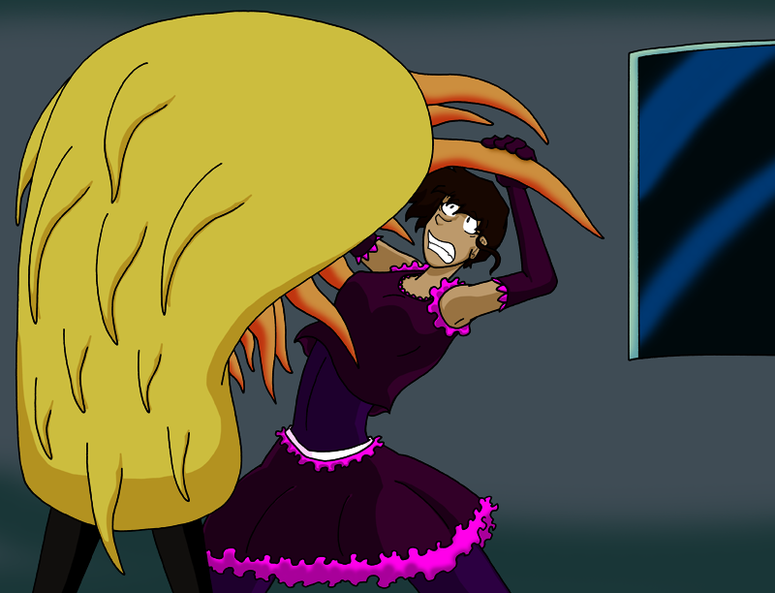

The aliens monitor Rico's stumbling efforts but show no clue of what they expect to happen or what they want Rico to do. They're clearly unsure of what the movies were for and feel the need to recreate what they've seen for some grand but unknown purpose. Upon seeing no Mars-saving grand gestures from their new woman, one alien comments meekly, "This does not seem to be working."

Rico is slammed up against the plastic barrier of the test room shouting at his captors, "Of course it's doesn't! Let me go, you moro-" before he's dragged away by plant-like creature that was likely just a dog in a cheap costume in its original movie.

Page 17

The aliens watch over Rico's tests (and his regular embarrassments and failures) dispassionately. Then, one poses dramatically, puffing itself up once more, and exclaims, "We must work harder! For our people!"

While he's recovering from a test, the aliens clamp a new tube into Rico's mouth. Instead of having a face mask, this one sucks onto his mouth, puckering his lips, so it appears as though he's kissing the machine. Rico struggles but is quickly taken into one of the aliens' rooms.

Plastic supports snap onto Rico's lower legs, lifting him into the air while also pointing and pulling his legs and feet down. The aliens leave the room and the tube seals closed.

Rico is in another tube, appearing to hover off the ground due to the devices on his legs, while the tube whirs to life as new goop churns through it. The tube fills up with the new brand of goo, rushing in from the bottom of the chamber. Rico watches it fill up, frozen in place by the devices humming against his body, but his face reveals a mixture of annoyance and angry resignation.

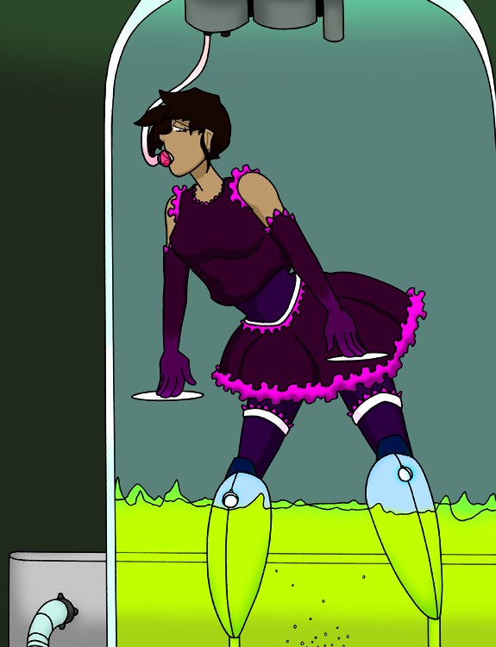

Page 18

Rico is shown in another battery of tests. His figure and hair are still the same but now his lips are plump and puckered like a starlet made up for a romantic movie scene and the outfit's boots have changed to high heels. The costume has changed slightly, more refined, a Cheerleader 2.0 for the tests. Obviously, none of this is helping Rico fight back against the trials.

The aliens watch from another room once more, displeased that the subject still isn't succeeding or displaying any world saving abilities. Rico is seen in the background stumbling on his boots as a giant creature chases him, its body like a giant Koosh ball with a periscope on top.

Another day, another trial. As the aliens bristle watching the scene of yet another of Rico's disappointments, one of them slowly speaks, "Perhaps... this creature is more clever than we have given it credit for... It is playing inept to hide its innate power and the gifts the warnings revealed to us and that we have delivered. Perhaps this being will take our power yet leave us doomed! Is this why the hails to Mars went unanswered?"

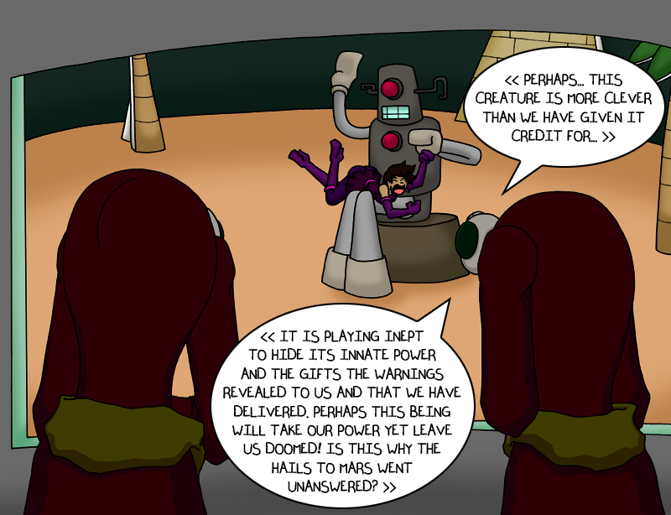

The other alien nods in agreement. "We have followed the displays of the cosmic messages and our work is perfect! The fault is within the creature's devious nature. It cannot hide from more testing!"

Page 19

Rico has clearly been back to the tube one or more times. His figure is curvier, a femme fatale, but one with hair covered in a stringy goop and that is being prodded by mechanical hands. Whether this test is to check his body for flaws or just try his patience by pestering him like a child fighting in the backseat of a car during a long road trip is unknown.

Freed from the chambers once more, movie star hair flows down Rico's head and rests on his shoulders as he groans and stumbles out into the room. Rico's costume has changed with him, refining itself to best support its unwilling bearer. Together, they make their way back into the testing course.

The aliens watch Rico and the testing room intently now. The alien speaks to the heavens and its voice booms sternly into the arena. "Creature! You will either display to us your power and cosmic benevolence or you will be destroyed as a terrorist and traitor to the creatures of the stars!" The aliens are quite pleased with their grandeur.

Down in the test chamber, a giant monster crawls into the arena from below. It seems confused but keys in on Rico as it lumbers up. Rico is already backpedaling away from the first potentially dangerous looking creature he's encountered. The monster appears to be a bipedal furry crocodile for its body with an electronic, almost microwave, device crammed on top for its head.

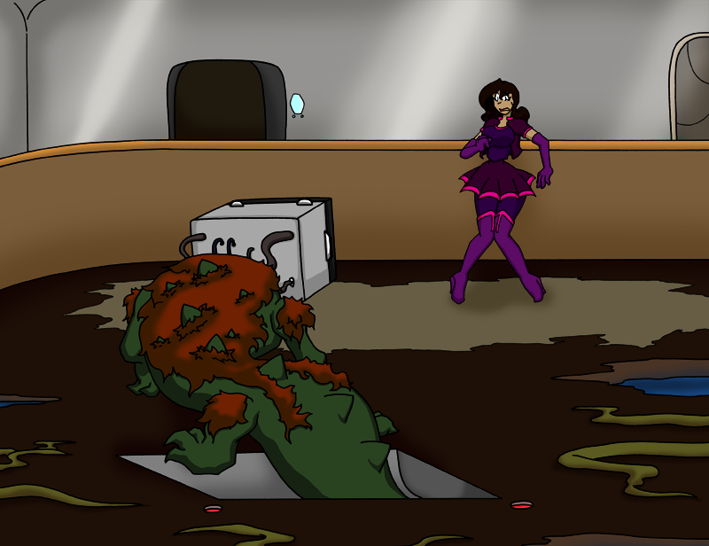

Page 20

Rico is bolting down the halls of the ship, the creature right behind him, and shattered plastic is around them leading the reader to see that the monster slammed into the arena dome and broke it. The creature is rather dangerous and will hurt Rico if it it catches him, but it doesn't show outright malice. The creature just seems to be designed for this task. Its true nature or not aside, Rico still flees as if his life depends on it.

The two aliens are chasing after Rico and the creature but are rapidly falling behind. It's clear that they aren't a physically inclined species. Aliens are wheezing but gasp out, "You are not fulfilling the experiment correctly!"

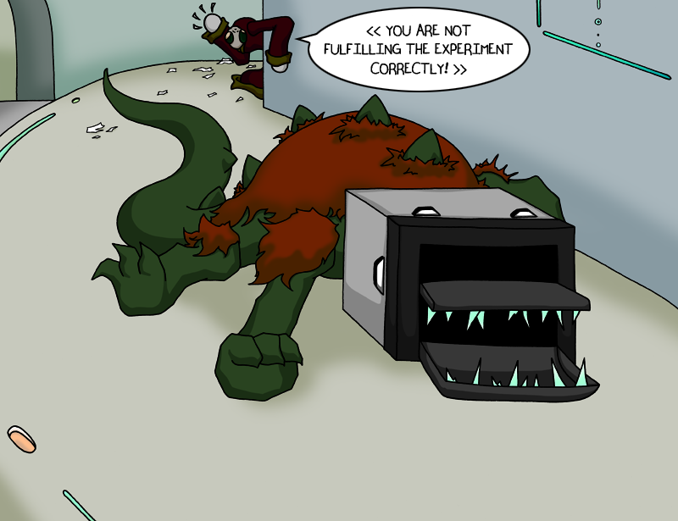

Rico dashes around a corner and slides/stumbles into a room to hide. The door seals behind him and Rico scrambles to the wall and presses himself tight against it. The sounds of the stomping creature and wheezy aliens are cut off in the quiet room.

We have a shot from within the room of Rico cowering, ducked low with his knees pulled tight against him, and through the room's window we see the creature surveying the area looking or sniffing around for Rico.

Page 21

Thinking he's safe, Rico has a moment to reflect on the body he's gripping tightly as he hides. He tugs at the skirt and gripes, "-just how dumb this looks. I have to get out of here, but... Where? How? And I can't go back home looking like this or I'll-"

The window suddenly bursts in, cutting Rico's whining off. The creature clambers into the window through a too-small opening, its gnarling and snapping pounding in Rico's ears.

Rico shrieks in a overly-girlish manner matching a scream queen from the aliens' cheesy sci-fi movies. Shards of the window clatter down to the ground as the creature continues to wriggle and thrash.

Rico scrambles back as the creatures forces its way further through the opening in the window. Rico stumbles back towards some of the devices set up in the room. As the scene unfolds, the aliens have finally caught up and angrily proclaim, "You are failing the test!"

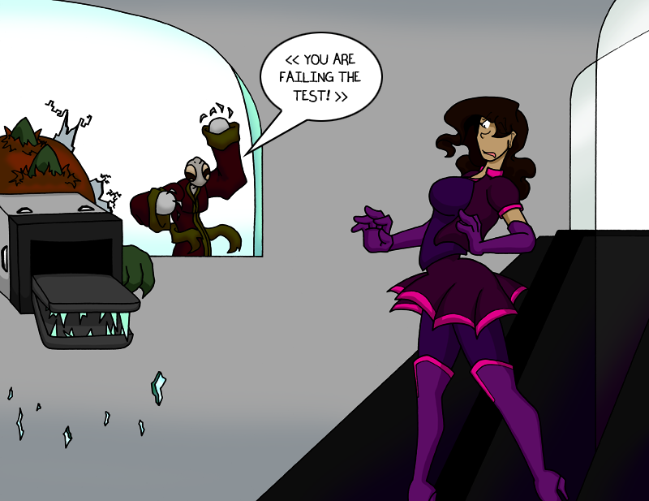

Page 22

Falling/flailing away from the monster, Rico stumbles back into one of the tubes in the room. As he passes through the entrance, the doorway glows and a panel on the side lights up.

Rico is sucked up into the device like a canister in a pneumatic tube at the bank. The entire tube glows and shines causing the aliens and the creature to shield their eyes and look away.

Rico flashes up through the glowing tube and dematerializes before hitting the ceiling. His body appearing to deconstruct itself as it zips up.

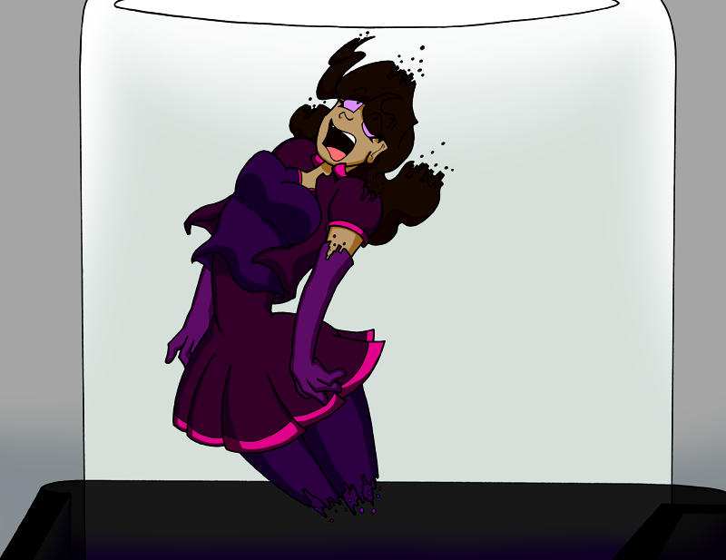

The device powers down with a "thwip" and leaves the aliens looking stern. One turns to the other and grunts out, "The experiment was obviously successful. It was the subject that was a failure." The other alien solemnly nods. The creature whimpers, still somewhat stuck in the window and sad that its plaything has run away.

Page 23

Rico's body reconstructs and materializes floating in unknown space. The world now realizes the full genius of the comic's title and applauds its comedy gold.

He immediately starts gasping and clawing for air in a panic. His confusion about his situation has been violently replaced by a desperation to survive.

Rico's suit/outfit reacts and a bubble helmet forms out of the costume's collar and covers his head. The clear bubble allows Rico to see and breathe normally even out here in space. The helmet then flickers from view and the suit briefly glows before the sheen flickers across his skin, protecting him from the vacuum of space and saving him from doom.

Rico is floating upside down, drifting through the empty space. He's dejectedly happy the outfit saved him but knows this means he's stuck with the suit. Ridiculous or not, it's his means of survival.

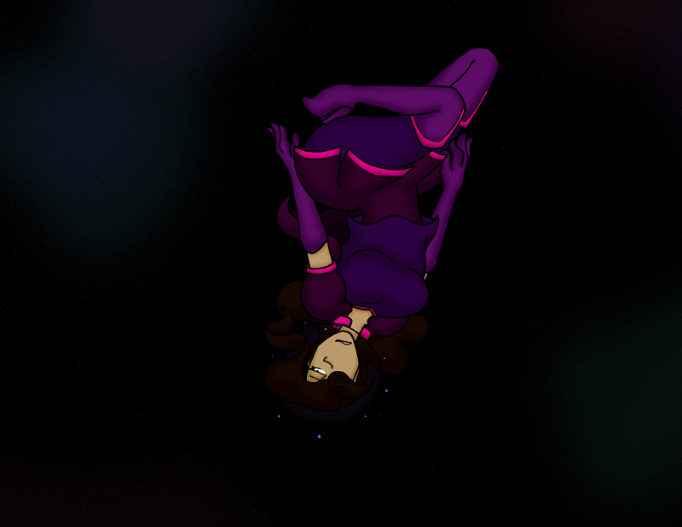

Page 24

Rico floats aimlessly through the empty expanse of space. Bored and annoyed, it's not even worth complaining about his situation in the emptiness as there's nobody to hear it or care.

Although, he can still gripe about the suit and its frilly ways. "Stupid costume can protect me from space but can't provide some damn pants..."

Time has passed but the stars in the background are still just distant lights as Rico continues to float along.

The camera is now panned all the way out to drive home just how almost inconceivably empty and boring space really is. Rico has his arms crossed in a huff. A ball of a cheerleader, just floating through a cold, indifferent universe.

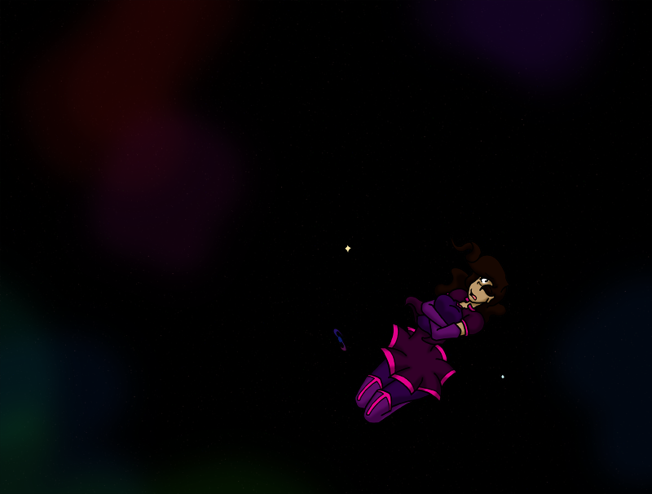

Page 25

A small ship appears from the blackness and pulls up behind Rico. It looks barely more advanced than a flying semi truck. Rico continues to float along, not noticing it behind him.

Suddenly, a voice speaks up in Rico's bubble helmet. "Hey, you okay out there? Looks like you need a hand."

Rico startles at the voice, not knowing his suit could transmit AND that somebody else exists out here. He spins around to see a blobish yellow with orange spots alien sitting at the helm of the space truck just behind him. A visor sits between its two eye stalks, not particularly shielding anything from sunlight or cosmic radiation.

Rico stares blankly at the creature, his mind momentarily shattered by the encounter and the creature before him. Rico was probably starting to expect to die out here alone, although that wouldn't have been his first choice, so seeing a new anything is a shock. The alien trucker casually raises a paw in a wave.

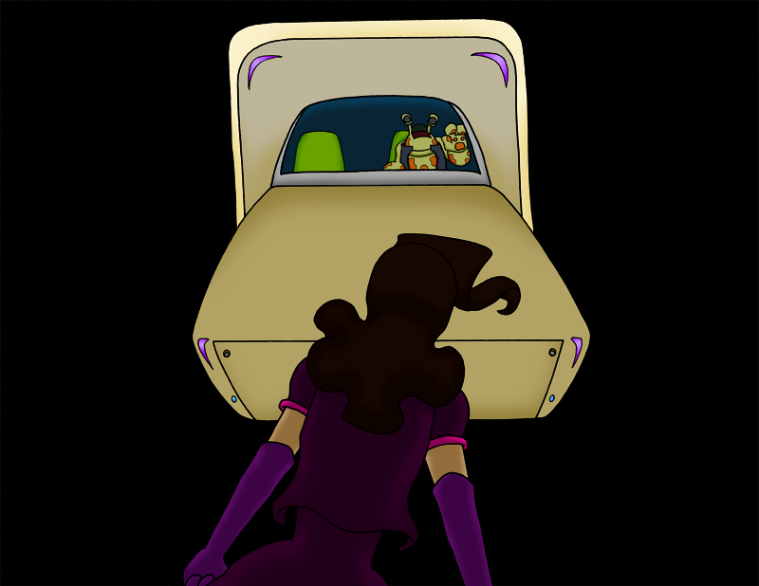

Page 26

The truck pulls up next to Rico and now caught in its field, he is able to "swim" over to the passenger side. A door appears when two panels slide away vertically, allowing Rico to come on board. The trucker pats the passenger seat for Rico and adjusts his visor. "It's a good thing I came by. Long float back to the station there."

Rico is still gawking even as he settles into the seat and the panels seal the cabin once more. The driver appears friendly, although rather foreign and strange.

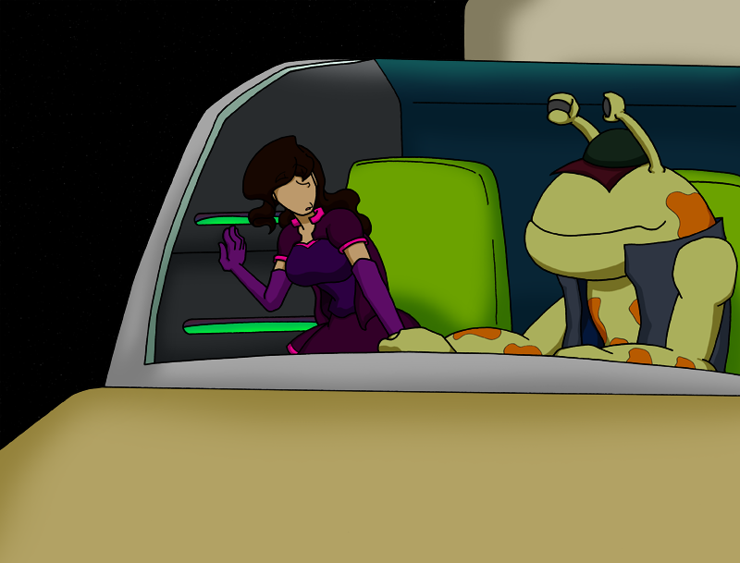

The trucker looks worried at Rico's silence and leans closer, surveying Rico's head. "Your translator out in there?"

The alien holds up a device to Rico's neck. Some lights scan back and forth before they stop and the device lets out a cheery beep. "No, nope. Everything scans in working order. A bit outdated, but it functions. Guess you're just the quiet type. Welcome aboard!"

Page 27

Rico and the alien driver make oddly plain small talk as the truck putters its way through space, stars whizzing by in the background. Rico just stares blankly ahead and grips the seat tight to keep himself together as they chat.

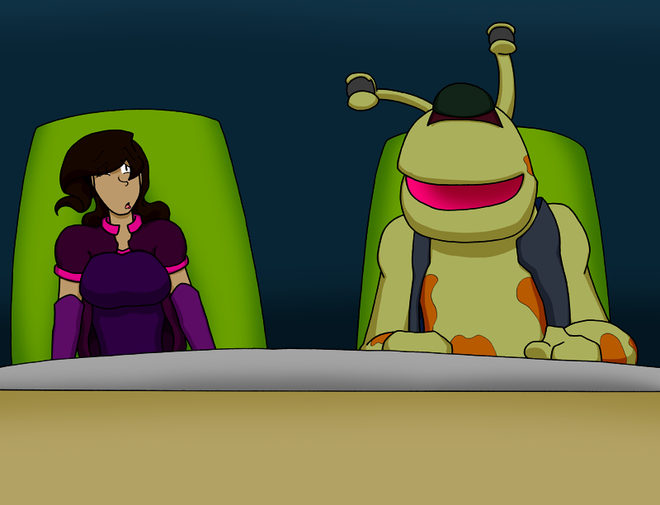

The alien turns to Rico, "So, where you headed?". Rico nods ever so slightly but doesn't turn to the alien, "Home."

The alien turns back to the "road". "Well, you'll be able to catch a lift back at the station, that's for sure."

The alien leans in towards Rico while still keeping its eye stalks focused ahead, "Say, it could be a while. Do you have your card on you?"

Page 28

Rico doesn't know what the alien means. He becomes one part quizzical and one part worried that he'll be in trouble if he doesn't have this card. The alien just calmly watches ahead.

Rico makes noncommittal noises as he pats down the suit, hoping his abductors gave him this needed thing. The alien subtly watches him with one eye stalk on Rico and the other on the path ahead.

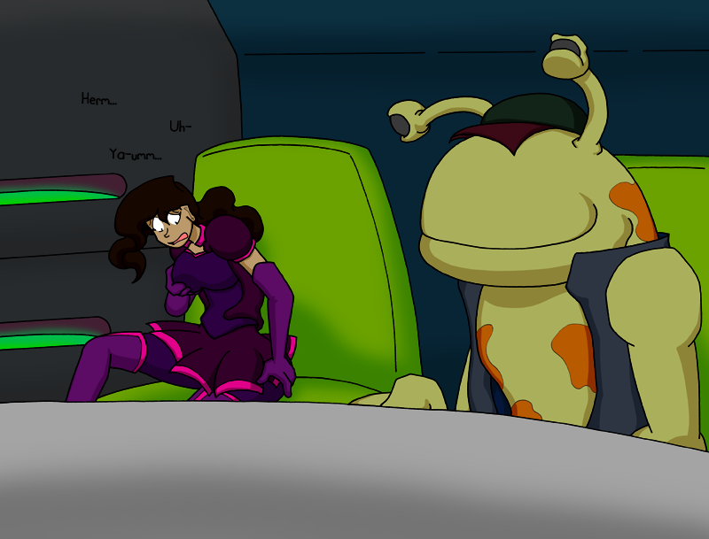

Rico squeaks out a passive "...No?", retreating slightly into himself for fear of the alien's backlash or that he might be kicked out of the truck.

The driver is saddened and turns back to focus his full attention on the flight. He just replies with a hollow, "Oh."

Page 29

The truck ship is slowing down so the stars are no longer blurs while small satellites start to pepper the background. Rico looks a little dejected, sorry he let his alien helper down, but still confused. It's implied that the rest of the trip has been quiet after the card incident.

As the truck pulls in more and comes to a stop, Rico is amazed to see that they're at a giant space port. Other ships are also pulling in and domes are connected to a city-sized station littered with signs and displays where glowing skyscrapers and needles rise above it all. The station looks like a futuristic neon-lit casino and the driver has stopped in a zone a short distance away from a depot that looks like a convention center.

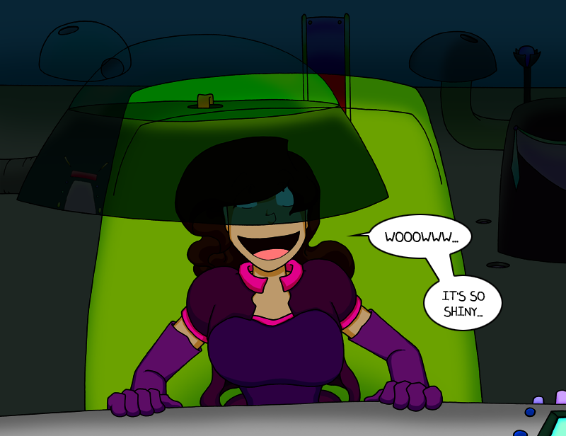

The driver's ship is now hooked up to arms and hoses that link it to an inspection/check-in hut and he's opened up the ports on the truck ship. He adjusts his hat and swings his body towards the door but turns his eye stalks to Rico while pointing down the street, "I'm on my way to make the deliveries. Wherever you're going, this place will help you out."

Rico nods in daft agreement and hops out of the truck, amazed to land on solid ground with a metallic "tip" as his heeled boots hit the surface. The trucker waves the manifest he's holding to Rico as they separate. "Hopefully we'll meet again when you have your card!". Rico politely waves his thanks back.

