ROXION
JUNE 2021 REQUEST STORY
BY CHALDEACHANGE
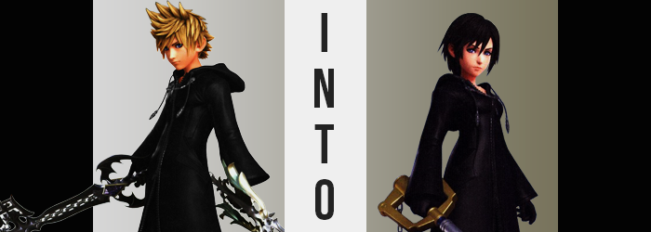

It had been a long and arduous fight, but a relative peace had finally settled upon not only the world Roxas knew, but the many worlds that spanned the very multiverse that he and his friends resided within. The threat posed by Xehanort, the Heartless, and every single unnecessary and convoluted threat out there had ultimately been put to rest, and yet the loss of Sora still weighed heavily on the hearts of the Keyblade wielders.

But on none quite like it did Kairi. It was her life that the boy had traded his own for, and of course she would feel some degree of guilt for that, even if she still felt like he was out there somewhere. The others worried about her, and so they often visited her to give her some company. It was for that reason that Roxas had swung by Destiny Island that day, but his attempt at offering Kairi support had hit something of a wall.

“It was my fault, really, but… Augh! What am I supposed to do about this!?” His visit had gone well in the beginning. The two had shared a snack, and Roxas had recalled some of his adventures to Kairi. She often commented that he and Sora were a lot alike throughout his tales, something that wasn’t all that surprising considering the nature of their connection. But after a few hours, things finally took a dive.

Kairi had invited him into her home, and they’d sat down for tea. The girl ended up taking off suddenly without a word, and Roxas was left alone. High strung as he was even though these were peace times, all it took was a scream from Kairi in another room for him to leap into action and burst through the door he’d heard the sound come from. Unfortunately? He didn’t know the layout of Kairi’s island house, and the room he’d crashed into?

Was the girl’s bathroom.

The maiden had slipped off her seat Roxas had come in at the perfect time to catch an eye full of her unmentionables. “ROXAS!?” The boy ended up bolting out of not only the room, but of Kairi’s house entirely, running until he found a cave to hide in along with the immense shame that he’d felt.

“THAT WAS SO EMBARRASSING!”

How was he supposed to face Kairi after that!? Roxas wasn’t emotionally equipped for it at all, and he couldn’t help but wish that he’d had an easier out in this case. Should he contact Lea? Maybe he’d know what to do? Or better yet… “I wish Xion was here, she’d know what I should say!” Well, that or verbally berate him for making such a clumsy mistake.

Now, Roxas had picked up something from another world during his travels. A small, inconspicuous gemstone that he was planning on giving Xion the next he saw her. What he didn’t realize was that it was actually a rare, wish-granting trinket. One that had just overheard his previous statement and was glimmering from within his jacket with such an intensity that he could help but notice. “Huh?”

He was quick to fish it out and held it with gloved fingertips, admiring the pink glow it gave off before the light diminished, its power spent. “What was up with that?” Had it been dangerous? Roxas hadn’t gotten that impression. Maybe it just glowed intermittently from time to time? Well, so long as he could still gift it to Xion later.

While admiring said stone’s light, though? Its powers had already begun to work their magic, granting Roxas’ perceived wish in a way he couldn’t have possibly expected. His wish for Xion ‘to be here’, after all, did not specify that she had to be here separate from itself. And, in fact, it was much simpler to fulfill this wish by using existing materials rather than displacing another person through both time and space.

To those ends, Roxas’ hair had been darkening. Spikes softened and flattened as the blonde escaped only to be replaced by an undeniable raven coloration that was unmistakably similar to Xion’s own. Even the hair’s style took on this resemblance, for flattened spikes shortened slightly so that it became a relatively shaggy bob cut – still sporting rather jagged edges.

In the meantime, the boy’s already androgynous face had begun to lean towards the feminine. The color of his eyes didn’t change much, the shade of blue merely taking a lighter shade compared to its usual glow, but it was the shape of those eyes that ended up tweaked to grow more Xion-esque. They became rounder, lashes complimented with extra, daintier length while darkened brows above thinned simultaneously, making his expressions more apparent than they had been before. Changes soon swept through the lower portion of his face as well, delivering a softer jawline, a flatter nose, more pronounced lips, and even shrunken teeth.

Until his Adam’s apple was eviscerated, and from the neck up, Roxas wholly resembled the girl he had wished was here.

“Well, a glowing stone doesn’t exactly help with my problem. Maybe I should contact Lea… after… all?” It took the boy a whole sentence (and then some) to realize, but was his voice higher? It almost sounded like… “Xion? Wait, why do I sound like Xion!?” In a panic, gloved fingers rubbed at his neck. Remarkably though, it wasn’t the touch of his neck that felt strange so much as it was the fit of those gloves.

They felt a little too loose? Well, it wasn’t very surprising seeing as his fingers themselves were shrinking, losing length, and gaining a little bit of excess fingernail. It was a phenomenon that was also replicated in his boots, but until he tried to a lift a foot he wouldn’t really notice. Roxas’ feet were daintier, his ankles narrower.

He was just, very generally, smaller all around. Height had been lost along with dwindling muscle and bone structure, but only so little that he’d lost roughly an inch of height. What became more noticeable were the area that began to grow in the face of all of this loss, beginning with— “My chest feels a little swollen?”

Not something he’d thought about nearly as hard as he likely should have, the front of his cloak appeared to be protruding. Breasts had grown, and this should have been a very shocking thing to witness as the front of the outfit had lifted. It wasn’t. It was much worse than that, at least in the sense of what it implied. “Swollen? But they’ve always been this size! I wish they’d grow a little, but it isn’t like I can do anything about it…”

Rather than be shocked that he had just grown breasts, he was instead lamenting their smaller sizes, almost like he’d comfortably possessed them for a long period of time prior to this realization. Quite simply, his wish hadn’t specified Xion’s presence in body alone – there was a mind that paired with it, and the granted wish had been progressively swapping out his old personality and even memories for these new ones.

But his transition into the Xion he had wished for hadn’t fully reached fruition yet, as evident by how his waistline dipped inward and his hips flared out several inches in preparation of what was to come. The boy’s boxers soon filled as what was to come finally, well, came, and plush fat paid dividends into his rear. It developed like a soft peach, pushing out the back of his cloak to give his silhouette a much curvier appeal.

Roxas’ posture shifted in slight as thighs developed similarly, muscles drowned out by a gentle layer of appealing gelatin that pulled his creamy skin softer around then. But then came cherry on top, or the… lack of a cherry on top? Regardless of phrasing, the reality was that his cock and balls had withered away, becoming one with the slit that formed and buried into the space between her legs. “Oh!?” It really didn’t register with the girl just what had happened, but it felt shocking enough for her to drop the stone with surprise.

Her outfit was still in disarray, though quick fixes saw them corrected. Whether it was a black bra wrapping around her B-cup breasts, or her boxers shifting into a pair of women’s panties that properly embraced her curls, her undergarments were wholly taken care of. As for everything else? Her cloak, gloves, and boats simply shrunk to adjust to her new frame, curves, and all.

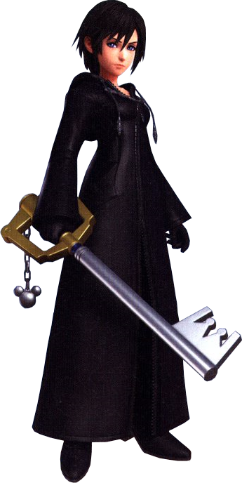
“Huh!? That was close, I almost left the gemstone that Roxas got me on the ground…” Her memories pieced back together, Xion bent down to pick up the pink gem that had actually been the trigger for her transformation. Its power spent, it had tweaked the girl’s memories to accommodate Roxas’ intentions to gift it to her, and now this Xion could remember her dear friend giving her the stone days before. “But this is Destiny Island, right? Why am I here? Isn’t this the day Roxas was supposed to visit Kairi?”

Likewise, when had she dropped that stone in the sand? A lot of things didn’t really make sense, but a familiar voice calling to her pulled her mind from it all. “Xion? What are you doing here?” It was Kairi’s voice, having entered from the cave’s entrance in search of Roxas. She’d been surprised to see someone else here. If Xion had been around, why hadn’t Roxas told her? “Actually, we can catch up later! Have you seen Roxas around? There was an, er… incident. And I wanted to apologize to him. I bet he feels bad.”

Xion brushed her hair back over her ears. “Roxas? Actually, I thought he was supposed to visit you today. So he is here? Let’s go find him, then! And hey, wanna tell me what happened along the way? Girl to girl?” She sensed a scoop, and based on the red-head’s blush, it was definitely good! And so, the two agreed to search for their friend together.

…But he never turned up, for very obvious reasons.

