MILFS OF THE WILD III.
BIWEEKLY STORY #81
BY CHALDEACHANGE
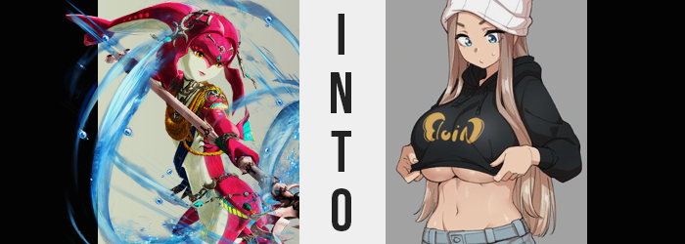

It had been a long journey out to Kakariko Village but considering the circumstances it was a journey that Princess Mipha of the Zora had been willing to make. She had recently received a troubling message from the elder of the village containing two pieces of unusual news. The first? Both Princess Zelda and Impa had mysteriously gone missing within the forests surrounding the village. That in itself warranted Mipha’s excursion.

The other piece of news? While they had not found the princess nor the Kakariko resident, they had found two women dressed in… well, they hadn’t exactly been wearing those clothes. But pieces of clothing belonging to the missing individuals. Supposedly they had even attempted to mount the guards that had taken them in. While disturbing behavior to be sure, they were possibly the only leads that everyone had when it came to finding the missing women.

That was why, upon arrival, Mipha had requested to meet with one of the woman in private. Apparently, they wouldn’t exactly answer questions appropriately. When asked where they came from, for example? They would name places that didn’t exist on Hyrule’s map. As if they had come from another world. Of course, everyone just assumed that the two were lying in an attempt to get away with their transgressions.

“What are you? Some kinda talking fish?”

“No…”

“Well I don’t wanna talk to y’all! Bring in a cute boy instead!”

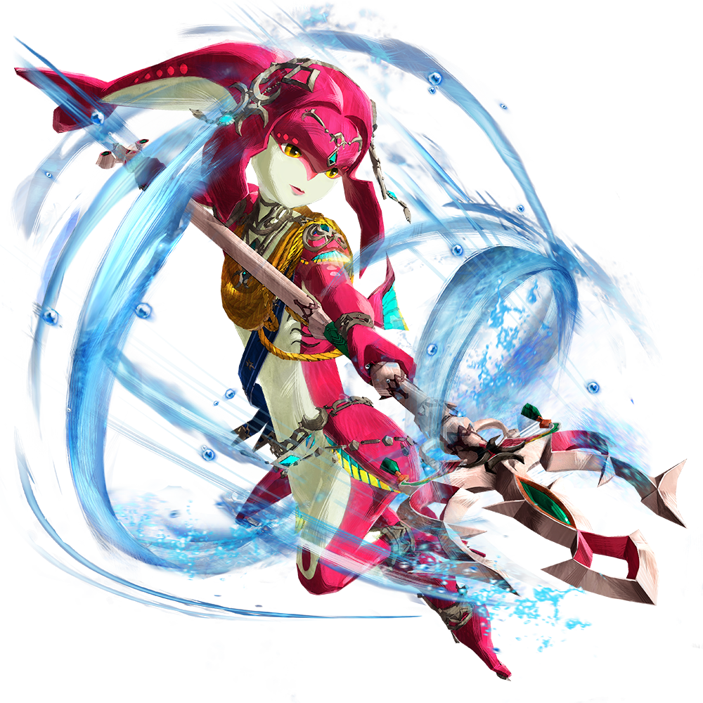
Unfortunately for her, Mipha had about just as much luck as anyone else. She had been prepared a room with a woman that called herself Sally. Her figure was… well it was certainly impressive, and she’d been given some robes by the local residents. But she had no interesting in talking to the Zora Princess… even spitting on her in the process. Well, she had been arrested, so Mipha couldn’t blame her for being a little upset, she supposed.

The woman had even gone as far as to turn her chair around so that she couldn’t see Mipha. Intent on ignoring every little noise she made and every little thing she said.

That said, it was unfortunate that some of that woman’s DNA had gotten on her. Because while the cause of this whole mess, an app that had magically been installed onto the Sheikah Slate was not present, there were other ways for the influence of MILF MATCH to spread. Not every victim had to become a MILF themselves, right? Even MILFs had families! And Mipha, quite shortly, would be becoming a part of one of those families.

Not that she had even realized it yet. She was wiping the spit off her arm where it had landed with a sigh. “Well, I suppose if you won’t talk with me, there isn’t much I can do. But if you ever wish to discuss anythin’…” The end of that sentence? It hung off of the tip of Mipha’s tongue for a moment while she attempted to process just what she had done. Had she involuntarily mocked the woman’s accent? Even so, she didn’t seem to react to hearing it if that was the case. Sally seemed intent on ignoring Mipha no matter what.

Rising from her seat, the Zora was on the cusp of making a swift departure from the temporarily holding cell. And yet? She was given enough pause to remain by the fact that she seemed to be on the verge of… tumbling over? She didn’t, but the sentiment had been there, for the balance of her body suddenly felt very off. “Oh?” She had needed to put her arms out to the side to even keep herself from spilling over.

“What on…? How strange…” Mipha thought, for just a moment, that perhaps the room seemed to be a little smaller than before? But after taking a moment to clear her head she realized… No, that was exactly what was happening. “I—?” The room did seem smaller, and it wasn’t because the room in question had shrunk. Instead, looking down at herself? She was growing taller.

And not in a way that made biological sense for a Zora, either. Her people were known for their short legs, but much of her new height was coming about because those legs were stretching. That wasn’t to say that the rest of her body was as well because her arms and torso were very much following suit, but it was definitely in her legs where it was most dramatic.

The cause of her imbalance was this changing height, and Mipha was pushed to put her arms out to the sides just to stop herself from tumbling. “This is impossible. There’s no way that somethin’ like… My legs are as long as a Hylian’s?” Not just her legs, but her entire body seemed to be a more appropriate height for a young Hylian woman, with her now standing at around 5’3”. She ended up appearing rather lanky with how thing she was, but these things certainly had a way of sorting themselves out.

Case in point? “Um…” Still looking down at her own body, the fish princess’ mouth dangled open slightly after a new feeling washed over her. It was similar to what she had felt while she was growing, what with the feeling of her body being yanked, but it wasn’t as widespread, nor was that pulling sensation keen on pulling her vertically. It was a horizontal force, and one that yanked at her hips.

As a result, Mipha’s lengthened legs began to pull away from one another so that ample space was left between them. It pulled at her tummy so that it too was wider, and yet at the same time? It somehow looked to be more toned than it had been before – at least for a Zora. “What is… Did you do somethin’ to me, ma!?” She gasped, immediately noticing what was wrong with what she had just said. She could only assume that Sally was the cause of this somehow, but why had she, even for a second, thought of that woman as her mother!?

Not that this wasn’t beginning to look more convincingly true. With her hips parted, much of Mipha’s frame began to fill in with proportions much more typical – and even far more abundant – than those of women hailing from different races altogether. “Nn…?” Her thighs rubbed together with little effort, for cream and crimson scaled skin had been stretched around a heft that made them thick and enticing, while in the rear her butt began to swell. Going further than that, a notable crack began to etch itself between bubbling cheeks.

The same was true of the woman’s chest, an area that, on a Zora woman, was typically very reserved in size. They did not have nipples because they didn’t feed milk to their young. If anything they were merely an evolutionary change to make it easier to distinguish between the two sexes. And yet? They didn’t just grow, they ballooned. “Ah? My titties!?” These white orbs swelled and swelled, obscuring the gills on the sides of her chest, and forcing her to breath through her mouth and tiny nostrils. It didn’t take long for them to bounce to a size that was even bigger than her head, their weight forcing Mipha to lean passively forward so that she wouldn’t fall over. Perhaps just as strange was the thought that had crossed her mind in the moment.

These look like they belong on an anime character!

A what!?

She didn’t know what that meant! But she also seemed to…? Why could she envision these moving drawings? Clenching her eyes shut, the woman shook her head from side to side… not even noticing the feeling of something brushing against her shoulders as she did so. Now, Zoras didn’t conventionally have anything on their head other than the tailed fin that dangled down like hair behind them. But that was exactly what had changed without her noticing. That tail had taken on a light brown that was of a similar color to Sally’s hair, before its shape suddenly came unbound and it had all fallen against her as a head of soft, beautiful hair. Needless to say, eyebrows, eyelashes and pubic hairs all appeared as well.

When her eyes finally opened once more, their yellows had waned in favor of a sparkling blue. It seemed changing colors were all that were required of her transformation now, for even her skin succumbed to it. Both reds and whites alike turned to a very Hylian pink as scales receded simultaneously. In the end this stripped Mipha of most of her remaining Zora traits as well. Her gills closed, and the flap that disguised her pussy eroded so that beneath the new bush of hair her snatch was fully exposed.

As her G-cup breasts changed color too, darker nubs emerged at their ends and swelled into a pair of nipples with areola so large that a golden coin piece would be smaller. Throw in a deep bellybutton, and a face that smoothed and flattened so that her forehead was the same depth as the rest of her face, and she certainly did not resemble a Zora in any capacity any longer.

“Y’all… I feel like I was hit by a truck.” Her voice was deeper and had the same, thick accent that Sally’s did. In fact there was quite a bit of shared resemblance between them. Which spoke to one other thing, really. The fact that she hadn’t become a Hylian. Like Sally, the ears that had grown from the sides of Mipha’s head were rounded – completely unrelated to any of the races in Hyrule. But that made sense from her perspective, seeing as she knew herself to be a human.

And with that final click, she shook her head one final time to clear away any doubts about herself.

“Ma? Why’re you dressed like that? Why am I wearin’ nothin’ but tacky jewelry?” Mary just didn’t understand. Where was she? Why was her mother in some kind of old age cosplay? Why was she basically naked? At twenty years of age, she was just a young country girl that braved the tip to the city every so often to go to one of her cons, often trying to get away from a mother that fucked pretty much any guy that crossed her path.

Not that Mary was innocent herself. While her preferences were solely aimed at other women, she had a habit of sleeping around at the cons. With tits and a toned body like hers, she didn’t have a hard time winning over any lesbians or bisexuals that were in attendance. But while this all seemed like it might be some sort of set at a booth from a con – what with the dingey dungeon setting and all – the presence of her slutty mother led her to believe that was not the case.

“Oh, Mary, hun!” The daughter was fully expecting to get some sort of answer from her mother. Which she absolutely didn’t get. “Have you seen any hotties around?”

“I DON’T CARE ‘BOUT MEN, MA!”

